# Programming Language

## PHP

### Introduction

With pure **HTML web pages**, the server simply serves **static HTML** that only display content. PHP is used to turn the web sites into interactive web application.

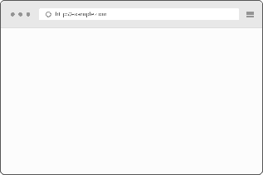  



Fig 1: Web Server 🡪 Static HTML File 🡪 Client Web Browser

With **PHP** in the mix, the web server is able to **dynamically generate HTML** web pages

   





Fig 2: Web Server 🡪 PHP 🡪 MySQL 🡪 PHP 🡪 Client Web Server

**PHP**: **Personal Home Pages**, it was later changed **PHP Hypertext Processor**.

**PHP**: **Server-side programming language** – it runs on a web server.

#### Simple Form(Form.html)

<!doctype html>

<**html**>

<**head**>

<**meta** charset = "UTF-8"/>

<**title**> Simple Form </**title**>

</**head**>

<**body**>

<**p**> Please fill out the form </**p**>

<**img** src = "database.png" width = "100" height = "175"

alt = "database picture"/><**br**/>

<**form** method = "post" action = "khan.photon@gmail.com">

<**label** for = "firstname"> First Name: </**label**>

<**input** type = "text" id = "filename" name = "firstname"/><**br**/>

<**label** for = "lastname"> Last Name: </**label**>

<**input** type = "text" id = "lastname" name = "lastname"/><**br**/>

<**label** for = "email"> Email: </**label**>

<**input** type = "email" id = "email" name = "email"/><**br**/>

<**label** for = "gender">Gender: </**label**>

Male <**input** type = "radio" id ="gender" name = "gender" value = "male">

Female <**input** type = "radio" id = "gender" name = "gender"

value = female"><**br**/>

<**label** for = "description"> Description: </**label**>

<**textarea** name = "description"> Max word 500 words </**textarea**><**br**/>

<**input** type = "submit" value = "Submit" name = "submit"/>

</**form**>

</**body**>

</**html**>

Code 1 (Form.html): Simple Form HTML Code

**Tags:** <**form**></**form**>, <**input></input>,** <**label></label>**

**Attributes**: action, type, id, method, name, class, value

#### Breakdown(Form.html)

Basic HTML Format

<!doctype html>

<**html**>

<**head**>

<**meta** charset = "UTF-8"/>

<**title**> Simple Form </**title**>

</**head**>

<**body**>

</**body**>

</**html**>

|  |  |
| --- | --- |
| **Labels/Tags** | **Description** |
| <!doctype html> | A document type declaration |
| <**html**> | Tells the browser that this is an HTML document |
| <**head**></**head**> | Includes title for the document, scripts, styles, meta information |
| <**meta** charset="UTF-8"/> | Specifies what character set is our website written with |
| "UTF-8" | Universal Character Set + Transformation Format 8-bit |
| <**body**></**body**> | This is where all the HTML contents are written |
| <**p**></**p**> | Paragraph |
| <**img** src="database.png"/> | Include Image, Attribute src is the image src path |
| alt="database picture" | Alternatively, text will show up if no image found |
| width="100" height="175" | Fixing the width and height of the image |

<**form** method = "post" action = "khan.photon@gmail.com">

Form action attribute should be changed

<**form** method = "post" action = "report.php"></**form**>

Form tag causes the PHP script to run on the server.

|  |  |
| --- | --- |
| **Labels/Tags** | **Description** |
| <**input><**/**input>** | Input tag is the input field where user can enter data |
| type="text | Attribute type is the value received and saved from the user |
| id="filename" | Attribute id is the unique identifier; used for manipulating the element |
| name="firstname" | Attribute name is the value received and saved from the user |

<**label** for = "gender">Gender: </**label**>

Male <**input** type = "radio" id ="gender" name = "gender" value = "male">

Female <**input** type = "radio" id = "gender" name = "gender" value = "female">

Label tag allows user clicks on the text within the <**label>** element, it toggles the control.

For attribute should be equal to the id attribute of the related element to bind together

<**textarea** name = "description"> Max word 500 words </**textarea**><**br**/>

Textarea tag allows users to type multi-lines, description type situations

<**input** type = "submit" value = "Submit" name = "submit"/>

Type attribute allows user to make a submit button

Value attribute allows user to change the text in the submit button

<**br**/>

It allows the display go to next line. Single line break.

#### Confirmation(Report.php)

<?php

**if**(!empty($_POST["submit"])):

$firstname = $_POST["firstname"];

$lastname = $_POST["lastname"];

$email = $_POST["email"];

$gender = $_POST["gender"];

$description = $_POST["description"];

**echo** "First Name: ".$firstname."<br/>";

**echo** "Last Name: ".$lastname."<br/>";

**echo** "Email: ".$email."<br/>";

**echo** "Gender: ".$gender."<br/>";

**echo** "Description: ".$description."<br/>";

**endif**;

?>

Code 2 (Report.php): Receiving the user input information from form.html

#### Breakdown(Report.php)

|  |  |
| --- | --- |
| **Labels/Tags** | **Description** |
| <?php ?> | It indicates that the PHP code is written in this block |
| **If**(condition): | If the condition is true, do the following statement |
| $_POST["submit"] | $_POST receives the value from the name attribute |
| $firstname | $ creates the variable |
| **echo** | Outputting information beyond the confines of the <?php ?> |

Web browser know nothing about PHP and, therefore, have no ability to run PHP scripts.

Web servers with PHP support are equipped to run PHP scripts and turn them into HTML web pages that browsers can understand.

Every PHP must end with a semicolon “;”.

Name the PHP file with “.php”

#### PHP Information(info.php)

<?php

phpinfo();

?>

Code 3 (Info.php): Detailed information about the PHP installed in the PC

#### Variable

* PHP variable names must begin with a dollar sign, and cannot contain spaces
* The first character after the dollar be a letter or an underscore “_”
* Characters after the first character after that can be a **letter, an underscore, or a number**
* Spaces and special characters are not allowed in any part of a variable name
* Use all lowercase for variable name
* Separate words in a multi-word variable name with underscores

#### Assigning value to the variable

$description = “I am the man.”;

Pieces of text(strings) must be enclosed by quotes, either single quotes or double quotes.

#### Special Variable

$_POST is a special variable that is known as a superglobal. It is a collection of storage locations used to hold data from a web form. It is also an **array**. This array is filled the values the user entered into the form.

#### Concatenation

**echo** "Description: ".$description."<br/>";

The period allows us to stick multiple strings of text together as one. This process is known as concatenation.

<?php

$name = "Jack Stubbort";

$age = "17";

$place = "Netherland";

$msg = $name."is ".

$age."-years-old. "

."He works in ".$place.".";

**echo** $msg;

?>

Code 4 (Concatenation.php): Long line of PHP codes spanned across multiple lines

#### Escape Characters

* Escape characters in PHP starts with a backlash “\”
* Escape characters can be escaped in double-quoted only
* Single-quoted string only allow ‘\’ but not ‘\\’

<?php

$name = "Allen Smith";

$age = "21";

$occupation = "Engineer";

**echo** '$name is $age-years-old. \r\n He is an \"$occupation.\"';

**echo** "<br/><br/>";

**echo** nl2br("**$name** is **$age**-years-old. **\n** He is an **\"$occupation**.**\"\n\n**");

**echo** "**\\** **\"**";

?>

Code 5 (DoubleSingle.php): Escape Characters.

For newline break, we need to use nl2br() function to go new line.

### Mailing

#### Initial Setup

We can send mail from localhost with sendmail package, sendmail package is inbuild in XAMPP. So, if we are using XAMPP then you can easily send mail from localhost.

For example: We can configure C:\xampp\php\php.ini and c:\xampp\sendmail\sendmail.ini for gmail to send mail.

In C:\xampp\php\php.ini find extension=php_openssl.dll and remove the semicolon from the beginning of that line to make SSL working for gmail for localhost.

In php.ini file find [mail function] and change

SMTP=smtp.gmail.com

smtp_port=587

sendmail_from = my-gmail-id@gmail.com

sendmail_path = "\"C:\xampp\sendmail\sendmail.exe\" -t"

Now Open C:\xampp\sendmail\sendmail.ini. Replace all the existing code in sendmail.ini with following code

[sendmail]

smtp_server=smtp.gmail.com

smtp_port=587

error_logfile=error.log

debug_logfile=debug.log

auth_username=my-gmail-id@gmail.com

auth_password=my-gmail-password

force_sender=my-gmail-id@gmail.com

Now you have done!! create php file with mail function and send mail from localhost.

PS: Don't forgot to replace my-gmail-id and my-gmail-password in above code. Also, don't forget to remove duplicate keys if you copied settings from above. For example comment following line if there is another sendmail_path : sendmail_path="C:\xampp\mailtodisk\mailtodisk.exe" in the php.ini file

Also remember to restart the server using the XAMMP control panel so the changes take effect.

For gmail please check [**https://support.google.com/accounts/answer/6010255**](https://support.google.com/accounts/answer/6010255%20) to allow access from less secure apps.

**Source:** [**https://stackoverflow.com/questions/15965376/how-to-configure-xampp-to-send-mail-from-localhost**](https://stackoverflow.com/questions/15965376/how-to-configure-xampp-to-send-mail-from-localhost)

#### Mailing(Mail.php)

<?php

**echo** '<!doctype html>';

**echo** ' <html>';

**echo** ' <head>';

**echo** ' <meta charset = "UTF-8"/>';

**echo** ' <title> Simple Form </title>';

**echo** ' </head>';

**echo** ' <body>';

**echo** ' <img src = "images/database.png" width = "100" height = "100"';

**echo** ' alt = "database picture"/><br/>';

**echo** ' <p> Please fill out the form </p>';

**echo** ' <form method = "post" action = "';

**echo** $_SERVER['PHP_SELF']."**\"**>";

**echo** ' <label for = "firstname"> First Name: </label>';

**echo** ' <input type = "text" id = "filename" name = "firstname"/><br/>';

**echo** ' <label for = "lastname"> Last Name: </label>';

**echo** ' <input type = "text" id = "lastname" name = "lastname"/><br/>';

**echo** ' <label for = "email"> Email: </label>';

**echo** ' <input type = "email" id = "email" name = "email"/><br/>';

**echo** ' <label for = "gender">Gender: </label>';

**echo** ' Male <input type = "radio" id ="gender" name = "gender" value = "male">';

**echo** ' Female <input type = "radio" id = "gender" name = "gender" value = "female"><br/>';

**echo** ' <label for = "description"> Description: </label>';

**echo** ' <textarea name = "description"> Max word 500 words </textarea><br/>';

**echo** ' <input type = "submit" value = "Submit" name = "submit"/>';

**echo** ' </form>';

**echo** ' </body>';

**echo** ' </html>';

?>

Code 6 (Mail.php): First Section.

Form.html file has been converted to PHP file by adding echo.

$_SERVER['PHP_SELF']

The form sends the data to the same page and not directing to another PHP file.

<?php

**if**(!**empty**($_POST["submit"])):

$firstname = $_POST["firstname"];

$lastname = $_POST["lastname"];

$email = $_POST["email"];

$gender = $_POST["gender"];

$description = $_POST["description"];

**echo** "First Name: ".$firstname."<br/>";

**echo** "Last Name: ".$lastname."<br/>";

**echo** "Email: ".$email."<br/>";

**echo** "Gender: ".$gender."<br/>";

**echo** "Description: ".$description."<br/>";

$to = "khan.photon@gmail.com";

$subject = "Extra Description";

$message = $description;

mail($to, $subject, $message, 'From:'.$email);

*//Allow less secure apps on*

**endif**;

?>

Code 7 (Mail.php): Second Section.

It is exactly like the Report.php file only the mail($to, $subject, $message, 'From:'.$email) function has been added.

|  |  |
| --- | --- |
| **Variable** | **Description** |
| $to | Whom you are sending email to |
| $subject | Subject part of the email |
| $message | The actual message of the email |
| 'From:'.$email | Email Address of the sender |
| "From:".$email."\r\nCc:".$cc | Separate From and CC using (\r\n), Use double quotation |

### Connecting to the Database

SQL: Structured Query Language, it is the language used to communicate.

MySQL: Stores data inside of database tables. MySQL databases are organized into tables, which store information as rows and columns of related data.



  

 

Fig 3: Client Web Server 🡪 Request 🡪 Web server Response

#### Communicating with a Databaser Server

PhpMyAdmin: It is a graphical tool that allows us to create databases and tables through a web interface

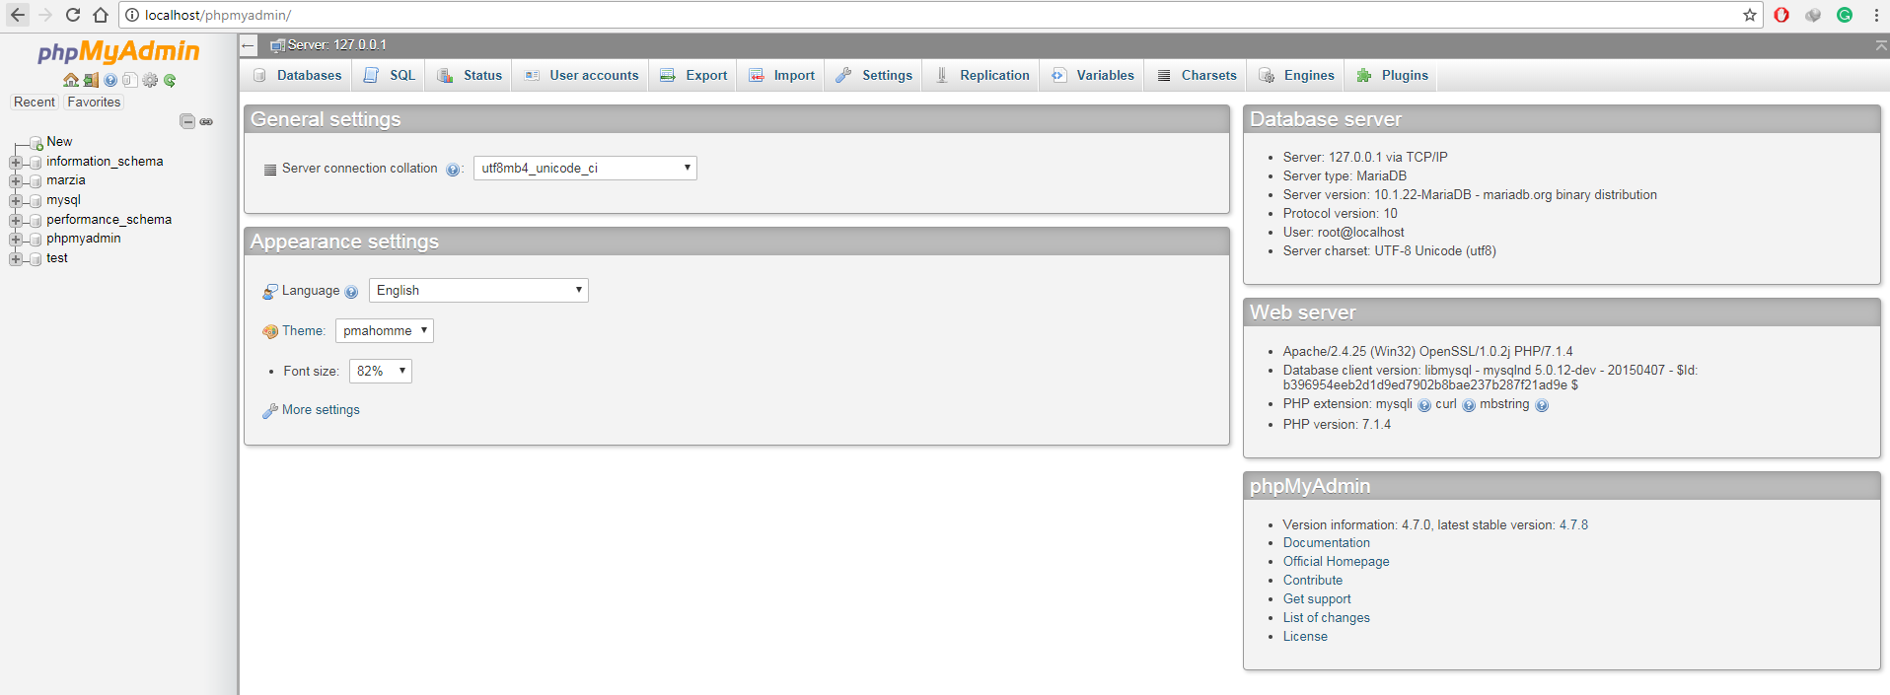

Fig 4: PhpMyAdmin

First of all, install XAMPP for Windows or install LAMPP for Linux.

#### Installing XAMPP for Windows

Go to this link, [**https://www.apachefriends.org/download.html**](https://www.apachefriends.org/download.html), Download the latest version of XAMPP through the Mozilla browser.

After installation, open the XAMPP software and turn on

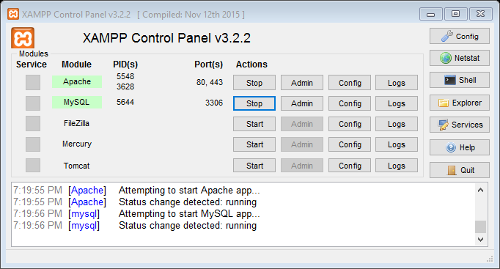

Fig 5: XAMPP Control Panel

Create a folder in **C:\xampp\htdocs\,** you can name folder anything, for the time being let us just create a folder named “practice”. Now we will have **C:\xampp\htdocs\practice,** we can create PHP or HTML files inside it and then deploy it on the browser. Let us create a file, **form.php**. Therefore, we will end up having **C:\xampp\htdocs\practice\form.php.**

Now go to your favorite browser, type [**http://localhost/practice/form.php**](http://localhost/practice/form.php)**,** code in PHP would display here. Therefore **C:\xampp\htdocs\** folder location gets replaced by [**http://localhost/**](http://localhost/) in your browser.

If we type, [**http://localhost/phpmyadmin/**](http://localhost/phpmyadmin/)**,** this will show our MySQL database.

#### Light Weight Editor (Sublime Text Editor)

From this link download, [**https://www.sublimetext.com/3**](https://www.sublimetext.com/3)**,** this is probably one of the best coding editor.

If you want to install packages in sublime text first you need to install **package control.** Press the **Ctrl+`** in sublime editor and copy paste the code given in [**https://packagecontrol.io/installation**](https://packagecontrol.io/installation)**.**

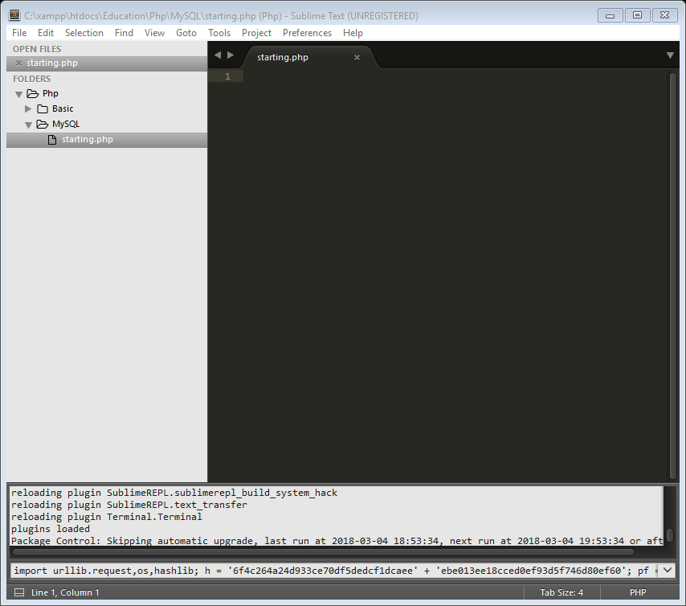

Fig 6: Sublime Text Editor (Package Control Install)

Once installed, press **Ctrl+Shift+P,** type in **Package Control: Install Package**

#### Installing XAMPP for Linux

Go to this link, <https://www.apachefriends.org/download.html>, Download the latest version of XAMPP.

Go to **/Home/Your-Username/Downloads.** Ex: **/Home/Photon/Downloads**

Open the command terminal there and type:

**sudo chmod 777 name-of-the-downloaded-file.**

Ex: **sudo chmod 777 ./xampp-linux-x64-7.2.2-0-installer.run**

This allows the administration permission to install the file

**sudo ./name-of-the-file**

Ex: **./xampp-linux-x64-7.2.2-0-installer.run**

This is how the installation of the file works

**sudo /opt/lamp/lampp start**

This starts the LAMPP on

#### Installing Sublime Editor for Linux

sudo apt-get-repository ppa:webupd8team/sublime-text-3

sudo apt-get update

sudo apt-get install sublime-text-installer

This is how the installation of the file works

### Creating a Database

Creating a database (form_table). Tables are stored in database

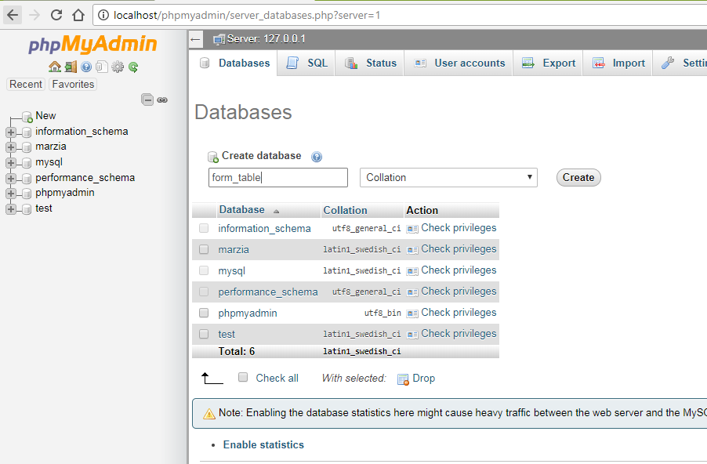

Fig 7: Creating a Database (form_table)

Click on New 🡪 Type in database name (form_table) 🡪 click on create

#### Creating a Table

Tables serves as a way to divide up the data in a database into related groups

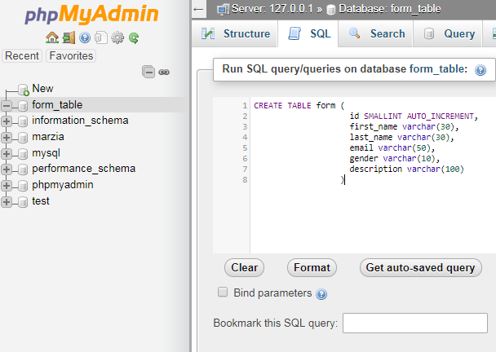

Fig 8: Creating a Table (Inside the form_table Database)

#### Breakdown (SQL: form)

CREATE TABLE form (

id INT AUTO_INCREMENT,

first_name VARCHAR(30),

last_name VARCHAR(30),

email VARCHAR(50),

gender VARCHAR(10),

description VARCHAR(100),

PRIMARY KEY(id)

)

Code 8: Create a form table

CREATE TABLE form

Name of the table is form

id INT AUTO_INCREMENT

Number the rows using id, (integer and it will increment by itself)

first_name VARCHAR(30)

First name will be stored here, its variable character length is 30

email VARCHAR(50)

Variable character length is 50

PRIMARY KEY(id)

This allows id to uniquely identify each record in the table

#### Using INSERT command

INSERT INTO form(first_name, last_name, email, gender, description)

VALUES('Photon', 'Khan', 'khan.photon@gmail.com', 'male', 'I am too fat')

Code 9: Insert data into the form table

INSERT INTO table_name (column_name, …. …. ….. ….)

VALUES (‘value 1’, ‘value 2’)

See the values are in single quotation. Values in the set of parentheses have to be in the same order as the database column names

#### Using SELECT command

SELECT columns FROM table_name

Ex: SELECT first_name, last_name FROM form

SELECT * FROM table_name

Ex: SELECT * FROM form

*: Fetch all the data from all the columns in the table

Code 10: Select data from the table

### Automating SQL using PHP

Using PHP all the data entered through the form will be saved into the database.

<?php

**echo** '<!doctype html>';

**echo** ' <html>';

**echo** ' <head>';

**echo** ' <meta charset = "UTF-8"/>';

**echo** ' <title> Simple Form </title>';

**echo** ' </head>';

**echo** ' <body>';

**echo** ' <p> Please fill out the form </p>';

**echo** ' <form method = "post" action = "';

**echo** $_SERVER['PHP_SELF']."**\"**>";

**echo** ' <label for = "firstname"> First Name: </label>';

**echo** ' <input type = "text" id = "filename" name = "firstname"/><br/>';

**echo** ' <label for = "lastname"> Last Name: </label>';

**echo** ' <input type = "text" id = "lastname" name = "lastname"/><br/>';

**echo** ' <label for = "email"> Email: </label>';

**echo** ' <input type = "email" id = "email" name = "email"/><br/>';

**echo** ' <label for = "gender">Gender: </label>';

**echo** ' Male <input type = "radio" id ="gender" name = "gender" value = "male">';

**echo** ' Female <input type = "radio" id = "gender" name = "gender" value = "female"><br/>';

**echo** ' <label for = "description"> Description: </label>';

**echo** ' <textarea name = "description"> Max word 500 words </textarea><br/>';

**echo** ' <input type = "submit" value = "Submit" name = "submit"/>';

**echo** ' </form>';

**echo** ' </body>';

**echo** ' </html>';

?>

Code 11: Form.php (First Part)

<?php

**if**(!**empty**($_POST["submit"])):

$firstname = $_POST["firstname"];

$lastname = $_POST["lastname"];

$email = $_POST["email"];

$gender = $_POST["gender"];

$description = $_POST["description"];

**echo** "First Name: ".$firstname."<br/>";

**echo** "Last Name: ".$lastname."<br/>";

**echo** "Email: ".$email."<br/>";

**echo** "Gender: ".$gender."<br/>";

**echo** "Description: ".$description."<br/>";

$server_name = "localhost";

$user_name = "root";

$password = "";

$database_name = "form_table";

$connection = mysqli_connect($server_name, $user_name, $password, $database_name)

**or** **die**("Could not connect to the server");

$query = "INSERT INTO form(first_name, last_name, email, gender, description)

VALUES('**$firstname**','**$lastname**', '**$email**', '**$gender**', '**$description**')";

$result = mysqli_query($connection, $query) **or** **die**("Error Querying database");

mysqli_close($connection);

**endif**;

?>

Code 12: Form.php (Second Part)

#### Breakdown (Form.php (Second Part))

$connection = mysqli_connect($server_name, $user_name, $password, $db_name)

**or** **die**("Could not connect to the server");

$query = "INSERT INTO form(first_name, last_name, email, gender, description)

VALUES('**$firstname**','**$lastname**', '**$email**', '**$gender**', '**$description**')";

$result = mysqli_query($connection, $query) **or** **die**("Error Querying database");

mysqli_close($connection);

**endif**;

|  |  |
| --- | --- |
| **Terms** | **Explanation** |
| Mysqli | “i” over here stands for improved |
| mysqli_connect | This allows us to connect to the database |
| $server_name | It is “localhost” by default if we are running website “locally” |
| $user_name | “root”, by default phpMyAdmin gives username as root |
| $password | “”, by default, there is no password |
| $db_name | Database name |
| mysqli_query() | It allows us to send the SQL command using PHP |
| mysqli_close() | Connection should be closed or else the DB might get corrupted |
| **die**() | This function terminates a PHP script and gives the feedback of the error |

To be sure check your phpMyAdmin home page

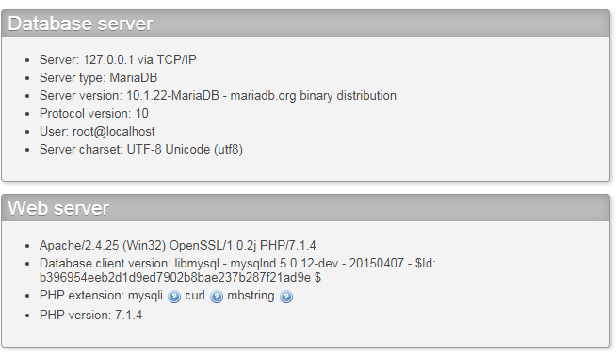

Fig 9: Checking the server name, user name and the password

#### Database check in actual website

First go to **your-name-of-the-website/cpanel**

Ex: [**www.sphotonkhan/cpanel**](http://www.sphotonkhan/cpanel)

Before going to phpMyAdmin, go to MySQL® Database Wizard

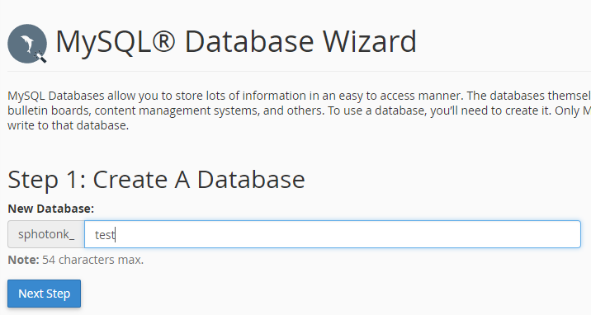

Fig 10: MySQL Database Wizard (1st Step)

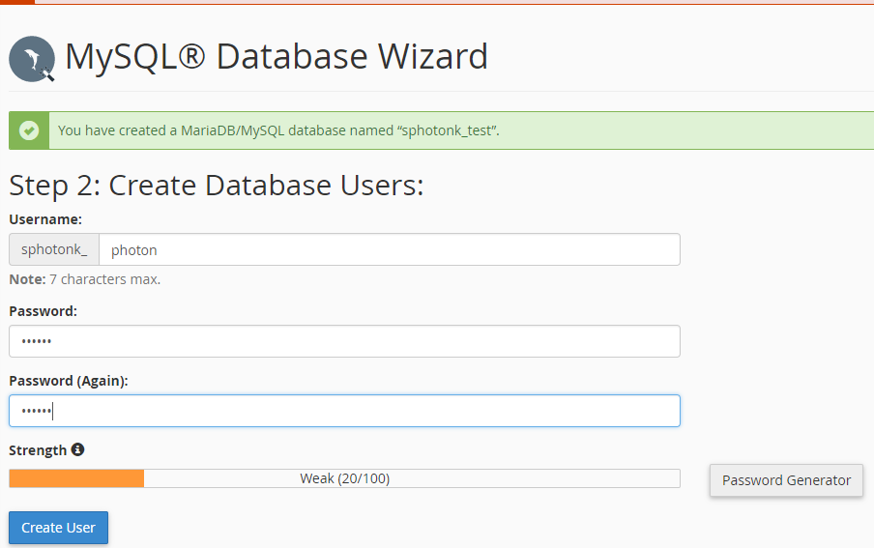

Fig 11: MySQL Database Wizard (2st Step)

|  |  |
| --- | --- |
| $server_name | bh-40 |
| $user_name | sphotonkhan |
| $password | photon |
| $db_name | sphotonk_test |

To get the server information go to Server Information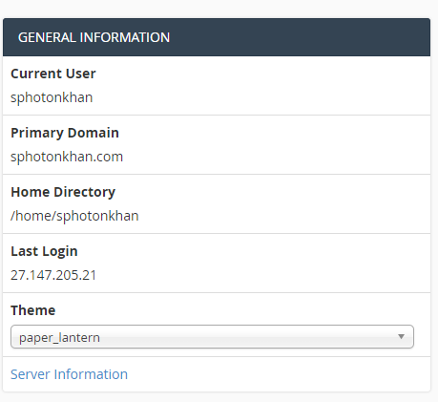

Fig 12: General Information 🡪 Server Information

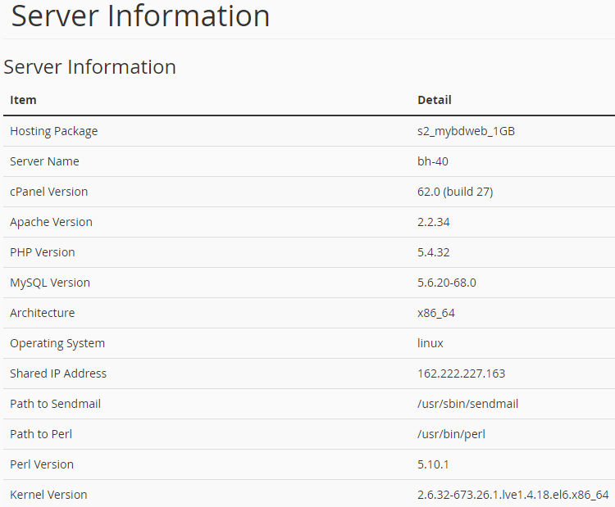

Fig 13: Server Information

#### Selecting all the data from the table

<?php

$server_name = "localhost";

$user_name = "root";

$password = "";

$db_name = "form_table";

$connection = mysqli_connect($server_name, $user_name, $password, $db_name)

**or** **die**("Could not connect to the database");

$query = "SELECT * FROM form";

$result = mysqli_query($connection, $query)

**or** **die**("Query not working");

**while**($row = mysqli_fetch_array($result)){

$id = $row['id'];

$first_name = $row['first_name'];

$last_name = $row['last_name'];

$email = $row['email'];

$gender = $row['gender'];

$description = $row['description'];

**echo** nl2br("Name: **$first_name** **$last_name\n**");

**echo** nl2br("Email: **$email\n**");

**echo** nl2br("Gender: **$gender\n**");

**echo** nl2br("Description: **$gender\n\n**");

}

mysqli_close($connection);

?>

Code 13: Select.php

### Web Application

A web application is a dynamic web site that designed to fulfill a particular purpose for it users.

A database is a container storing data in a very structured way. Table stores data in a grid-like pattern of columns and rows. Columns consists of specific type of data. Rows are collection of columns where a single row consists one of each column. Table rows are horizontal, and table columns are vertical.

**Application Purpose**: Customer wants to add into the newsletter program for a particular shop, i.e. get emails about the discounts and so on. Customer also have the authority to get removed from the newsletter program.

    

Add Email PHP Script PHP Engine Server Database

    

Send Email PHP Script PHP Engine Server Client



Database

Fig 14: Web Application

CREATE DATABASE is the SQL command used to create a new database.

CREATE DATABASE database_name

Ex: CREATE DATABASE store

Text data takes more room to store than integer data. To create a table, we need to know what type of data is stored in each table column.

**Column Types**

CHAR: Character, Highly efficient for the texts with fixed length

INT: Integer, Whole Number, Negative numbers can also be stored

TINYINT: Small Integer

BLOB: Large gobs of binary data

DEC: Decimal

DATETIME: She keeps track of the date

TIMESTAMP: She keeps track of the date

DATE: Keep track of dates

VARCHAR: Variable Character

TEXT: Store huge amount of text

CREATE TABLE SQL is used to create a new table in a database.

CREATE TABLE table_name (column name column type, …)

It is not possible to recreate the same table using CREATE TABLE

USE command selects a database as the default database for subsequent SQL statements

Ex: USE store

DESCRIBE reveals the structure of tables

Ex: DESCRIBE store

DROP deletes a table and all its data from the database

Ex: DROP TABLE store

#### Add Email Script

First Create Table

CREATE TABLE email_list(

id INT AUTO_INCREMENT,

first_name VARCHAR(250),

last_name VARCHaR(250),

email VARCHAR(60),

PRIMARY KEY(id)

)

<!doctype html>

<**html**>

<**head**>

<**title**> Add Email </**title**>

<**meta** charset = "UTF-8"/>

</**head**>

<**body**>

<**p**> Enter Your Details </**p**>

<**form** method = "post" action = "addemail.php">

<**label** for = "first_name"> First Name: </**label**>

<**input** type = "text" name = "first_name" id = "first_name"><**br**/>

<**label** for = "last_name"> Last Name: </**label**>

<**input** type = "text" name = "last_name" id = "last_name"><**br**/>

<**label** for = "email"> Email: </**label**>

<**input** type = "email" name = "email" id = "email"><**br**/>

<**input** type = "submit" name = "submit" value = "Submit"/>

</**form**>

</**body**>

</**html**>

Code 14: addemail.html

<?php

$server_name = "localhost";

$user_name = "root";

$password = "";

$db_name = "store";

**if**(!**empty**($_POST['submit'])):

$connection = mysqli_connect($server_name,

$user_name,

$password, $db_name)

**or** **die**("Could not connect to the server");

$first_name = $_POST['first_name'];

$last_name = $_POST['last_name'];

$email = $_POST['email'];

$sql = "INSERT INTO email_list(first_name,

last_name,

email)

VALUES('**$first_name**','**$last_name**','**$email**')";

$result = mysqli_query($connection, $sql)

**or** **die**("Query Denied");

**echo** nl2br("<h1>Confirmation Message</h1> **\n**");

**echo** nl2br("<p>Name: **$first_name** **$last_name**</p>");

**echo** nl2br("<p>Email: **$email**</p> **\n**");

mysqli_close($connection);

**endif**;

?>

Code 15: addemail.php

<!doctype html>

<**htmL**>

<**head**>

<**title**> Send Email </**title**>

<**meta** charset = "UTF-8"/>

</**head**>

<**body**>

<**form** method = "post" action = "sendemail.php">

<**label** for = "subject">Subject</**label**><**br**/>

<**input** type = "text" name = "subject" id = "subject"/><**br**/>

<**label** for = "body_of_email"> Body of Email </**label**><**br**/>

<**textarea** name = "body_of_email" id = "body_of_email"

rows = "8" cols = "60"></**textarea**><**br**/>

<**input** type = "submit" id = "submit" name = "submit"

value = "Submit"/>

</**body**>

</**htmL**>

Code 16: sendemail.html

<?php

**if**(!empty($_POST['submit'])):

$from = "khan.photon@gmail.com";

$subject = $_POST['subject'];

$body_of_email = $_POST['body_of_email'];

$server_name = "localhost";

$user_name = "root";

$password = "";

$db_name = "store";

$connection = mysqli_connect($server_name,

$user_name,

$password,

$db_name)

**or** **die**("Could connect to the server");

$query = "SELECT * FROM email_list";

$result = mysqli_query($connection, $query)

**or** **die**("Query Denied");

**while**($row = mysqli_fetch_array($result)){

$to = $row['email'];

mail($to, $subject, $body_of_email, "From: **$from**");

}

mysqli_close($connection);

**endif**;

?>

Code 17: sendemail.php

mysqli_fetch_array($result)

This function stores a row of data in an array.

A while loop repeats code while a condition is met. $row is interpreted as true since it isn’t set to 0 or false. When there is no more data available, mysqli_fetch_array($result) return false. Anything other than 0 or False is always interpreted as true.

#### Removing data using DELETE and WHERE

A where clause narrows down a query to focus on specific rows of data. A where clause in a DELETE statement let us pinpoint the row we want to remove.

DELETE FROM email_list

WHERE email = “khan.photon@gmail.com”

email = Name of the table column

[khan.photon@gmail.com](mailto:khan.photon@gmail.com) = Check whether this exists in the database.

<!doctype html>

<**html**>

<**head**>

<**title**> Remove Email </**title**>

<**meta** charset = "UTF-8"/>

</**head**>

<**body**>

<**p**> Enter Email Address to Remove </**p**><**br**/>

<**form** method = "post" action = "removeemail.php">

<**label** for = "email">Email</**label**><**br**/>

<**input** type = "email" name = "email" id = "email"/><**br**/>

<**input** type = "submit" value = "Submit" name = "submit"/>

</**form**>

</**body**>

<**html**>

Code 18: removeemail.html

<?php

$server_name = "localhost";

$user_name = "root";

$password = "";

$db_name = "store";

**if**(!**empty**($_POST)):

$email = $_POST['email'];

$connection = mysqli_connect($server_name,

$user_name,

$password,

$db_name)

**or** **die**("Could not connect to the server");

$query = "DELETE FROM email_list where email = '**$email**'";

mysqli_query($connection, $query) **or**

**die**("Query Denied");

**echo** nl2br("**$email** has been successfully removed**\n**");

mysqli_close($connection);

**endif**;

?>

Code 19: removeemail.php

#### Server-Side Validation

It assures the data we get is the data we expect.

isset(): It tests to see if a variable exists, which means that it’s been assigned a value.

empty(): Determines where the variable contains empty value

PHP defines as 0, an empty string (‘’ or “”), or the values false or NULL

PHP logic operators make it possible to structure more elegant if statements.

Logical AND is coded as && while logical OR is coded as ||

<!doctype html>

<**htmL**>

<**head**>

<**title**> Send Email </**title**>

<**meta** charset = "UTF-8"/>

</**head**>

<**body**>

<**form** method = "post" action = "sendvalidatedemail.php">

<**label** for = "subject">Subject</**label**><**br**/>

<**input** type = "text" name = "subject" id = "subject"/><**br**/>

<**label** for = "body_of_email"> Body of Email </**label**><**br**/>

<**textarea** name = "body_of_email" id = "body_of_email"

rows = "8" cols = "60"></**textarea**><**br**/>

<**input** type = "submit" id = "submit" name = "submit"

value = "Submit"/>

</**body**>

</**htmL**>

Code 20: sendvalidatedemail.html

<?php

**if**(**empty**($_POST['subject']) && !**empty**($_POST['body_of_email'])):

**echo** "Your subject is empty!";

**elseif**(**empty**($_POST['body_of_email']) && !**empty**($_POST['subject'])):

**echo** "Your body of email is empty!";

**elseif**(**empty**($_POST['subject']) && **empty**($_POST['body_of_email'])):

**echo** "Your subject and body of email are empty!";

**elseif**(!empty($_POST['submit']) && !**empty**($_POST['subject']) && !**empty**($_POST['body_of_email'])):

$from = "khan.photon@gmail.com";

$subject = $_POST['subject'];

$body_of_email = $_POST['body_of_email'];

$server_name = "localhost";

$user_name = "root";

$password = "";

$db_name = "store";

$connection = mysqli_connect($server_name,

$user_name,

$password,

$db_name)

**or** **die**("Could connect to the server");

$query = "SELECT * FROM email_list";

$result = mysqli_query($connection, $query)

**or** **die**("Query Denied");

**while**($row = mysqli_fetch_array($result)){

$to = $row['email'];

mail($to, $subject, $body_of_email, "From: **$from**");

}

mysqli_close($connection);

**else**:

**endif**;

?>

Code 21: sendvalidatedemail.php

#### Self-Referencing and Sticky Forms

An HTML form that is part of the PHP script that processes it is known as **self-referencing.**

**Sticky forms** remember the data the user has already correctly entered.

$_SERVER[‘PHP_SELF’] stores away the name of the current script

<?php

$error = [];

$error['sub'] = "";

$error['body'] = "";

**if**(**empty**($_POST['subject']) && !**empty**($_POST['body_of_email'])):

$error['sub'] = "Your subject is empty!";

**endif**;

**if**(**empty**($_POST['body_of_email']) && !**empty**($_POST['subject'])):

$error['body'] = "Your body of email is empty!";

**endif**;

**if**(**empty**($_POST['subject']) && **empty**($_POST['body_of_email'])):

$error['sub'] = "Your subject is empty!";

$error['body'] = "Your body of email is empty!";

**endif**;

**if**(!**empty**($_POST['submit']) && !**empty**($_POST['subject']) && !**empty**($_POST['body_of_email'])):

$from = "khan.photon@gmail.com";

$subject = $_POST['subject'];

$body_of_email = $_POST['body_of_email'];

$server_name = "localhost";

$user_name = "root";

$password = "";

$db_name = "store";

$connection = mysqli_connect($server_name,

$user_name,

$password,

$db_name)

**or** **die**("Could connect to the server");

$query = "SELECT * FROM email_list";

$result = mysqli_query($connection, $query)

**or** **die**("Query Denied");

**while**($row = mysqli_fetch_array($result)){

$to = $row['email'];

mail($to, $subject, $body_of_email, "From: **$from**");

**echo** "Your email has been successfully sent";

}

mysqli_close($connection);

**endif**;

?>

<!doctype html>

<htmL>

<head>

<title> Send Email </title>

<meta charset = "UTF-8"/>

</head>

<body>

<form method = "post" action = "<?php **echo** $_SERVER['PHP_SELF'];?>">

<label for = "subject">Subject</label><br/>

<input type = "text" name = "subject" id = "subject"

value = "<?php **if**(!**empty**($_POST['subject'])) **echo** $_POST['subject']; ?>"/>

<?php **if**($error['sub'] && !**empty**($_POST['submit'])) **echo** $error['sub'];?><br/>

<label for = "body_of_email"> Body of Email </label><br/>

<textarea name = "body_of_email" id = "body_of_email"

rows = "8" cols = "60"><?php **if**(!**empty**($_POST['body_of_email'])) **echo** $_POST['body_of_email'];?></textarea>

<?php **if**($error['body'] && !**empty**($_POST['submit'])) **echo** $error['body'];?><br/>

<input type = "submit" id = "submit" name = "submit"

value = "Submit"/>

</body>

</htmL>

Code 22: sendemailupdated.php

#### Avoid duplicate entry in Database

Table rows should be **uniquely identifiable.** Therefore, we will create a unique integer column, also called a **primary key**

To alter the table that already exists

ALTER TABLE table_name ADD column_name, column_type

Location: first in the table

ALTER TABLE email_list ADD id INT NOT NULL AUTO_INCREMENT FIRST, ADD PRIMARY KEY(id)

Column that we want to add Increase the value of id by 1 automatically id is the primary key

A primary key is a column in our table that makes each row unique

<!doctype html>

<html>

<head>

<title> Remove Email </title>

<meta charset = "UTF-8"/>

</head>

<body>

<p> Delete Email Addresses </p>

<?php

$showform = **TRUE**;

$server_name = "localhost";

$user_name = "root";

$password = "";

$db_name = "store";

$connection = mysqli_connect($server_name,

$user_name,

$password,

$db_name)

**or** **die**("Could not connect to the server");

**if**(isset($_POST['submit'])):

$email = $_POST['email'];

$showform = **FALSE**;

$query = "SELECT * FROM email_list WHERE email = '**$email**'";

$result = mysqli_query($connection, $query) **or**

**die**("Select Query Denied");

**echo** "<form method = 'post' action = '".$_SERVER['PHP_SELF']."'>";

**while**($row = mysqli_fetch_array($result)){

$id = $row['id'];

$name = $row['first_name']." ".$row['last_name'];

$email = $row['email'];

**echo** "<input type = 'checkbox' value = **\"$id\**" name = \"todelete[] **\"**/>";

**echo** "**$name** **$email**<br/>";

}

**echo** "<br/><input type = 'submit' value = 'Remove' name = 'remove'/>";

**echo** "</form>";

**endif**;

**if**(isset($_POST['remove'])):

$showform = **FALSE**;

**foreach**($_POST['todelete'] **as** $delete_id){

$query = "DELETE FROM email_list where id = '**$delete_id**'";

mysqli_query($connection, $query) **or** **die** ("Remove Query Denied");

}

**echo** "Customers Removed Successfully";

**endif**;

?>

<?php

**if**($showform):

?>

<form method = "post" action = "<?php **echo** $_SERVER['PHP_SELF'];?>">

<label for = "email">Email</label><br/>

<input type = "email" name = "email" id = "email"/><br/>

<input type = "submit" value = "Submit" name = "submit"/>

</form>

</body>

<html>

<?php

**endif**;

?>

Code 23: removeemailupdated.php

#### Inventory (ALTER TABLE)

Making a web application related to a shop

|  |  |  |  |  |
| --- | --- | --- | --- | --- |
| **ID** | **Date Added** | **Product** | **Price** | **Image** |
| 1 | 2007-04-22 14:37:34 | Lip stick | 25.00 | --- |
| 2 | 2009-01-12 21:27:54 | Chocolate | 5.23 | --- |
| 3 | 2011-12-23 09:06:35 | Shampoo | 40.15 | --- |
| 4 | 2013-08-04 09:12:53 | Shoe | 150.14 | --- |
| 5 | 2012-02-21 14:09:50 | Soap | 9.19 | --- |

The Alter statement is used to change the structure of a database

ALTER TABLE inventory ADD COLUMN age TINYINT

Add a column to a table

ALTER TABLE inventory CHANGE COLUMN image screenshot VARCHAR(255)

Change the name and data type of the column

ALTER TABLE inventory DROP COLUMN age

Drops the column

ALTER TABLE inventory MODIFY COLUMN date DATETIME AFTER age

Only First & AFTER can be used to alter the position

Changes the data type or position of a column within a table

#### Uploading a File

<form enctype = "multipart/form=data" method = "post"

action = "<?php echo **$_SERVER['PHP_SELF']**;?>">

enctype attribute tells the form to use a special type of encoding required for the upload – it affects how the POST data is bundled and sent when the form is submitted

<input type = "hidden" name = "MAX_FILE_SIZE" value = "32768"/>

Establishes the maximum file size for file uploads in this case, 32 KB (32,768)

INSERT INTO inventory VALUES(NOW(), ‘$name’, ‘$price’, ‘$image’)

NOW() function is used to insert the current date/time.

Image filenames are stored in the database as part of an INSERT statement

$_FILES

It is a built-in super global variable provides access to information about uploaded files.

$_FILES[‘image’][‘name’]

The name of the uploaded file

$_FILES[‘image’][‘type’]

MIME type of the uploaded file

$_FILES[‘image’][‘tmp_name’]

Temporary storage location of the file on the server

$_FILES[‘error’][‘error’]

The error code for the file upload, 0 indicates a success, other values indicate failure

move_uploaded_file($_FILES[‘image’][‘tmp_name’], $target)

Placing an image on a web page only requires reference to the image file.

The file that is being uploaded actually stores in a temporary folder on the server. Temporary folder after a certain time deletes the file. Therefore. to save the file, we need to use move_uploaded_file() function to move the file from temporary to the current directory.

UPLOAD_PATH = “images/”

It is a constant, it values stays the same

Define a constant using define(‘UPLOAD_PATH’, ‘/images’)

$target = UPLOAD_PATH.$FILES[‘image’][‘name]

Therefore, the target location is “images/name-of-the-file.png”

<!doctype html>

<html>

<head>

<title> Inventory Index </title>

<meta charset = "UTF-8"/>

</head>

<body>

<h1> Inventory **List** </h1>

<p><a href = "addinventory.php">Add Item</a></p>

<p> **List** of items are given below</p>

<?php

$server_name = "localhost";

$user_name = "root";

$password = "";

$db_name = "store";

define("UPLOAD_PATH","images/");

$connection = mysqli_connect($server_name, $user_name,

$password, $db_name)

**or** **die**("Could not conenct to the database");

$query = "SELECT * FROM inventory";

$result = mysqli_query($connection, $query);

**echo** "<table>";

**echo** "<tr>";

**echo** "<th>Date</th>";

**echo** "<th>Name</th>";

**echo** "<th>Price</th>";

**echo** "<th>Image</th>";

**echo** "</tr>";

**while**($row = mysqli_fetch_array($result)){

**echo** "<tr>";

**echo** "<td>".$row['date']."</td>";

**echo** "<td>".$row['name']."</td>";

**echo** "<td>".$row['price']."</td>";

**echo** "<td><img src ='".UPLOAD_PATH.$row['image']."' alt = 'Inventory Image'

height = '20px' width = '20px'/></td>";

**echo** "</tr>";

}

**echo** "</table>";

?>

</body>

</html>

Code 24: inventoryindex.php

<?php

$show_form = **TRUE**;

define("UPLOAD_PATH","images/");

$server_name = "localhost";

$user_name = "root";

$password = "";

$db_name = "store";

$connection = mysqli_connect($server_name, $user_name, $password, $db_name)

**or** **die**("Server Connection Denied");

**if**(isset($_POST['submit'])):

$name = $_POST['item_name'];

$price = $_POST['price'];

$image_name = $_FILES['image']['name'];

**if**(!**empty**($name) && !**empty**($price) && !**empty**($image_name)):

$show_form = **FALSE**;

$target = UPLOAD_PATH.$image_name;

*// $date = date("Y-m-d h:i:s");*

$query = "INSERT INTO inventory VALUES(0, NOW(), '**$name**', '**$price**', '**$image_name**')";

mysqli_query($connection, $query) **or** **die**("Query Denied");

move_uploaded_file($_FILES['image']['tmp_name'], $target);

**echo** "Inventory Added Successfully";

**endif**;

**endif**;

?>

<?php

**if**($show_form):

?>

<!doctype html>

<html>

<head>

<title> Add Inventory </title>

<meta charset = "UTF-8"/>

</head>

<body>

<p> Add Inventory </p>

<form enctype = "multipart/form-data" method = "post"

action = "<?php **echo** $_SERVER['PHP_SELF'];?>">

<!-- <input type = "hidden" name = "MAX_FILE_SIZE" value = "32768"/> -->

<label for = "item_name"> Item Name: </label><br/>

<input type = "text" name = "item_name" id = "item_name"/><br/>

<label for = "price"> Price: </label><br/>

<input type = "number" name = "price" id = "price" step = "0.01"/><br/>

<input type = "file" name = "image" id = "image"/><br/><br/>

<input type = "submit" value = "Add Item" name = "submit"/>

</body>

</html>

<?php

**endif**;

?>

Code 25: addinventory.php

#### Check File or not

<?php

$file_path = "images/chips.png";

**if**(is_file($file_path) && filesize($file_path)):

**echo** "It is a file";

**endif**;

?>

Code 26: checkfile.php

Databases are great for storing text data, but it’s normally better for them to reference binary data in external files.

#### Sharing Data

Shared script data needs to be accessible throughout an application without code duplication. Include files allows us to share code across multiple scripts

require_once, the name “include file” comes from a PHP statement called include that is very similar to require_once. The difference is that require_once results in an error if the included file cannot be found. “include” won’t reveal an error if an include file is missing. There are in total four of them: include, include_once, require, require_once.

Therefore, **require** and **require_once,** will shot **fatal error** if the file is missing

Therefore, **include** and **include_once**, will show warning and continue load the rest of the page.

Therefore, difference between **include** and **include_once**, if the code from a file has been already included then it will not be included again if we use **include_once()**. Means **include_once()** include the file only once at a time. Same for **require** and **require_once.**

require_once statement inserts shared script code into other scripts.

Let’s reorganize the previous files

<?php

define("UPLOAD_PATH","images/");

$server_name = "localhost";

$user_name = "root";

$password = "";

$db_name = "store";

?>

Code 27: databaseinfo.php

<!doctype html>

<html>

<head>

<title> Inventory Index </title>

<meta charset = "UTF-8"/>

</head>

<body>

<h1> Inventory **List** </h1>

<p><a href = "addinventory.php">Add Item</a></p>

<p> **List** of items are given below</p>

<?php

**require_once**("common/databaseinfo.php");

$connection = mysqli_connect($server_name, $user_name,

$password, $db_name)

**or** **die**("Could not conenct to the database");

$query = "SELECT * FROM inventory";

$result = mysqli_query($connection, $query);

**echo** "<table>";

**echo** "<tr>";

**echo** "<th>Date</th>";

**echo** "<th>Name</th>";

**echo** "<th>Price</th>";

**echo** "<th>Image</th>";

**echo** "</tr>";

**while**($row = mysqli_fetch_array($result)){

**echo** "<tr>";

**echo** "<td>".$row['date']."</td>";

**echo** "<td>".$row['name']."</td>";

**echo** "<td>".$row['price']."</td>";

**echo** "<td><img src ='".UPLOAD_PATH.$row['image']."' alt = 'Inventory Image'

height = '20px' width = '20px'/></td>";

**echo** "</tr>";

}

**echo** "</table>";

?>

</body>

</html>

Code 28: updatedinventoryindex.php

<?php

**require_once**("common/databaseinfo.php");

$show_form = **TRUE**;

$connection = mysqli_connect($server_name, $user_name, $password, $db_name)

**or** **die**("Server Connection Denied");

**if**(isset($_POST['submit'])):

$name = $_POST['item_name'];

$price = $_POST['price'];

$image_name = $_FILES['image']['name'];

**if**(!**empty**($name) && !**empty**($price) && !**empty**($image_name)):

$show_form = **FALSE**;

$target = UPLOAD_PATH.$image_name;

*// $date = date("Y-m-d h:i:s");*

$query = "INSERT INTO inventory VALUES(0, NOW(), '**$name**', '**$price**', '**$image_name**')";

mysqli_query($connection, $query) **or** **die**("Query Denied");

move_uploaded_file($_FILES['image']['tmp_name'], $target);

**echo** "Inventory Added Successfully";

**endif**;

**endif**;

?>

<?php

**if**($show_form):

?>

<!doctype html>

<html>

<head>

<title> Add Inventory </title>

<meta charset = "UTF-8"/>

</head>

<body>

<p> Add Inventory </p>

<form enctype = "multipart/form-data" method = "post"

action = "<?php **echo** $_SERVER['PHP_SELF'];?>">

<!-- <input type = "hidden" name = "MAX_FILE_SIZE" value = "32768"/> -->

<label for = "item_name"> Item Name: </label><br/>

<input type = "text" name = "item_name" id = "item_name"/><br/>

<label for = "price"> Price: </label><br/>

<input type = "number" name = "price" id = "price" step = "0.01"/><br/>

<input type = "file" name = "image" id = "image"/><br/><br/>

<input type = "submit" value = "Add Item" name = "submit"/>

</body>

</html>

<?php

**endif**;

?>

Code 29: updatedinventoryadd.php

#### Order the table data

SELECT * FROM inventory ORDER BY ASC, price DESC;

<!doctype html>

<htmL>

<head>

<title> Order Inventory </title>

<meta charset = "UTF-8"/>

</head>

<body>

<?php

**require_once**("common/databaseinfo.php");

$connection = mysqli_connect($server_name, $user_name,

$password, $db_name)

**or** **die**("Could not conenct to the database");

$query = "SELECT * FROM inventory ORDER BY price DESC";

$result = mysqli_query($connection, $query);

**echo** "<table>";

**echo** "<tr>";

**echo** "<th>Date</th>";

**echo** "<th>Name</th>";

**echo** "<th>Price</th>";

**echo** "<th>Image</th>";

**echo** "</tr>";

$i = 0;

**while**($row = mysqli_fetch_array($result)){

**if**($i == 0):

**echo** "<p>Most Expensive Product: ".$row['name']."</p>";

**echo** "<p>Price: ".$row['price']."</p>";

**echo** "<p>Date Added: ".$row['date']."</p>";

**endif**;

**echo** "<tr>";

**echo** "<td>".$row['date']."</td>";

**echo** "<td>".$row['name']."</td>";

**echo** "<td>".$row['price']."</td>";

**echo** "<td><img src ='".UPLOAD_PATH.$row['image']."' alt = 'Inventory Image'

height = '20px' width = '20px'/></td>";

**echo** "</tr>";

$i++;

}

**echo** "</table>";

?>

</body>

</htmL>

Code 30: orderinventory.php

#### File Validation

$_FILES[‘image’][‘size’]

It gives the information about the file size

$_FILES[‘image’][‘size’]

It gives the information about the file type

unlink() + @ = @unlink

It deletes a file from the web server. We can suppress error reporting with @ in case the file upload didn’t actually happen.

<?php

**require_once**("common/databaseinfo.php");

$show_form = **TRUE**;

$connection = mysqli_connect($server_name, $user_name, $password, $db_name)

**or** **die**("Server Connection Denied");

**if**(isset($_POST['submit'])):

$name = $_POST['item_name'];

$price = $_POST['price'];

$image_name = $_FILES['image']['name'];

$type = $_FILES['image']['type'];

$size = $_FILES['image']['size'];

$error = $_FILES['image']['error'];

**if**(!**empty**($name) && !**empty**($price) && !**empty**($image_name)):

**if**( ($type == "image/gif")

|| ($type == "image/jpeg")

|| ($type == "image/png")

|| ($type == "image/pjpeg") && ($size > 0) && $error == 0):

$show_form = **FALSE**;

$target = UPLOAD_PATH.$image_name;

*// $date = date("Y-m-d h:i:s");*

$query = "INSERT INTO inventory VALUES(0, NOW(), '**$name**', '**$price**', '**$image_name**')";

mysqli_query($connection, $query) **or** **die**("Query Denied");

move_uploaded_file($_FILES['image']['tmp_name'], $target);

**echo** "Inventory Added Successfully";

**endif**;

**endif**;

@unlink($_FILES['image']['tmp_name']);

**endif**;

?>

<?php

**if**($show_form):

?>

<!doctype html>

<html>

<head>

<title> Add Inventory </title>

<meta charset = "UTF-8"/>

</head>

<body>

<p> Add Inventory </p>

<form enctype = "multipart/form-data" method = "post"

action = "<?php **echo** $_SERVER['PHP_SELF'];?>">

<!-- <input type = "hidden" name = "MAX_FILE_SIZE" value = "32768"/> -->

<label for = "item_name"> Item Name: </label><br/>

<input type = "text" name = "item_name" id = "item_name"/><br/>

<label for = "price"> Price: </label><br/>

<input type = "number" name = "price" id = "price" step = "0.01"/><br/>

<input type = "file" name = "image" id = "image"/><br/><br/>

<input type = "submit" value = "Add Item" name = "submit"/>

</body>

</html>

<?php

**endif**;

?>

Code 31: filevalidation.php

#### Admin Page

Web applications often include pages for public access, as well as admin pages that are only for site maintenance. The two types of web requests, GET and POST, control how we shuttle data between scripts.

#### Post and Get Requests

|  |  |
| --- | --- |
| **POST** | **GET** |
| It sends data to the server, after which the state of server usually changes in response to the data sent | Primarily to retrieve data from the server without affecting anything on the server |
| Works only in form tag | Works outside the form tag as well |
| POST requests can only be initiated through a form | The url of a script can be used to pass data as a GET request. |
| Data passed are not seen in the url | Data passed are seen in the url |
| INSERT, DELETE, UPDATE, SELECT | SELECT |

#### Limit

DELETE FROM inventory WHERE id = “$id” LIMIT 1

This puts safety, by creating a limit on the number of rows that can be deleted.

#### Remove Data Using GET and POST

<?php

**require**("common/databaseinfo.php");

$connection = mysqli_connect($server_name, $user_name, $password, $db_name);

$query = "SELECT * FROM inventory";

$result = mysqli_query($connection, $query);

?>

<!doctype html>

<html>

<head>

<title> Admin Remove Inventory </title>

</head>

<body>

<?php

**echo** "<table>";

**echo** "<tr>";

**echo** "<th>Date</th>";

**echo** "<th>Name</th>";

**echo** "<th>Price</th>";

**echo** "<th>Image</th>";

**echo** "<th>Remove</th>";

**echo** "</tr>";

**while**($row = mysqli_fetch_array($result)){

**echo** "<tr>";

**echo** "<td>".$row['date']."</td>";

**echo** "<td>".$row['name']."</td>";

**echo** "<td>".$row['price']."</td>";

**echo** "<td><img src ='".UPLOAD_PATH.$row['image']."' alt = 'Inventory Image'

height = '20px' width = '20px'/></td>";

**echo** "<td><a href = 'adminremoveinventory.php?inventory_id=".$row['inventory_id']

."&amp;date=".$row['date']

."&amp;name=".$row['name']

."&amp;price=".$row['price']

."&amp;image=".$row['image']

."'>Remove</a></td>";

**echo**"</tr>";

}

**echo** "</table>";

mysqli_close($connection);

?>

</form>

</body>

</html>

Code 32: admingetremove.php

<?php

$showconfirmform= **TRUE**;

**require**("common/databaseinfo.php");

**if**($showconfirmform):

**echo** "<!doctype html>";

**echo** " <html>";

**echo** " <head>";

**echo** " <title> Remove Inventory Confirmation </title>";

**echo** " <meta charset = 'UTF-8'/>";

**echo** " </head>";

**echo** " <body>";

$connection = mysqli_connect($server_name, $user_name, $password, $db_name)

**or** **die**("Server Error");

**if**( isset($_GET['inventory_id']) &&

isset($_GET['name']) &&

isset($_GET['price']) &&

isset($_GET['image'])

):

**echo** "<h2> Are you sure? </h2>";

**echo** "<form method = 'post' action = '".$_SERVER['PHP_SELF']."'>";

$inventory_id = $_GET['inventory_id'];

$name = $_GET['name'];

$price = $_GET['price'];

$image = $_GET['image'];

$query = "SELECT * FROM inventory WHERE inventory_id = '**$inventory_id**'";

$result = mysqli_query($connection, $query) **or** **die**("Query Denied");

**while**($row = mysqli_fetch_array($result)){

**echo** "Name: ".$row['name']."<br/>";

**echo** "Price: ".$row['price']."<br/>";

**echo** "<img src = '".UPLOAD_PATH.$row['image']

."' alt = 'Inventory Image'"

."height='30px' width='30px'"

."/><br/>";

**echo** "<input type = 'hidden' name = 'inventory_id' value = '**$inventory_id**'/>";

**echo** "<input type = 'hidden' name = 'image' value = '".UPLOAD_PATH.$row['image']."'/>";

**echo** "Yes<input type = 'radio' name = 'confirmation' value = 'yes'/>";

**echo** "No <input type = 'radio' name = 'confirmation' value = 'no'/><br/>";

**echo** "<input type = 'submit' name = 'submit' value = 'Confirm'/>";

}

**endif**;

**endif**;

?>

</form>

</body>

</html>

<?php

**if**(isset($_POST['submit']) && ($_POST['confirmation'] == "yes")):

$showconfirmform = **FALSE**;

$inventory_id = $_POST['inventory_id'];

$query = "DELETE FROM inventory WHERE inventory_id = '**$inventory_id**'";

mysqli_query($connection, $query) **or** **die**("Query Denied");

@unlink($_POST['image']);

**echo** "Deleted Successfully!";

**endif**;

**if**(isset($_POST['submit']) && ($_POST['confirmation'] == "no")):

$showconfirmform = **FALSE**;

**echo** "<p><a href = 'admingetremove.php'>Home Page</a></p>";

**endif**;

?>

Code 33: adminremoveinventory.php

### Securing Application

HTTP authentication provides a simple way to secure to a page using PHP. HTTP is the hyper -text transfer protocol.

Username: $_SERVER[‘PHP_AUTH_USER’]

Password: $_SERVER[‘PHP_AUTH_PW’]

Browser and servers use headers quite often to communicate outside of the context of PHP, but PHP does allow us to send a header.

All web pages are delivered with the help of headers. HTTP authentication requires headers. Header control precisely how and what kind of information is passed back and forth between a web browser and web server.

#### HTTP Request

Get /index.php HTTP/1

It’s GET request for the page

Host: [www.google.com](http://www.google.com)

Most individual headers consist of a name/value pair separated by a colon

Checking header information using Chrome browser,

User-Agent: Mozilla/4.0…

Header specifies the browser that is doing the requesting

#### HTTP Response

HTTP/1.1 200 OK

Server’s JTTP response

Content-Type: text/html

This header tells the browser that the content is HTML code

Checking the header using the google chrome browser

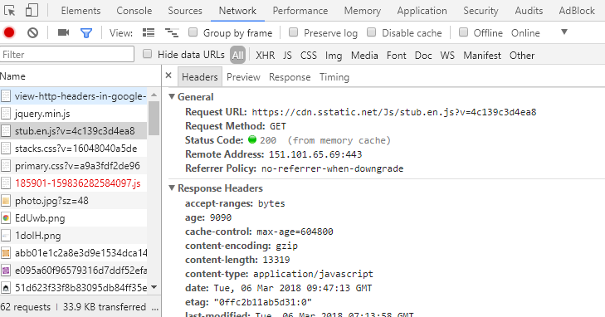

Fig 15: Checking Header (CTRL+SHIFT+I) or F12

#### Headers

The header() function lets you create and send a header from a PHP script

Headers(‘Content-Type: text/html’);

// There should be no space before <?php tag

<?php

Server send this header to the browser for processing before attempting to send any of the HTML content in the page.

**Header(‘Content-Type: text/html’);**

Spaces inside of the <?php ?> tags aren’t a problem because they aren’t passed along to the browser.

?>

Two specific headers are required to request the authentication of a web page.

HTTP/1.1. 401 Unauthorized

This header lets the browser know that the user in not authorized to view the page

WWW-Authenticate: Basic realm=”store”

Basic realm is just a phrase used to uniquely identify this. Particular authentication-it appears in the authentication window.

exit()

An application has an opportunity to exit the script and display a custom denial message.

Headers can be used for other purposes too.

<?php

Header(’Location:http://www.addinventory.php’);

?>

The header is called a location header and redirects the current page to addinventory.php

<?php

Header(’Refresh: 5; url=http://www.addinventory.php’);

?>

This header is called a refresh header since it refreshes a page after a period of time.

<?php

Header(’Content-Type: text-plain’);

?>

Headers must be the very first thing sent to the browser in a PHP file. It is because the headers must be sent before any content, it is extremely important to not allow even a single space to appear outside of PHP code before calling the header() function in a PHP script.

Basic Realm defines a security zone that is protected by a particular username and password. Once the user name and password have been successfully entered for a given realm, the browser will remember it and not continue to display the authentication window for subsequent authentication headers in the same realm. In other words, realms allow a browser to remember that we have met the security requirements of a given collection of pages—just specify the same realm for the authentication headers in the pages.

<?php

$username = "photon";

$password = "khan";

**if**(

!isset($_SERVER['PHP_AUTH_USER']) ||

!isset($_SERVER['PHP_AUTH_PW']) ||

($_SERVER['PHP_AUTH_USER'] != $username) ||

($_SERVER['PHP_AUTH_PW'] != $password)

):

header('HTTP/1.1 401 Unauthorized');

header('WWW-Authenticate: Basic realm="Store"');

**exit**('<h2> You must enter a valid username and password');

**endif**;

?>

Code 34: header.php

#### Human Moderation

Human moderation is an excellent way to improve the integrity of user-submitted content.

Adding approval link beside the remove

ALTER TABLE inventory ADD COLUMN approved TINYINT;

Alternatively, ALTER TABLE inventory ADD COLUMN approved ENUM(‘yes’, ‘no’)

UPDATE inventory SET approved = 1 WHERE inventory_id = '$inventory_id'

Use this to update the data in the table

#### SQL Injection

Tricking MySQL with comments. A double hyphen (--) is used in SQL to comment out the remainder of a line of SQL code. To make it work, it is double hyphen with a space (-- ), everything after it is ignored.

SQL code:

INSERT INTO inventory VALUES(0, NOW(), ‘Hacker’, ‘10000000’, ‘hacker.png’, 1) – hacker.png

1 is used to approve and everything after – is commented.

Form fields are security weak point for web applications because they allow users to enter data.

Dangerous characters are any characters that could possibly change the nature of any SQL-query, such as commas, quotes or – comment characters. Even the spaces at the end of a piece of data can prove harmful. SQL injections can be prevented by properly processing form data.

trim()

Eliminates Leading or trailing spaces

Ex: $name = trim($_POST[‘name’]);

mysqli_real_escape_string($connection, trim($_POST[‘name]));

It converts dangerous characters into an escaped format that won’t adversely affect SQL queries.

The id and approved columns can then be allowed to default to AUTO_INCREMENT and 0, respectively.

<!doctype html>

<html>

<head>

<title> Inventory Index </title>

<meta charset = "UTF-8"/>

</head>

<body>

<h1> Inventory **List** </h1>

<p><a href = "addinventory.php">Add Item</a></p>

<p> **List** of items are given below</p>

<?php

**require_once**("common/databaseinfo.php");

$connection = mysqli_connect($server_name, $user_name,

$password, $db_name)

**or** **die**("Could not conenct to the database");

$query = "SELECT * FROM inventory";

$result = mysqli_query($connection, $query);

**echo** "<table>";

**echo** "<tr>";

**echo** "<th>Date</th>";

**echo** "<th>Name</th>";

**echo** "<th>Price</th>";

**echo** "<th>Image</th>";

**echo** "</tr>";

**while**($row = mysqli_fetch_array($result)){

**echo** "<tr>";

**if**($row['approved'] == 1):

**echo** "<td>".$row['date']."</td>";

**echo** "<td>".$row['name']."</td>";

**echo** "<td>".$row['price']."</td>";

**echo** "<td><img src ='".UPLOAD_PATH.$row['image']."' alt = 'Inventory Image'

height = '20px' width = '20px'/></td>";

**endif**;

**echo** "</tr>";

}

**echo** "</table>";

?>

</body>

</html>

Code 35: inventoryindex.php

<?php

**require_once**("common/databaseinfo.php");

$show_form = **TRUE**;

$connection = mysqli_connect($server_name, $user_name, $password, $db_name)

**or** **die**("Server Connection Denied");

**if**(isset($_POST['submit'])):

$name = mysqli_real_escape_string($connection, trim($_POST['item_name']));

$price = mysqli_real_escape_string($connection, trim($_POST['price']));

$image_name = mysqli_real_escape_string($connection, trim($_FILES['image']['name']));

**if**(!**empty**($name) && !**empty**(is_numeric($price)) && !**empty**($image_name)):

$show_form = **FALSE**;

$target = UPLOAD_PATH.$image_name;

*// $date = date("Y-m-d h:i:s");*

$query = "INSERT INTO inventory(date, name, price, image)

VALUES(NOW(), '**$name**', '**$price**', '**$image_name**')";

mysqli_query($connection, $query) **or** **die**("Query Denied");

move_uploaded_file($_FILES['image']['tmp_name'], $target);

**echo** "Inventory Added Successfully";

**endif**;

**endif**;

?>

<?php

**if**($show_form):

?>

<!doctype html>

<html>

<head>

<title> Add Inventory </title>

<meta charset = "UTF-8"/>

</head>

<body>

<p> Add Inventory </p>

<form enctype = "multipart/form-data" method = "post"

action = "<?php **echo** $_SERVER['PHP_SELF'];?>">

<!-- <input type = "hidden" name = "MAX_FILE_SIZE" value = "32768"/> -->

<label for = "item_name"> Item Name: </label><br/>

<input type = "text" name = "item_name" id = "item_name"/><br/>

<label for = "price"> Price: </label><br/>

<input type = "number" name = "price" id = "price" step = "0.01"/><br/>

<input type = "file" name = "image" id = "image"/><br/><br/>

<input type = "submit" value = "Add Item" name = "submit"/>

</body>

</html>

<?php

**endif**;

?>

Code 36: addinventory.php

<?php **require_once**("common/header.php"); ?>

<?php

**require_once**("common/databaseinfo.php");

$connection = mysqli_connect($server_name, $user_name, $password, $db_name);

$query = "SELECT * FROM inventory";

$result = mysqli_query($connection, $query);

?>

<!doctype html>

<html>

<head>

<title> Admin Remove Inventory </title>

</head>

<body>

<?php

**echo** "<table>";

**echo** "<tr>";

**echo** "<th>Date</th>";

**echo** "<th>Name</th>";

**echo** "<th>Price</th>";

**echo** "<th>Image</th>";

**echo** "<th>Remove</th>";

**echo** "<th>Status</th>";

**echo** "</tr>";

**while**($row = mysqli_fetch_array($result)){

**echo** "<tr>";

**echo** "<td>".$row['date']."</td>";

**echo** "<td>".$row['name']."</td>";

**echo** "<td>".$row['price']."</td>";

**echo** "<td><img src ='".UPLOAD_PATH.$row['image']."' alt = 'Inventory Image'

height = '20px' width = '20px'/></td>";

**echo** "<td><a href = 'adminremoveinventory.php?inventory_id=".$row['inventory_id']

."&amp;date=".$row['date']

."&amp;name=".$row['name']

."&amp;price=".$row['price']

."&amp;image=".$row['image']

."'>Remove</a></td>";

**if**($row['approved'] == 0):

**echo** "<td><a href = 'approve.php?inventory_id=".$row['inventory_id']."'>Approve</a></td>";

**endif**;

**echo**"</tr>";

}

**echo** "</table>";

mysqli_close($connection);

?>

</form>

</body>

</html>

Code 37: admingetremove.php

<?php **require_once**("common/header.php");?>

<?php

$showconfirmform= **TRUE**;

**require**("common/databaseinfo.php");

**if**($showconfirmform):

**echo** "<!doctype html>";

**echo** " <html>";

**echo** " <head>";

**echo** " <title> Approve Inventory </title>";

**echo** " <meta charset = 'UTF-8'/>";

**echo** " </head>";

**echo** " <body>";

$connection = mysqli_connect($server_name, $user_name, $password, $db_name)

**or** **die**("Server Error");

**if**(isset($_GET['inventory_id'])):

**echo** "<h2> Are you sure? </h2>";

**echo** "<form method = 'post' action = '".$_SERVER['PHP_SELF']."'>";

$inventory_id = $_GET['inventory_id'];

$query = "SELECT * FROM inventory WHERE inventory_id = '**$inventory_id**'";

$result = mysqli_query($connection, $query) **or** **die**("Query Denied");

**while**($row = mysqli_fetch_array($result)){

**echo** "Name: ".$row['name']."<br/>";

**echo** "Price: ".$row['price']."<br/>";

**echo** "<img src = '".UPLOAD_PATH.$row['image']

."' alt = 'Inventory Image'"

."height='30px' width='30px'"

."/><br/>";

**echo** "<input type = 'hidden' name = 'inventory_id' value = '**$inventory_id**'/>";

**echo** "<input type = 'hidden' name = 'image' value = '".UPLOAD_PATH.$row['image']."'/>";

**echo** "Yes<input type = 'radio' name = 'confirmation' value = 'yes'/>";

**echo** "No <input type = 'radio' name = 'confirmation' value = 'no'/><br/>";

**echo** "<input type = 'submit' name = 'submit' value = 'Confirm'/>";

}

**endif**;

**endif**;

?>

</form>

</body>

</html>

<?php

**if**(isset($_POST['submit']) && ($_POST['confirmation'] == "yes")):

$showconfirmform = **FALSE**;

$inventory_id = $_POST['inventory_id'];

$query = "UPDATE inventory SET approved = 1 WHERE inventory_id = '**$inventory_id**'";

mysqli_query($connection, $query) **or** **die**("Query Denied");

**echo** "Approved Successfully!";

**echo** "<p><a href = 'admingetremove.php'>Home Page</a></p>";

**endif**;

**if**(isset($_POST['submit']) && ($_POST['confirmation'] == "no")):

$showconfirmform = **FALSE**;

**echo** "<p><a href = 'admingetremove.php'>Home Page</a></p>";

**endif**;

?>

Code 38: approve.php

### Personal Web Application

Personal web applications thrive on personal information, which requires users to be able to access an application on a personal level.

User Log-ins allow web applications to get personal with users. An application log-in requires a user interface for entering the username and password. The asterisks displayed in a password form field simple provide visual security, preventing someone from looking over our should as we enter the password. When the form is submitted, the password itself is submitted, not the asterisks. That’s why it’s important for the password to be encrypted before inserting it into the database.

MySQL, SHA() function encrypts a piece of text into a unique 40-character code.

The SHA() function provides one-way encryption-we can’t decrypt data that has been encrypted.

SHA() functions stands for **Secure Hash Algorithm**. A “**hash**” is a programming term that refers to a unique, fixed-length string that uniquely represents a string of text. In the case of SHA(), the hash is the 40-character hexadecimal encrypted string of text, which uniquely represents the original password.

Other ways to encrypt data is using **MD5()** in my **MySQL**

**SHA()** is considered a little secure more than **MD5()**

PHP also offers a equivalent function (**sha1()** and **md5()**)

**HTTP authentication** is intended to be carried out once for a **given page or collection of pages**—it’s only reset when the **browser is shut down**. In other words, a user is never “logged out” of an HTTP authenticated web page until the browser is shut down or the user manually clears the HTTP authenticated session.

<?php

**require_once**("common/database.php");

**require_once**("common/constants.php");

$connection = mysqli_connect($server_name, $user_name, $password, $db_name)

**or** **die** ("Server Denied");

$showform = **TRUE**;

**if**(isset($_POST['submit'])):

**if**(

!**empty**($_POST['username']) &&

!**empty**($_POST['password']) &&

!**empty**($_POST['first_name']) &&

!**empty**($_POST['last_name']) &&

!**empty**($_POST['gender']) &&

!**empty**($_POST['date']) &&

!**empty**($_POST['city']) &&

!**empty**($_POST['state']) &&

!**empty**($_FILES['picture']) &&

$_POST['password'] == $_POST['password_two']

):

$showform = **FALSE**;

$username = isset($_POST['username'])? mysqli_real_escape_string($connection, trim($_POST['username'])): **NULL**;

$password = isset($_POST['password'])? mysqli_real_escape_string($connection, trim($_POST['password'])): **NULL**;

$first_name = isset($_POST['first_name'])? mysqli_real_escape_string($connection, trim($_POST['first_name'])): **NULL**;

$last_name = isset($_POST['last_name'])? mysqli_real_escape_string($connection, trim($_POST['last_name'])): **NULL**;

$gender = isset($_POST['gender'])? mysqli_real_escape_string($connection, trim($_POST['gender'])): **NULL**;

$date = isset($_POST['date'])? mysqli_real_escape_string($connection, trim($_POST['date'])): **NULL**;

$city = isset($_POST['city'])? mysqli_real_escape_string($connection, trim($_POST['city'])): **NULL**;

$state = isset($_POST['state'])? mysqli_real_escape_string($connection, trim($_POST['state'])): **NULL**;

$picture = isset($_FILES['picture'])? mysqli_real_escape_string($connection, trim($_FILES['picture']['name'])): **NULL**;

$query = "INSERT INTO mismatch_user(username, password, join_date, first_name, last_name, gender, birth_date, city, state, picture)

VALUES('**$username**', SHA('**$password**'), NOW(), '**$first_name**', '**$last_name**', '**$gender**', '**$date**', '**$city**', '**$state**', '**$picture**')";

mysqli_query($connection, $query);

$destination = UPLOAD_PATH.$_FILES['picture']['name'];

move_uploaded_file($_FILES['picture']['tmp_name'], $destination);

**echo** "User Successfully Added";

**endif**;

**endif**;

**if**($showform):

**echo** '<!doctype html>';

**echo** ' <html>';

**echo** ' <head>';

**echo** ' <title> Add Users </title>';

**echo** ' <meta charset = "UTF-8"/>';

**echo** ' </head>';

**echo** ' <body>';

**echo** " <form enctype = 'multipart/form-data' method = 'post' action = '".$_SERVER['PHP_SELF']."'>";

**echo** ' <label for = "username">Username</label><br/>';

**echo** ' <input type = "text" name = "username"/><br/>';

**echo** ' <label for = "password">Password</label><br/>';

**echo** ' <input type = "password" name = "password"/><br/>';

**echo** ' <label for = "password_two">Retype Password</label><br/>';

**echo** ' <input type = "password" name = "password_two"/><br/>';

**echo** ' <label for = "first_name">First Name</label><br/>';

**echo** ' <input type = "text" name = "first_name"/><br/>';

**echo** ' <label for = "last_name">Last Name</label><br/>';

**echo** ' <input type = "text" name = "last_name"/><br/>';

**echo** ' <label for = "gender">Gender</label><br/>';

**echo** ' Male<input type = "radio" name = "gender" value = "male"/>';

**echo** ' Female<input type = "radio" name = "gender" value = "female"/><br/>';

**echo** ' <label for = "date">Date</label><br/>';

**echo** ' <input type = "date" name = "date"/><br/>';

**echo** ' <label for = "city">City</label><br/>';

**echo** ' <input type = "text" name = "city"/><br/>';

**echo** ' <label for = "state">State</label><br/>';

**echo** ' <input type = "text" name = "state"/><br/>';

**echo** ' <label for = "picture">Picture</label><br/>';

**echo** ' <input type = "file" name = "picture"/><br/>';

**echo** ' <input type = "submit" name = "submit" value = "Submit"/><br/>';

**echo** ' </form>';

**echo** ' </body>';

**echo** ' </html>';

**endif**;

?>

Code 38: signup.php

<?php

**require_once**("database.php");

**if**(!isset($_SERVER['PHP_AUTH_USER']) || !isset($_SERVER['PHP_AUTH_PW'])):

header('HTTP/1.1 Unauthorized');

header('WWW-Authenticate: Basic realm="Mismatch"');

**exit**('<h3> Mismatch </h3> Sorry, you must enter your username and

this password to log in and access');

**endif**;

$connection = mysqli_connect($server_name, $user_name, $password, $db_name)

**or** **die** ("Server Denied");

$user_username = mysqli_real_escape_string($connection, trim($_SERVER['PHP_AUTH_USER']));

$user_password = mysqli_real_escape_string($connection, trim($_SERVER['PHP_AUTH_PW']));

$query = "SELECT user_id, username FROM mismatch_user WHERE username = '**$user_username**' AND password = SHA('**$user_password**')";

$data = mysqli_query($connection, $query) **or** **die** ("Query Denied");

**if**(mysqli_num_rows($data) == 1){

$row = mysqli_fetch_array($data);

$user_id = $row['user_id'];

$username = $row['username'];

}

**else**{

header('HTTP/1.1 Unauthorized');

header('WWW-Authenticate: Basic realm="Mismatch"');

**exit**('<h3> Mismatch </h3> Sorry, you must enter your username and

this password to log in and access');

}

?>

Code 39: authentication.php

HTTP authentication stores data persistently on the client but doesn’t allow us to delete it when we are done.

mysqli_num_rows($data)

Checks the number of rows in $data

#### Cookies

Cookies allow us to persistently store **small pieces of data on the client** that can outlive any single script and can be deleted at will. Cookie data is stored on the user’s computer by their web browser. A cookie stores a single piece of data under a unique name, much like a variable in PHP. A cookie can have an expiration date. When this expiration date arrives, the cookie is destroyed. PHP setcookie() function allows us to store data in cookies. The superglobal is called $_COOKIE.

setcookie(name, value, expire, path, domain, secure, httponly);

setcookie($cookie_name, $cookie_value, time() + (86400 * 30), "/");

The cookie will expire after 30 days (86400 * 30). The "/" means that the cookie is available in entire website

Ex: setcookie(‘username’, ‘sidneyk’);

Ex: $_COOKIE[‘username’];

setcookie() function also accepts an optional third argument that sets the expiration date of the cookie, which is the date upon which the cookie is automatically deleted.

To delete cookie, setcookie(‘username’, ‘marylee’, time() - (60 * 60);

To delete a cookie, just set its expiration date to a time in the past.

dirname($_SERVER['PHP_SELF'])

/education/Php/7. Personal Web Application

$_SERVER['HTTP_HOST']

Localhost

<?php

define("UPLOAD_PATH","images/");

?>

Code 40: constant.php

<?php

$server_name = "localhost";

$user_name = "root";

$password = "";

$db_name = "mismatch";

?>

Code 41: database.php

<?php

**require_once**("common/constants.php");

**require_once**("common/database.php");

$connection = mysqli_connect($server_name, $user_name, $password, $db_name)

**or** **die**("Server Denied");

**echo** "<!doctype html>";

**echo** " <html>";

**echo** " <head>";

**echo** " <title> Home Page </title>";

**echo** " <meta charset = 'UTF-8'/>";

**echo** " </head>";

**echo** " <body>";

**echo** " <h1> Mismatch - Leave the Love Ones Behind </h1>";

**if**(!isset($_COOKIE['username'])){

**echo** "<p><a href = 'login.php'>Log In</a>/<a href = 'signup.php'>Sign Up</a></p>";

}

**else**{

**echo** "<p><a href = 'view.php'>View</a>/<a href = 'edit.php'>Edit</a></p>";

**echo** "<p><a href = 'logout.php'>Log Out</a></p>";

}

**echo** " <table>";

**echo** " <tr>";

**echo** " <th> Latest Members</th>";

**echo** " <th></th>";

**echo** " </tr>";

$query = "SELECT first_name, last_name, picture FROM mismatch_user ORDER BY birth_date DESC LIMIT 5";

$result = mysqli_query($connection, $query) **or** **die**("Query Denied");

**while**($row = mysqli_fetch_array($result)){

**echo** "<tr>";

**echo** " <td>".$row['first_name']." ".$row['last_name']."</td>";

**echo** " <td><img src = '".UPLOAD_PATH.$row['picture']."' alt = 'profile photo'"

."height = '50px' width = '50px'"

."</td>";

**echo** "</tr>";

}

**echo** " </table>";

**echo** " </body>";

**echo** " </html>";

?>

Code 41: home.php

<?php

**require_once**("common/database.php");

**require_once**("common/constants.php");

$connection = mysqli_connect($server_name, $user_name, $password, $db_name)

**or** **die** ("Server Denied");

$showform = **TRUE**;

**if**(isset($_POST['submit'])):

**if**(

!**empty**($_POST['username']) &&

!**empty**($_POST['password']) &&

!**empty**($_POST['first_name']) &&

!**empty**($_POST['last_name']) &&

!**empty**($_POST['gender']) &&

!**empty**($_POST['date']) &&

!**empty**($_POST['city']) &&

!**empty**($_POST['state']) &&

!**empty**($_FILES['picture']) &&

$_POST['password'] == $_POST['password_two']

):

$showform = **FALSE**;

$username = isset($_POST['username'])? mysqli_real_escape_string($connection, trim($_POST['username'])): **NULL**;

$password = isset($_POST['password'])? mysqli_real_escape_string($connection, trim($_POST['password'])): **NULL**;

$first_name = isset($_POST['first_name'])? mysqli_real_escape_string($connection, trim($_POST['first_name'])): **NULL**;

$last_name = isset($_POST['last_name'])? mysqli_real_escape_string($connection, trim($_POST['last_name'])): **NULL**;

$gender = isset($_POST['gender'])? mysqli_real_escape_string($connection, trim($_POST['gender'])): **NULL**;

$date = isset($_POST['date'])? mysqli_real_escape_string($connection, trim($_POST['date'])): **NULL**;

$city = isset($_POST['city'])? mysqli_real_escape_string($connection, trim($_POST['city'])): **NULL**;

$state = isset($_POST['state'])? mysqli_real_escape_string($connection, trim($_POST['state'])): **NULL**;

$picture = isset($_FILES['picture'])? mysqli_real_escape_string($connection, trim($_FILES['picture']['name'])): **NULL**;

$query = "INSERT INTO mismatch_user(username, password, join_date, first_name, last_name, gender, birth_date, city, state, picture)

VALUES('**$username**', SHA('**$password**'), NOW(), '**$first_name**', '**$last_name**', '**$gender**', '**$date**', '**$city**', '**$state**', '**$picture**')";

mysqli_query($connection, $query);

$destination = UPLOAD_PATH.$_FILES['picture']['name'];

move_uploaded_file($_FILES['picture']['tmp_name'], $destination);

**echo** "User Successfully Added";

**endif**;

**endif**;

**if**($showform):

**echo** '<!doctype html>';

**echo** ' <html>';

**echo** ' <head>';

**echo** ' <title> Add Users </title>';

**echo** ' <meta charset = "UTF-8"/>';

**echo** ' </head>';

**echo** ' <body>';

**echo** " <form enctype = 'multipart/form-data' method = 'post' action = '".$_SERVER['PHP_SELF']."'>";

**echo** ' <label for = "username">Username</label><br/>';

**echo** ' <input type = "text" name = "username"/><br/>';

**echo** ' <label for = "password">Password</label><br/>';

**echo** ' <input type = "password" name = "password"/><br/>';

**echo** ' <label for = "password_two">Retype Password</label><br/>';

**echo** ' <input type = "password" name = "password_two"/><br/>';

**echo** ' <label for = "first_name">First Name</label><br/>';

**echo** ' <input type = "text" name = "first_name"/><br/>';

**echo** ' <label for = "last_name">Last Name</label><br/>';

**echo** ' <input type = "text" name = "last_name"/><br/>';

**echo** ' <label for = "gender">Gender</label><br/>';

**echo** ' Male<input type = "radio" name = "gender" value = "male"/>';

**echo** ' Female<input type = "radio" name = "gender" value = "female"/><br/>';

**echo** ' <label for = "date">Date</label><br/>';

**echo** ' <input type = "date" name = "date"/><br/>';

**echo** ' <label for = "city">City</label><br/>';

**echo** ' <input type = "text" name = "city"/><br/>';

**echo** ' <label for = "state">State</label><br/>';

**echo** ' <input type = "text" name = "state"/><br/>';

**echo** ' <label for = "picture">Picture</label><br/>';

**echo** ' <input type = "file" name = "picture"/><br/>';

**echo** ' <input type = "submit" name = "submit" value = "Submit"/><br/>';

**echo** ' </form>';

**echo** ' </body>';

**echo** ' </html>';

**endif**;

?>

Code 42: signup.php

<?php

**require_once**("common/database.php");

**if**(!isset($_COOKIE['user_id'])):

**if**(isset($_POST['submit'])):

$connection = mysqli_connect($server_name, $user_name, $password, $db_name)

**or** **die** ("Server Denied");

$user_username = mysqli_real_escape_string($connection, trim($_POST['username']));

$user_password = mysqli_real_escape_string($connection, trim($_POST['password']));

**if**(!**empty**($user_username) && !**empty**($user_password)):

$query = "SELECT user_id, username FROM mismatch_user WHERE username = '**$user_username**' AND password = SHA('**$user_password**')";

$data = mysqli_query($connection, $query) **or** **die** ("Query Denied");

**if**(mysqli_num_rows($data) == 1):

$row = mysqli_fetch_array($data);

setcookie('user_id',$row['user_id'],time() + (86400 * 30), "/");

setcookie('username',$row['username'],time() + (86400 * 30), "/");

$home_url = "http://".$_SERVER['HTTP_HOST'].dirname($_SERVER['PHP_SELF'])."/home.php";

**echo** "Successfully Logged In";

header("Location: ".$home_url);

**endif**;

**endif**;

**endif**;

**endif**;

**if**(**empty**($_COOKIE['user_id'])){

**echo** "<!doctype html>";

**echo** " <html>";

**echo** " <head>";

**echo** " <title>Log in</title>";

**echo** " <meta charset = 'UTF-8'/>";

**echo** " </head>";

**echo** " <body>";

**echo** " <h3> Log In </h3>";

**echo** " <form method = 'post' action = ''>";

**echo** " <label for = 'username'>Username</label><br/>";

**echo** " <input type = 'text' name = 'username'><br/>";

**echo** " <label for = 'password'> Password </label><br/>";

**echo** " <input type = 'password' name = 'password'/><br/>";

**echo** " <input type = 'submit' name = 'submit' value = 'Confirm'/>";

**echo** " </form>";

**echo** " </body>";

**echo** " </html>";

}

**else**{

**echo** "You are logged in as ".$_COOKIE['username'];

}

?>

Code 42: login.php

<?php

**if**(

isset($_COOKIE['username']) && !**empty**($_COOKIE['username']) &&

isset($_COOKIE['user_id']) && !**empty**($_COOKIE['user_id'])

):

**echo** "<p>".$_COOKIE['username']." Successfully logged out</p>";

setcookie('username',' ', time() - 3600, "/");

setcookie('user_id',' ', time() - 3600, "/");

$home_url = "http://".$_SERVER['HTTP_HOST'].dirname($_SERVER['PHP_SELF'])."/home.php";

header("Location: ".$home_url);

**endif**;

?>

Code 43: logout.php

<?php

**require_once**("common/constants.php");

**require_once**("common/database.php");

$connection = mysqli_connect($server_name, $user_name, $password, $db_name)

**or** **die**("Server Denied");

**if**(isset($_COOKIE['username']) && isset($_COOKIE['user_id'])):

**echo** "<!doctype html>";

**echo** " <html>";

**echo** " <head>";

**echo** " <title> Home Page </title>";

**echo** " <meta charset = 'UTF-8'/>";

**echo** " </head>";

**echo** " <body>";

**echo** " <h1> Mismatch - Leave the Love Ones Behind </h1>";

**echo** " <p> You are in logged in as ".$_COOKIE['username']

.",<a href = 'logout.php'> Log Out</a>"

."</p>";

$query = "SELECT * FROM mismatch_user WHERE user_id =".$_COOKIE['user_id'];

$result = mysqli_query($connection, $query) **or** **die**("Query Denied");

**while**($row = mysqli_fetch_array($result)){

**echo** " <table>";

**echo** " <tr>";

**echo** " <th></th>";

**echo** " <th></th>";

**echo** " </tr>";

**echo** " <tr>";

**echo** " <td>";

**echo** " <p> Username: </p>";

**echo** " <p> First Name: </p>";

**echo** " <p> Last Name: </p>";

**echo** " <p> Join Date: </p>";

**echo** " <p> Birth Date: </p>";

**echo** " <p> City: </p>";

**echo** " <p> State: </p>";

**echo** " </td>";

**echo** " <td>";

**echo** "<p>".$row['username']."</p>";

**echo** "<p>".$row['first_name']."</p>";

**echo** "<p>".$row['last_name']."</p>";

**echo** "<p>".$row['join_date']."</p>";

**echo** "<p>".$row['birth_date']."</p>";

**echo** "<p>".$row['city']."</p>";

**echo** "<p>".$row['state']."</p>";

**echo** " </td>";

**echo** " </tr>";

**echo** " </table>";

**echo** " <p>Photo</p>";

**echo** " <img src = '".UPLOAD_PATH.$row['picture']."' alt = 'profile photo'"."height = '100px' width = '100px'/>";

}

**echo** "<p> Would you like to <a href = 'edit.php'>edit</a> your profile?</p>";

**echo** "<p> <a href = 'home.php'>Home</a></p>";

**echo** " </body>";

**echo** " </html>";

**endif**;

?>

Code 44: view.php

#### Sessions

Sessions allow us to persistently store **small pieces of data on the server**, independently of the client. Since, session data is stored on the server, it is more secure and more reliable than data stored in cookies. Session variables are automatically destroyed as soon as a session ends (closing the browser), which usually coincides with the user shutting down the browser. Session can store larger amounts of data than a cookie.

|  |  |
| --- | --- |
| **COOKIE** | **SESSION** |
| Data saved on the client | Data saved on the server |
| setcookie() to store data | $_SESSION assign to the super variable |
| Smaller amount of data | Larger amount of data |
| Less Secure | More Secure |
| setcookie() does the work | Session ID to share access |
| setcookie() closes to negative time | $_SESSION = array() |
| Has an expiration date to destroy | Short lived, browser closes destroys |

To start a session: session_start();

The PHP session_start() starts a session and allows us to begin storing data in session variables.

To close a session: session_destroy();

The session ID is used behind the scenes to allow multiple pages to share access to session data. The session ID isn’t destroyed until the session is closed, which happens either when the browser is closed or when we call the session_destroy() function. This doesn’t destroy the session variables.

Unlike cookies, session variables don’t require any kind of special function to set them—we just assign a value to the $_SESSION superglobal.

$_SESSION = array();

This code kills all of the session variables in the current session.

$_SESSION is the superglobal

Ex: $_SESSION(‘username’) = ‘marylee’;

$_COOKIE[session_name()]

If a session is using a cookie to help remember the session ID, then the ID is stored in a cookie named after session

setcookie($_COOKIE[session_name(), ‘’, time() - 3600, ‘/’];

Destroy the session cookie by settings its expiration to an hour in the past.

SESSION without COOKIES may not work if our PHP settings in php.ini aren’t configured properly on the server. Therefore, we can pass session ID among different pages by appending to the URL of each page, which takes place automatically if the **session.use_trans_id** setting is **set to 1** (true) in the **php.ini** file on the server. We can manually append the session ID to the URL of session pages by

<a href = “view.php?<?php echo SID; ?>”>View Your Profile</a>

Session and Cookie are not stored in database because it is ideally suited for holding permanent data.

Therefore, we can use the combination of cookies and session to increase the persistence of the website.

<?php

**require_once**("common/constants.php");

**require_once**("common/database.php");

session_start();

**if**(!isset($_SESSION['user_id']) || !isset($_SESSION['username'])):

**if**(isset($_COOKIE['user_id']) && isset($_COOKIE['username'])):

$_SESSION['user_id'] = $_COOKIE['user_id'];

$_SESSION['username'] = $_COOKIE['username'];

**endif**;

**endif**;

$connection = mysqli_connect($server_name, $user_name, $password, $db_name)

**or** **die**("Server Denied");

**echo** "<!doctype html>";

**echo** " <html>";

**echo** " <head>";

**echo** " <title> Home Page </title>";

**echo** " <meta charset = 'UTF-8'/>";

**echo** " </head>";

**echo** " <body>";

**echo** " <h1> Mismatch - Leave the Love Ones Behind </h1>";

**if**(!isset($_COOKIE['username'])){

**echo** "<p><a href = 'loginsession.php'>Log In</a>/<a href = 'signup.php'>Sign Up</a></p>";

}

**else**{

**echo** "<p><a href = 'view.php'>View</a>/<a href = 'edit.php'>Edit</a></p>";

**echo** "<p><a href = 'logoutsession.php'>Log Out</a></p>";

}

**echo** " <table>";

**echo** " <tr>";

**echo** " <th> Latest Members</th>";

**echo** " <th></th>";

**echo** " </tr>";

$query = "SELECT first_name, last_name, picture FROM mismatch_user ORDER BY birth_date DESC LIMIT 5";

$result = mysqli_query($connection, $query) **or** **die**("Query Denied");

**while**($row = mysqli_fetch_array($result)){

**echo** "<tr>";

**echo** " <td>".$row['first_name']." ".$row['last_name']."</td>";

**echo** " <td><img src = '".UPLOAD_PATH.$row['picture']."' alt = 'profile photo'"

."height = '50px' width = '50px'"

."</td>";

**echo** "</tr>";

}

**echo** " </table>";

**echo** " </body>";

**echo** " </html>";

?>

Code 44: homesession.php

<?php

session_start();

**if**(

isset($_SESSION['username']) && !**empty**($_SESSION['username']) &&

isset($_SESSION['user_id']) && !**empty**($_SESSION['user_id'])

):

$_SESSION = **array**();

**if**(isset($_COOKIE[session_name()])):

setcookie(session_name(), '', time() - 3600, '/');

**endif**;

session_destroy();

**endif**;

**if**(

isset($_COOKIE['username']) && !**empty**($_COOKIE['username']) &&

isset($_COOKIE['user_id']) && !**empty**($_COOKIE['user_id'])

):

setcookie('username',' ', time() - 3600, "/");

setcookie('user_id',' ', time() - 3600, "/");

$home_url = "http://".$_SERVER['HTTP_HOST'].dirname($_SERVER['PHP_SELF'])."/homesession.php";

header("Location: ".$home_url);

**endif**;

?>

Code 44: logoutsession.php

<?php

**require_once**("common/database.php");

session_start();

**if**(!isset($_COOKIE['user_id'])):

**if**(isset($_POST['submit'])):

$connection = mysqli_connect($server_name, $user_name, $password, $db_name)

**or** **die** ("Server Denied");

$user_username = mysqli_real_escape_string($connection, trim($_POST['username']));

$user_password = mysqli_real_escape_string($connection, trim($_POST['password']));

**if**(!**empty**($user_username) && !**empty**($user_password)):

$query = "SELECT user_id, username FROM mismatch_user WHERE username = '**$user_username**' AND password = SHA('**$user_password**')";

$data = mysqli_query($connection, $query) **or** **die** ("Query Denied");

**if**(mysqli_num_rows($data) == 1):

$row = mysqli_fetch_array($data);

$_SESSION['user_id'] = $row['user_id'];

$_SESSION['username'] = $row['username'];

setcookie('user_id',$row['user_id'],time() + (86400 * 30), "/");

setcookie('username',$row['username'],time() + (86400 * 30), "/");

$home_url = "http://".$_SERVER['HTTP_HOST'].dirname($_SERVER['PHP_SELF'])."/homesession.php";

**echo** "Successfully Logged In";

header("Location: ".$home_url);

**endif**;

**endif**;

**endif**;

**endif**;

**if**(**empty**($_COOKIE['user_id'])){

**echo** "<!doctype html>";

**echo** " <html>";

**echo** " <head>";

**echo** " <title>Log in</title>";

**echo** " <meta charset = 'UTF-8'/>";

**echo** " </head>";

**echo** " <body>";

**echo** " <h3> Log In </h3>";

**echo** " <form method = 'post' action = ''>";

**echo** " <label for = 'username'>Username</label><br/>";

**echo** " <input type = 'text' name = 'username'><br/>";

**echo** " <label for = 'password'> Password </label><br/>";

**echo** " <input type = 'password' name = 'password'/><br/>";

**echo** " <input type = 'submit' name = 'submit' value = 'Confirm'/>";

**echo** " </form>";

**echo** " </body>";

**echo** " </html>";

}

**else**{

**echo** "You are logged in as ".$_COOKIE['username'];

}

?>

Code 44: loginsession.php

#### Templates

Templates allow a PHP application to be build out of reusable script components. Typical parts of templates are headers, navigation menu, footer.

Headers appears at the top of every page, and displays the application title as well as a page-specific title. Footer provides content along the bottom of every page, which includes a copyright notice.

<?php

**echo** "<p>Copyright &copy;".date("Y")." Jack Enterprise Inc.";

?>

Code 44: pagefooter.php

### Control Data

Schema

A description of the data (the tables and columns) in our database, along with any other related objects and the way they all connect is known as a schema. Creating a diagram of a table lets us keep the design of the table separate from the data that’s inside of it.

A **foreign key** is a column in a table **references the primary key** of another table.

Binding together tables with primary keys and foreign keys allows us to connect data between them in a consistent manner. We can even structure our database so that primary keys and their respective foreign keys are required to match up. This is known as **referential integrity;** all keys must be valid.

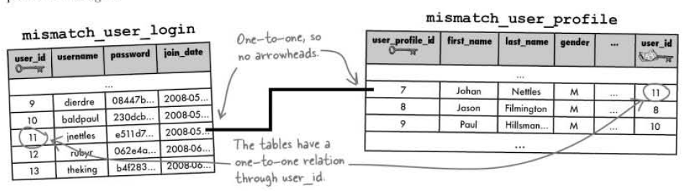

Fig 16: One-to-One Schema Design

One-to-One: Exactly one row of a parent table is related to one row of a child table.

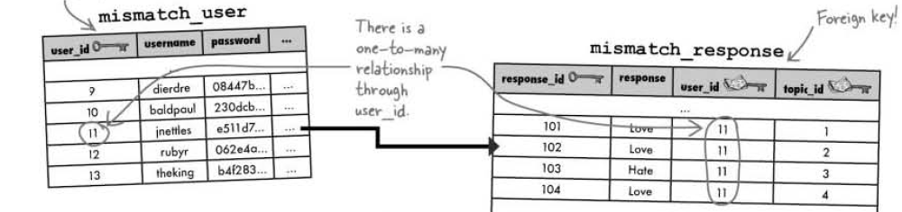

Fig 17: One-to-Many Schema Design

One-to-Many: Exactly one row of a parent table is related to multiple rows of a child table

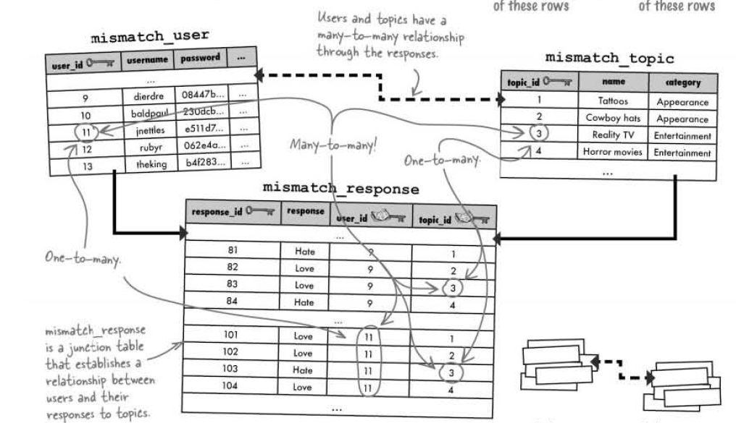

Fig 18: Many-to-Many Schema Design

Many-to-Many: Multiple rows of a parent table are related to multiple rows of child table

Response table is as **junction table,** by serving as a convenient go-between for the users and topics.

If we start with a well-designed database, every other piece of the application puzzle becomes that much easier to build and assemble.

**array_push()**

It tacks a new element onto the end of an array, causing the array to grow by one

<?php  
 $a=array("a"=>"red","b"=>"green");  
 array_push($a,"blue","yellow");  
 print_r($a);  
?>

**Solution:** Array ([a] => red [b] => green [0] => blue [1] => yellow)

**Foreach**

foreach($array as $key => $value){  
    // Code to be executed  
}

<?php

$superhero = **array**(

"name" => "Peter Parker",

"email" => "peterparker@mail.com",

"age" => 18

);

*// Loop through superhero array*

**foreach**($superhero **as** $key => $value){

**echo** $key . " : " . $value . "<br>";

}

?>

**Solution**

name : Peter Parker  
email : peterparker@mail.com  
age : 18

Code 45: foreach(key,value).php

**Data driven forms rely on data in a MySQL database to generate HTML form fields.**

The ternary ? : operator can be used to code if-else statements in a compact form

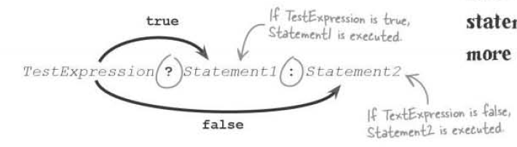

<?php

**require_once**("common/sessionstarter.php");

**require_once**("common/database.php");

*// Check if the cookier user id exists or not*

$cookie_user_id = $_COOKIE['user_id'];

**if**(!isset($cookie_user_id)):

$url = "http://".$_SERVER['HTTP_HOST'].dirname($_SERVER['PHP_SELF'])."/home.php";

header("Location: **$url**");

**endif**;

$connection = mysqli_connect($server_name, $user_name, $password, $db_name)

**or** **die**("Server Denied");

*/\*\**

*\**

*\* Filling up the mismatch_response with topic_ids w.r.t user_id*

*\**

*\*/*

*//Check whether the mismatch_response has any topic_id, response_id, response w.r.t user_id in the mismatch_response*

$query = "SELECT * FROM mismatch_response WHERE user_id = '**$cookie_user_id**'";

$result = mysqli_query($connection, $query) **or** **die**("User in Response Table Query Denied");

$topicIDs = **array**();

*//If the mismatch_response has no data, create topic_id w.r.t user_id*

**if**(mysqli_num_rows($result) == 0):

*//Selecting all the topic_id from the topic table*

$query = "SELECT topic_id from mismatch_topic ORDER BY topic_id";

$result = mysqli_query($connection, $query) **or** **die**("Collecting Topics Query Denied");

**while**($row = mysqli_fetch_array($result)){

array_push($topicIDs, $row['topic_id']);

}

*//Insert topic_id w.r.t user_id in the mismatch_response*

**foreach**($topicsIDS **as** $topic_id){

$query = "INSERT INTO mismatch_response(user_id, topic_id) VALUES('**$cookie_user_id**','**$topic_id**')";

mysqli_query($connection, $query) **or** **die** ("Inserting Topics Query Denied");

}

**endif**;

*//If the questionnaire form has been submitted, write the form responses to the database*

**if**(isset($_POST['submit'])):

**foreach**($_POST **as** $response_id => $response){

$query = "UPDATE mismatch_response SET response = '**$response**' WHERE response_id = '**$response_id**'";

mysqli_query($connection, $query) **or** **die** ("Updated the response Query Denied");

}

**endif**;

*/\*\**

*\**

*\* Fetching the response data from the database to generate form*

*\**

*\*/*

*//Collect response_id, topic_id, response w.r.t user_id from mismatch_response*

$query = "SELECT response_id, topic_id, response FROM mismatch_response WHERE user_id = '**$cookie_user_id**'";

$result = mysqli_query($connection, $query) **or** **die**("Fetching the data Query Denied");

$responses = **array**();

**while**($response_row = mysqli_fetch_array($result)){

$topic_id = $response_row['topic_id'];

*//Select name, category from the mismatch_topic using the mismatch_response topic_id*

$query2 = "SELECT name, category FROM mismatch_topic WHERE topic_id = '**$topic_id**'";

$topic_data = mysqli_query($connection, $query2) **or** ("Fetching category, name Query Denied");

*//Check if there is one topic_id that matches*

**if**(mysqli_num_rows($topic_data) == 1):

$topic_row = mysqli_fetch_array($topic_data);

$response_row['topic_name'] = $topic_row['name'];

$response_row['category_name'] = $topic_row['category'];

*//Feeding the topic name, category name to the $responses array*

array_push($responses, $response_row);

**endif**;

}

mysqli_close($connection);

*/\*\**

*\**

*\* Generate the questionnaire form by looping throung the response array*

*\**

*\*/*

**echo** "<form method = 'post' action ='".$_SERVER['PHP_SELF']."'>";

**echo** "<p> How do you feel about the each topic? </p>";

*//Display the first category*

$category = $responses[0]['category_name'];

**echo** "<h3>".$responses[0]['category_name']."</h3>";

**foreach**($responses **as** $response){

*//Change the category when the category for the response changes*

**if**($category != $response['category_name']):

$category = $response['category_name'];

**echo** "<h3>".$response['category_name']."</h3>";

**endif**;

*//Display the topic form fields*

**echo** "<label for = '".$response['response_id']."'>".$response['topic_name']." </label>";

**echo** "<input type = 'radio' name = '".$response['response_id']."' value = '1'"

.($response['response'] == 1?'checked="checked"' : '')."/>Love";

**echo** "<input type = 'radio' name = '".$response['response_id']."' value = '2'"

.($response['response'] == 2?'checked="checked"' : '')."/>Hate<br/>";

}

**echo** "<br/><input type = 'submit' value = 'Save' name = 'submit'/>";

**echo** "</form>";

?>

Code 45: question.php

**STEPS**

1. Check whether the mismatch_response has any topic_id, response_id, response w.r.t user_id in the mismatch_response
2. If the mismatch_response has no data, create topic_id w.r.t user_id
3. Selecting all the topic_id from the topic table
4. Insert topic_id w.r.t user_id in the mismatch_response
5. If the questionnaire form has been submitted, write the form responses to the database
6. Collect response_id, topic_id, response w.r.t user_id from mismatch_response
7. Select name, category from the mismatch_topic using the mismatch_response topic_id
8. Check if there is one topic_id that matches
9. Feeding the topic name, category name to the $responses array
10. Display the first category
11. Change the category when the category for the response changes
12. Display the topic form fields

#### Normalization

Normalization means designing a database to reduce duplicate data and improve the relationships between data.

Thinking Process:

* The main thing that we want table to be about
* How will we use the table, list of information that we are going to need about that one thing?
* How can we easily query the table?

Atomic data is data that has been broken down into the smallest form needed for a given database. Making our data atomic is the first step in creating a normal table.

Normalization has its benefits, namely improvements in database size and speed. Normal tables won’t have duplicate data which will reduce the size of our database. With less data to search through, our queries will be faster. Normalizing database involves strictly adhering to a series of design steps.

1. Columns should be atomic
2. Each table should have its own primary key
3. Making sure that the non-key columns aren’t dependent on each other.

More tables lead to less messier queries.

A join grabs results from multiple tables in a single query. In an INNER JOIN, it selects two rows from two tables based on a condition.

SELECT mismatch_topic.topic_id, mismatch_category.name

FROM mismatch_topic

INNER JOIN mismatch_category

ON (mismatch_topic.category_id = mismatch_category.category_id)

Dot notation allows us to reference the table a column belongs to within a join.

An INNER JOIN combines rows from two tables using comparison operators in a condition

SELECT mismatch_topic.topic_id, mismatch_category.name

FROM mismatch_topic

INNER JOIN mismatch_category

ON (mismatch_topic.category_id = mismatch_category.category_id)

WHERE mismatch_topic.name = “Easy Listening Music”

Rewrite on with using for more concise inner join queries that match on a common column. The column names must be the same in order to use the USING statement in an inner join.

SELECT mismatch_topic.topic_id, mismatch_category.name

FROM mismatch_topic

INNER JOIN mismatch_category

USING (category_id)

WHERE mismatch_topic.name = “Easy Listening Music”

An **Alias** allows us to rename a table or column within a query to help simplify the query in some way. When a column is renamed with an alias the alias is what appears in the query results.

SELECT mt.topic_id, mc.name

FROM mismatch_topic AS mt

INNER JOIN mismatch_category AS mc

USING (category_id)

WHERE mt.name = “Easy Listening Music”

**Joins** are more efficient and require less code than nested queries. Other types of **Inner Joins** include equijoins, non-equijoins and natural joins. **Equijoins** when the query search for equal columns. **Non-Equijoins** are inequality comparison. **Natural joins** involve comparing all columns that have the same name between two tables. There are several **Outer Joins, Left Outer Join, Right Outer Join, Full Outer Join.** In outer join the rows in the joined table don’t have to match, in order to make it into the join.

**Foreign Key**

CREATE TABLE Orders (  
    OrderID int NOT NULL,  
    OrderNumber int NOT NULL,  
    PersonID int,  
    PRIMARY KEY (OrderID),  
    FOREIGN KEY (PersonID) REFERENCES Persons(PersonID)  
);

The following SQL creates a **FOREIGN KEY** on the "PersonID" column when the "Orders" table is created:

ALTER TABLE Orders  
ADD FOREIGN KEY (PersonID) REFERENCES Persons(PersonID);

SQL FOREIGN KEY on ALTER TABLE

ALTER TABLE Orders  
DROP FOREIGN KEY FK_PersonOrder;

Drop FOREIGN KEY

**Array Slice**

array_slice(array,start,length,preserve)

<?php  
 $a=array("red","green","blue","yellow","brown");  
 print_r(array_slice($a,2));  
?>

Solution:: Array ( [0] => blue [1] => yellow [2] => brown )

Code 46: array_slice.php

### Search

MySQL searches are by default case-insensitive. SQL queries can be flexible with LIKE

SELECT job_id title, description FROM jobs WHERE title LIKE ‘%fighter’

The keyword LIKE lets us look for matches that aren’t exactly the same as the word in quotes and still case-insensitive. The % signs are **wildcards,** they stand in any other characters before or after the word. LIKE match the search search as part of a larger word or phrase.

LIKE ‘ _ _ _ _ fighters%’

Find the string fighter with any four characters in front of it, and any characters after it.

<?php

**require_once**("common/database.php");

$connection = mysqli_connect(SERVER, USER, PASS, DB);

**echo** "<!doctype html>";

**echo** " <html>";

**echo** " <head>";

**echo** " <title> Job Search Engine </title>";

**echo** " <meta charset = 'UTF-8'/>";

**echo** " </head>";

**echo** " <body>";

**echo** " <form method = 'post' action = '".$_SERVER['PHP_SELF']."'>";

**echo** " <label for = 'search'> Jobs, that you are looking for? </label><br/>";

$search = !**empty**($_POST['search'])? $_POST['search'] : '';

**echo** " <input type = 'text' name = 'search' value = '**$search**'/>";

**echo** " <input type = 'submit' name = 'submit' value = 'Search'/>";

**echo** " </form>";

**echo** " </body>";

**echo** " </html>";

**if**(isset($_POST['submit'])):

**if**(!**empty**($_POST['search'])){

$search = mysqli_real_escape_string($connection, trim($_POST['search']));

$query = "SELECT * FROM riskyjobs WHERE description LIKE '%**$search**%'";

$result = mysqli_query($connection, $query) **or** **die** ("Search Query Denied");

**echo** "<table>";

**echo** "<tr>";

**echo** " <th>Title</th>";

**echo** " <th>Description</th>";

**echo** " <th>City</th>";

**echo** " <th>State</th>";

**echo** " <th>Zip</th>";

**echo** " <th>Company</th>";

**echo** " <th>Date Posted</th>";

**while**($row = mysqli_fetch_array($result)){

**echo** "<tr>";

**echo** " <td>".$row['title']."</td>";

**echo** " <td>".$row['description']."</td>";

**echo** " <td>".$row['city']."</td>";

**echo** " <td>".$row['state']."</td>";

**echo** " <td>".$row['zip']."</td>";

**echo** " <td>".$row['company']."</td>";

**echo** " <td>".$row['date_posted']."</td>";

**echo** "</tr>";

}

**echo** "</table>";

}

**else**{

$error = "You cannot leave the search box empty!";

**echo** "<span>".$error."</span>";

}

**endif**;

?>

Code 46: search.php

#### Break Up the Phrases

The **explode()** function breaks a string into an array of substrings.

Ex: $search_words = explode(‘ ‘, ‘Hulk Hogan’);

The $search_words variable now stores the array of search terms. ‘ ‘ 🡪 This is what separated the substrings within the string, in this case a space. We can specify one or more characters, which are called **delimiter**.

The **implode()** function takes an array of strings and builds a single string out of them.

Ex: $string_attach = implode(‘-‘, $list);

$together = ‘’;

$lists = [‘apple’, ‘orange’, ‘banana’];

foreach($lists as $item){

$together .= $item;

}

echo($together);

**Solution:** appleorangebanana

Code 47: stringattach.php

<?php

**require_once**("common/database.php");

$connection = mysqli_connect(SERVER, USER, PASS, DB);

**echo** "<!doctype html>";

**echo** " <html>";

**echo** " <head>";

**echo** " <title> Job Search Engine </title>";

**echo** " <meta charset = 'UTF-8'/>";

**echo** " </head>";

**echo** " <body>";

**echo** " <form method = 'post' action = '".$_SERVER['PHP_SELF']."'>";

**echo** " <label for = 'search'> Jobs, that you are looking for? </label><br/>";

$search = !**empty**($_POST['search'])? $_POST['search'] : '';

**echo** " <input type = 'text' name = 'search' value = '**$search**'/>";

**echo** " <input type = 'submit' name = 'submit' value = 'Search'/>";

**echo** " </form>";

**echo** " </body>";

**echo** " </html>";

**if**(isset($_POST['submit'])):

**if**(!**empty**($_POST['search'])){

$search = mysqli_real_escape_string($connection, trim($_POST['search']));

$search_words = explode(' ', $search);

**echo** "<table>";

**echo** "<tr>";

**echo** " <th>Title</th>";

**echo** " <th>Description</th>";

**echo** " <th>City</th>";

**echo** " <th>State</th>";

**echo** " <th>Zip</th>";

**echo** " <th>Company</th>";

**echo** " <th>Date Posted</th>";

**echo** "</tr>";

*// foreach($search_words as $search){*

*// $query = "SELECT * FROM riskyjobs WHERE description LIKE '%$search%'";*

*// $result = mysqli_query($connection, $query) or die ("Search Query Denied");*

*// while($row = mysqli_fetch_array($result)){*

*// echo "<tr>";*

*// echo " <td>".$row['title']."</td>";*

*// echo " <td>".$row['description']."</td>";*

*// echo " <td>".$row['city']."</td>";*

*// echo " <td>".$row['state']."</td>";*

*// echo " <td>".$row['zip']."</td>";*

*// echo " <td>".$row['company']."</td>";*

*// echo " <td>".$row['date_posted']."</td>";*

*// echo "</tr>";*

*// }*

*// }*

*/\*\**

*\* Alternatively*

*\*/*

$where_list = **array**();

**foreach**($search_words **as** $word){

$where_list[] = " description LIKE '%**$word**%' ";

}

$where_clause = implode('OR', $where_list);

**if**(!**empty**($where_clause)):

$where_clause = "WHERE **$where_clause**";

**endif**;

$query = "SELECT * FROM riskyjobs **$where_clause**";

$result = mysqli_query($connection, $query) **or** **die** ("Search Query Denied");

**while**($row = mysqli_fetch_array($result)){

**echo** "<tr>";

**echo** " <td>".$row['title']."</td>";

**echo** " <td>".$row['description']."</td>";

**echo** " <td>".$row['city']."</td>";

**echo** " <td>".$row['state']."</td>";

**echo** " <td>".$row['zip']."</td>";

**echo** " <td>".$row['company']."</td>";

**echo** " <td>".$row['date_posted']."</td>";

**echo** "</tr>";

}

**echo** "</table>";

}

**else**{

$error = "You cannot leave the search box empty!";

**echo** "<span>".$error."</span>";

}

**endif**;

?>

Code 47: brokenphrase.php

**Preprocessing data** allows us to remove unwanted characters and make the data easier to process.

str_replace(‘delimiter’, ‘replace_item’, $string);

The substring ‘delimiter’ gets replaced by ‘replace item’ in the string

<?php

**require_once**("common/database.php");

$connection = mysqli_connect(SERVER, USER, PASS, DB);

**echo** "<!doctype html>";

**echo** " <html>";

**echo** " <head>";

**echo** " <title> Job Search Engine </title>";

**echo** " <meta charset = 'UTF-8'/>";

**echo** " </head>";

**echo** " <body>";

**echo** " <form method = 'post' action = '".$_SERVER['PHP_SELF']."'>";

**echo** " <label for = 'search'> Jobs, that you are looking for? </label><br/>";

$search = !**empty**($_POST['search'])? $_POST['search'] : '';

**echo** " <input type = 'text' name = 'search' value = '**$search**'/>";

**echo** " <input type = 'submit' name = 'submit' value = 'Search'/>";

**echo** " </form>";

**echo** " </body>";

**echo** " </html>";

**if**(isset($_POST['submit'])):

**if**(!**empty**($_POST['search'])){

$search = mysqli_real_escape_string($connection, trim($_POST['search']));

$clean_words = str_replace(","," ",$search);

$search_words = explode(' ', $clean_words);

$final_words = **array**();

**foreach**($search_words **as** $words){

**if**(!**empty**($words)):

$final_words[] = $words;

**endif**;

}

**echo** "<table>";

**echo** "<tr>";

**echo** " <th>Title</th>";

**echo** " <th>Description</th>";

**echo** " <th>City</th>";

**echo** " <th>State</th>";

**echo** " <th>Zip</th>";

**echo** " <th>Company</th>";

**echo** " <th>Date Posted</th>";

**echo** "</tr>";

$where_list = **array**();

**foreach**($final_words **as** $word){

$where_list[] = " description LIKE '%**$word**%' ";

}

$where_clause = implode('OR', $where_list);

**if**(!**empty**($where_clause)):

$where_clause = "WHERE **$where_clause**";

**endif**;

$query = "SELECT * FROM riskyjobs **$where_clause**";

$result = mysqli_query($connection, $query) **or** **die** ("Search Query Denied");

**while**($row = mysqli_fetch_array($result)){

**echo** "<tr>";

**echo** " <td>".$row['title']."</td>";

**echo** " <td>".$row['description']."</td>";

**echo** " <td>".$row['city']."</td>";

**echo** " <td>".$row['state']."</td>";

**echo** " <td>".$row['zip']."</td>";

**echo** " <td>".$row['company']."</td>";

**echo** " <td>".$row['date_posted']."</td>";

**echo** "</tr>";

}

**echo** "</table>";

}

**else**{

$error = "You cannot leave the search box empty!";

**echo** "<span>".$error."</span>";

}

**endif**;

?>

Code 48: replacestring.php

substr(string, start, length)

The PHP function **substr()** function allows us to extract a portion of a string**.**

$string = “Hello world”

0 1 2 3 4 5 6 7 8 9

-10-9-8-7-6 -5-4 -3 -2 -1

substr($row['description'], 0,100)

substr($row['date_posted'], 0, 9)

#### Custom Functions

**Customs functions** allow us to organize a chunk of PHP code by name so that it can be easily reused.

A function is a block of code separate from the rest of our code that can execute where we want in our script.

<?php

**require_once**("common/database.php");

**require_once**("buildquery.php");

**require_once**("sort.php");

**require_once**("generate_sort_links.php");

$connection = mysqli_connect(SERVER, USER, PASS, DB);

**echo** "<!doctype html>";

**echo** " <html>";

**echo** " <head>";

**echo** " <title> Job Search Engine </title>";

**echo** " <meta charset = 'UTF-8'/>";

**echo** " </head>";

**echo** " <body>";

**echo** " <form method = 'get' action = '".$_SERVER['PHP_SELF']."'>";

**echo** " <label for = 'search'> Jobs, that you are looking for? </label><br/>";

$search = !**empty**($_GET['search'])? $_GET['search'] : '';

**echo** " <input type = 'text' name = 'search' value = '**$search**'/>";

**echo** " <input type = 'submit' name = 'submit' value = 'Search'/>";

**echo** " </form><br/>";

**echo** " </body>";

**echo** " </html>";

**if**(isset($_GET['submit'])):

**if**(!**empty**($_GET['search'])){

$sortby = (!**empty**($_GET['sort'])) ? $_GET['sort'] : 1;

**echo** generate_sort_links($_GET['search'], $sortby);

$search = mysqli_real_escape_string($connection, trim($_GET['search']));

$where_clause = build_query($search);

$order_by = sorting($sortby);

$query = "SELECT * FROM riskyjobs **$where_clause** **$order_by**";

$result = mysqli_query($connection, $query) **or** **die** ("Search Query Denied");

**echo** "<table>";

**echo** "<tr>";

**echo** " <th>Title</th>";

**echo** " <th>Description</th>";

**echo** " <th>City</th>";

**echo** " <th>State</th>";

**echo** " <th>Zip</th>";

**echo** " <th>Company</th>";

**echo** " <th>Date Posted</th>";

**echo** "</tr>";

**while**($row = mysqli_fetch_array($result)){

**echo** "<tr>";

**echo** " <td>".$row['title']."</td>";

**echo** " <td>".substr($row['description'], 0,100)."</td>";

**echo** " <td>".$row['city']."</td>";

**echo** " <td>".$row['state']."</td>";

**echo** " <td>".$row['zip']."</td>";

**echo** " <td>".$row['company']."</td>";

**echo** " <td>".substr($row['date_posted'], 0, 9)."</td>";

**echo** "</tr>";

}

**echo** "</table>";

}

**else**{

$error = "You cannot leave the search box empty!";

**echo** "<span>".$error."</span>";

}

**endif**;

?>

Code 49: replacestring.php

<?php

**function** build_query($post_search){

$clean_words = str_replace(","," ",$post_search);

$search_words = explode(' ', $clean_words);

$final_words = **array**();

**foreach**($search_words **as** $words){

**if**(!**empty**($words)):

$final_words[] = $words;

**endif**;

}

$where_list = **array**();

**foreach**($final_words **as** $word){

$where_list[] = " description LIKE '%**$word**%' ";

}

$where_clause = implode('OR', $where_list);

**if**(!**empty**($where_clause)):

$where_clause = "WHERE **$where_clause**";

**endif**;

**return** $where_clause;

}

?>

Code 50: buildquery.php

<?php

**function** sorting($sortby){

$string = 'ORDER BY ';

**switch**($sortby){

**case** 1:

$string .= " title ASC";

**break**;

**case** 2:

$string .= " title DESC";

**break**;

**case** 3:

$string .= " state ASC";

**break**;

**case** 4:

$string .= " state DESC";

**break**;

**case** 5:

$string .= " date_posted ASC";

**break**;

**case** 6:

$string .= " date_posted DESC";

**break**;

**default**:

}

**return** $string;

}

?>

Code 51: sort.php

<?php

**function** generate_sort_links($user_search, $sort){

$string = '';

$self = $_SERVER['PHP_SELF'];

**switch**($sort){

**case** 1:

$string .= "<p><a href = '".$self."?search=".$user_search."&amp;sort=2&amp;submit=1'>Job Title</a> /";

$string .= "<a href = '".$self."?search=".$user_search."&amp;sort=3&amp;submit=1'>State</a> /";

$string .= "<a href = '".$self."?search=".$user_search."&amp;sort=5&amp;submit=1'>Date Posted</a></p>";

**break**;

**case** 3:

$string .= "<p><a href = '".$self."?search=".$user_search."&amp;sort=1&amp;submit=1'>Job Title</a> / ";

$string .= "<a href = '".$self."?search=".$user_search."&amp;sort=4&amp;submit=1'>State</a> / ";

$string .= "<a href = '".$self."?search=".$user_search."&amp;sort=5&amp;submit=1'>Date Posted</a></p>";

**break**;

**case** 5:

$string .= "<p><a href = '".$self."?search=".$user_search."&amp;sort=1&amp;submit=1'>Job Title</a> / ";

$string .= "<a href = '".$self."?search=".$user_search."&amp;sort=3&amp;submit=1'>State</a> / ";

$string .= "<a href = '".$self."?search=".$user_search."&amp;sort=6&amp;submit=1'>Date Posted</a></p>";

**break**;

**default**:

$string .= "<p><a href = '".$self."?search=".$user_search."&amp;sort=1&amp;submit=1'>Job Title</a> / ";

$string .= "<a href = '".$self."?search=".$user_search."&amp;sort=3&amp;submit=1'>State</a> / ";

$string .= "<a href = '".$self."?search=".$user_search."&amp;sort=5&amp;submit=1'>Date Posted</a></p>";

}

**return** $string;

}

?>

Code 52: generate_sort_links.php

#### Pagination

**Pagination** breaks query results into sets, and display search set on its own web page. Limit controls what and how many rows are returned by an SQL query. When two arguments are given to the Limit SQL, the first arguments controls how many rows we skip, and the second argument controls how many rows we get back.

SELECT FROM table_name WHERE COLUMN = match LIMIT num(skip) num(show)

<?php

**function** generate_page_links($user_search, $sortby, $cur_page, $num_pages){

$string = '';

$self = $_SERVER['PHP_SELF'];

$previous = $cur_page - 1;

$next = $cur_page + 1;

*//If this is not the first page, generate the "Previous Links"*

**if**($cur_page > 1){

$string .= "<p><a href = '".$self."?search=".$user_search."&amp;sort=**$sortby**&amp;submit=1"

."&amp;page=**$previous**'><--</a>";

}

**else**{

$string .=' ';

}

**for**($i = 1; $i <= $num_pages; $i++){

$string .= "<a href = '".$self."?search=".$user_search."&amp;sort=**$sortby**&amp;submit=1"

."&amp;page=**$i**'>**$i**</a>";

}

**if**($cur_page < $num_pages){

$string .= "<a href = '".$self."?search=".$user_search."&amp;sort=**$sortby**&amp;submit=1"

."&amp;page=**$next**'>--></a></p>";

}

**else**{

$string .=' ';

}

**return** $string;

}

?>

Code 52: generate_pagination_links.php

<?php

**require_once**("common/database.php");

**require_once**("buildquery.php");

**require_once**("sort.php");

**require_once**("generate_sort_links.php");

**require_once**("generate_page_links.php");

$connection = mysqli_connect(SERVER, USER, PASS, DB);

**echo** "<!doctype html>";

**echo** " <html>";

**echo** " <head>";

**echo** " <title> Job Search Engine </title>";

**echo** " <meta charset = 'UTF-8'/>";

**echo** " </head>";

**echo** " <body>";

**echo** " <form method = 'get' action = '".$_SERVER['PHP_SELF']."'>";

**echo** " <label for = 'search'> Jobs, that you are looking for? </label><br/>";

$search = !**empty**($_GET['search'])? $_GET['search'] : '';

**echo** " <input type = 'text' name = 'search' value = '**$search**'/>";

**echo** " <input type = 'submit' name = 'submit' value = 'Search'/>";

**echo** " </form><br/>";

**echo** " </body>";

**echo** " </html>";

**if**(isset($_GET['submit'])):

**if**(!**empty**($_GET['search'])){

*//Sort value from GET*

$sortby = (!**empty**($_GET['sort'])) ? $_GET['sort'] : 1;

*//Generating the links to order the query*

**echo** generate_sort_links($_GET['search'], $sortby);

*//Get the search data*

$search = mysqli_real_escape_string($connection, trim($_GET['search']));

*//Clean up the data*

$where_clause = build_query($search);

*//Sort the data*

$order_by = sorting($sortby);

*//Find out the number of rows*

$query = "SELECT * FROM riskyjobs **$where_clause** **$order_by**";

$result = mysqli_query($connection, $query) **or** **die** ("Total Query Denied");

*//Calculating the LIMIT skip for the query*

$cur_page = isset($_GET['page'])? $_GET['page']: 1;

$results_per_page = 5;

$skip = ($cur_page - 1) * $results_per_page;

$total_query = mysqli_num_rows($result);

$num_pages = ceil($total_query/$results_per_page);

*//Generate pagination link*

**echo** generate_page_links($_GET['search'], $sortby, $cur_page, $num_pages);

$query = "SELECT * FROM riskyjobs **$where_clause** **$order_by** LIMIT **$skip**, **$results_per_page**";

**echo** $query;

$result = mysqli_query($connection, $query) **or** **die** ("Search Query Denied");

**echo** "<table>";

**echo** "<tr>";

**echo** " <th>Title</th>";

**echo** " <th>Description</th>";

**echo** " <th>City</th>";

**echo** " <th>State</th>";

**echo** " <th>Zip</th>";

**echo** " <th>Company</th>";

**echo** " <th>Date Posted</th>";

**echo** "</tr>";

**while**($row = mysqli_fetch_array($result)){

**echo** "<tr>";

**echo** " <td>".$row['title']."</td>";

**echo** " <td>".substr($row['description'], 0,100)."</td>";

**echo** " <td>".$row['city']."</td>";

**echo** " <td>".$row['state']."</td>";

**echo** " <td>".$row['zip']."</td>";

**echo** " <td>".$row['company']."</td>";

**echo** " <td>".substr($row['date_posted'], 0, 9)."</td>";

**echo** "</tr>";

}

**echo** "</table>";

}

**else**{

$error = "You cannot leave the search box empty!";

**echo** "<span>".$error."</span>";

}

**endif**;

?>

Code 52: replacestring.php

ceil($total_query/$results_per_page)

This rounds up the value

### Regular Expression

#### Validation

<?php

$show_form = **TRUE**;

$error = **array**();

**if**(isset($_POST['submit'])):

$first_name = $_POST['first_name'];

$last_name = $_POST['last_name'];

$email = $_POST['email'];

$phone = $_POST['phone'];

$desired_job = $_POST['desired_job'];

$resume_paste = $_POST['resume_paste'];

**if**(**empty**($first_name)):

$error['first_name'] = "Please enter your first name!";

$show_form = **TRUE**;

**endif**;

**if**(**empty**($last_name)):

$error['last_name'] = "Please enter your last name!";

$show_form = **TRUE**;

**endif**;

**if**(**empty**($email)):

$error['email'] = "Please enter your email!";

$show_form = **TRUE**;

**endif**;

**if**(**empty**($phone)):

$error['phone'] = "Please enter your phone number!";

$show_form = **TRUE**;

**endif**;

**if**(**empty**($desired_job)):

$error['desired_job'] = "Please fill in your desired job!";

$show_form = **TRUE**;

**endif**;

**if**(**empty**($resume_paste)):

$error['resume_paste'] = "Please fill in your resume!";

$show_form = **TRUE**;

**endif**;

**endif**;

**if**($show_form):

**echo** "<!doctype html>";

**echo** " <html>";

**echo** " <head>";

**echo** " <title> Resume </title>";

**echo** " <meta charset = 'UTF-8'/>";

**echo** " </head>";

**echo** " <body>";

**echo** " <form method = 'post' action = '".$_SERVER['PHP_SELF']."'>";

**echo** " <label for = 'first_name'> First Name </label><br/>";

**echo** " <input type = 'text' name = 'first_name'/>";

$first_error = (!**empty**($error['first_name']))? $error['first_name'] : "";

**echo** " <span>".$first_error."</span>";

**echo** " <br/>";

**echo** " <label for = 'last_name'> Last Name </label><br/>";

**echo** " <input type = 'text' name = 'last_name'/>";

$last_error = (!**empty**($error['last_name']))? $error['last_name'] : "";

**echo** " <span>".$last_error."</span>";

**echo** " <br/>";

**echo** " <label for = 'email'> Email </label><br/>";

**echo** " <input type = 'email' name = 'email'/>";

$email_error = (!**empty**($error['email']))? $error['email'] : "";

**echo** " <span>".$email_error."</span>";

**echo** " <br/>";

**echo** " <label for = 'phone'> Phone </label><br/>";

**echo** " <input type = 'text' name = 'phone'>";

$phone_error = (!**empty**($error['phone']))? $error['phone'] : "";

**echo** " <span>".$phone_error."</span>";

**echo** " <br/>";

**echo** " <label for = 'desired_job'> Desired Job </label><br/>";

**echo** " <input type = 'text' name = 'desired_job'/>";

$desired_error = (!**empty**($error['desired_job']))? $error['desired_job'] : "";

**echo** " <span>".$desired_error."</span>";

**echo** " <br/>";

**echo** " <label for = 'resume_paste'> Resume Paste </label><br/>";

**echo** " <textarea name = 'resume_paste'></textarea>";

$resume_error = (!**empty**($error['resume_paste']))? $error['resume_paste'] : "";

**echo** " <span>".$resume_error."</span>";

**echo** " <br/>";

**echo** " <input type = 'submit' name = 'submit' value = 'Confirm'/>";

**echo** " </form>";

**echo** " </body>";

**echo** " </html>";

**endif**;

?>

Code 53: resume.php

**Regular Expressions** are rules used to match patterns in one or more strings.

Example: US Phone numbers has 0 digits

**/^\d\d\d\d\d\d\d\d\d\d$/**

**^** **Carat,** start matching at the begging of the string

**\d Digit,** the first character in the string must be a digit.

**$ Dollar,** string must end

**| Vertical Pipe,** Indicates sets of options to choose from

Now this can be replaced with **/^{d10}$/**

**{10},** shorthand way to say 10 digits

**Metacharacters** let us describe patterns of text within a regular expression

**\d,** any number from **0 to 9**

**\w,** any alphanumeric character, either a letter or number **a-z, A-Z, 0-9**

**\s,** whitespace, tab character, or a newline or carriage return

**^,** looking for the start of the string “**40 soldiers**” from “**We have 40 soldiers**”

**$,** looking for the end of the string

**.,** matches any one character except newline. It will match **letter, digit, space or tab**

Regular Expressions(Regex) supports a feature called quantifier. **A Quantifier** specifies how many times a metacharacter should appear.

**{min,max}** A metacharacter should appear between min to max times

**+** A metacharacter must appear **one or more times**

**\*** The metacharacter must appear **one or more times or not at all**

**?** The metacharacter must appear **once or not at all**

Therefore, US 9-digit number with 4-digit extension(optional) would be

**/^\d{3}-\d{3}-d{3}(-\d{4})?$/**

A **character class** is a set of rules for matching a single character.

**[0-2],** this matches a range of numbers. It will match **0, 1, 2**

**[A-D],** This will match **A, B, C and D**

**[^b-f],** Match everything **except b to f**

In united states the first digit 0 connects to an operator, and 1 dials long distance

Therefore, **/^[0-2]\d{2}-\d{3}-\d{3}(-\d{4})?$/**

[m-z, M-Z], those extra spaces will be interpreted as part of the set of characters that should match the text string

We can use reserve characters in our regular expressions by escaping them.

preg_match($regex, $my_string)

This function takes a regex pattern and a text string, it returns true if it matches

preg_replace($pattern, $replacement, $my_string)

The pattern gets replaced by ‘replacement’ in the string

Standardizing our data gives us better SQL query results.

**(###)-###-#### 🡪 ##########**

To remove it we can use preg_replace($regex, $replacement, $string)

$regex = “/^\(\)\-\s$/”

$replacement = “”

Validation is often a trade-off between what’s allowed and what is practical to accept.

**Domain name system** is a distributed data service provides a worldwide directory of domains and their IP addresses. It names possible. Without DNS, we would be typing 208.201.239.36. We can check the domain portion of the email address using the PHP function **checkdnsrr($domain)**

For email, $regex = "/^[a-zA-Z0-9\_\.][+@[a-zA-Z0-9]+\.\w{3}$/](mailto:+@[a-zA-Z0-9]+\.\w%7b3%7d$/)";

<?php

$show_form = **TRUE**;

$error = **array**();

**if**(isset($_POST['submit'])){

$first_name = $_POST['first_name'];

$last_name = $_POST['last_name'];

$email = $_POST['email'];

$phone = $_POST['phone'];

$desired_job = $_POST['desired_job'];

$resume_paste = $_POST['resume_paste'];

**if**(**empty**($first_name)){

$error['first_name'] = "Please enter your first name!";

$show_form = **TRUE**;

}

**if**(**empty**($last_name)){

$error['last_name'] = "Please enter your last name!";

$show_form = **TRUE**;

}

**if**(**empty**($email)){

$error['email'] = "Please enter your email!";

$show_form = **TRUE**;

}

**if**(!**empty**($email)){

*// $regex = "/^[a-zA-Z0-9\_\.]+@[a-zA-Z0-9]+\.\w{3}$/";*

$regex = "/^[a-zA-Z0-9\_\.]+@/";

**if**(!preg_match($regex, $email)){

$error['email_format'] = "xxxx@xxxx.xxx format do not match!";

}

**else**{

$domain = preg_replace($regex, '', $email);

**if**(!checkdnsrr($domain)){

$error['email_format'] = "Domain do not match!";

}

}

}

**if**(**empty**($phone)){

$error['phone'] = "Please enter your phone number!";

$show_form = **TRUE**;

}

**if**(!**empty**($phone)){

$regex = "/^[0-2]\d{2}-\d{3}-\d{3}(\d{4})?$/";

**if**(!preg_match($regex, $phone)){

$error['phone_format'] = "XXX-XXX-XXX format do not match!";

}

}

**if**(**empty**($desired_job)){

$error['desired_job'] = "Please fill in your desired job!";

$show_form = **TRUE**;

}

**if**(**empty**($resume_paste)){

$error['resume_paste'] = "Please fill in your resume!";

$show_form = **TRUE**;

}

}

**if**($show_form){

**echo** "<!doctype html>";

**echo** " <html>";

**echo** " <head>";

**echo** " <title> Resume </title>";

**echo** " <meta charset = 'UTF-8'/>";

**echo** " </head>";

**echo** " <body>";

**echo** " <form method = 'post' action = '".$_SERVER['PHP_SELF']."'>";

**echo** " <label for = 'first_name'> First Name </label><br/>";

$first_name =(!**empty**($_POST['first_name']))? $_POST['first_name'] : "";

**echo** " <input type = 'text' name = 'first_name' value = '"

.$first_name

."'/>";

$first_error = (!**empty**($error['first_name']))? $error['first_name'] : "";

**echo** " <span>".$first_error."</span>";

**echo** " <br/>";

**echo** " <label for = 'last_name'> Last Name </label><br/>";

$last_name =(!**empty**($_POST['last_name']))? $_POST['last_name'] : "";

**echo** " <input type = 'text' name = 'last_name' value ='"

.$last_name

."'/>";

$last_error = (!**empty**($error['last_name']))? $error['last_name'] : "";

**echo** " <span>".$last_error."</span>";

**echo** " <br/>";

**echo** " <label for = 'email'> Email </label><br/>";

$email =(!**empty**($_POST['email']))? $_POST['email'] : "";

**echo** " <input type = 'text' name = 'email' value = '"

.$email

."'/>";

$email_error = (!**empty**($error['email']))? $error['email'] : "";

$email_format = (!**empty**($error['email_format']))? $error['email_format'] : "";

**echo** " <span>".$email_error." ".$email_format."</span>";

**echo** " <br/>";

**echo** " <label for = 'phone'> Phone </label><br/>";

$phone =(!**empty**($_POST['phone']))? $_POST['phone'] : "";

**echo** " <input type = 'text' name = 'phone' value = '"

.$phone

."'/>";

$phone_error = (!**empty**($error['phone']))? $error['phone'] : "";

$phone_format = (!**empty**($error['phone_format']))? $error['phone_format'] : "";

**echo** " <span>".$phone_error." ".$phone_format."</span>";

**echo** " <br/>";

**echo** " <label for = 'desired_job'> Desired Job </label><br/>";

$desired_job =(!**empty**($_POST['desired_job']))? $_POST['desired_job'] : "";

**echo** " <input type = 'text' name = 'desired_job' value ='"

.$desired_job

."'/>";

$desired_error = (!**empty**($error['desired_job']))? $error['desired_job'] : "";

**echo** " <span>".$desired_error."</span>";

**echo** " <br/>";

**echo** " <label for = 'resume_paste'> Resume Paste </label><br/>";

$resume_paste = (!**empty**($_POST['resume_paste']))? $_POST['resume_paste'] : "";

**echo** " <textarea name = 'resume_paste'>"

.$resume_paste

."</textarea>";

$resume_error = (!**empty**($error['resume_paste']))? $error['resume_paste'] : "";

**echo** " <span>".$resume_error."</span>";

**echo** " <br/>";

**echo** " <input type = 'submit' name = 'submit' value = 'Confirm'/>";

**echo** " </form>";

**echo** " </body>";

**echo** " </html>";

}

?>

Code 54: resumevalidation.php

### Graphics

All web forms are at risk of attack from spam bots.

A **CAPTCHA** is a program that protects a web site from automated bots by using a test of some sort. **Completely Automated Public Turing Test to Tell Computers and Humans Apart**. It is optical character recognition test for humans.

PHP has graphics capabilities that can dynamically generate images that can then display using HTML code. Its graphic library is called **GD (Graphics Draw).**

rand()

This function returns a random integer within a certain range. This built in function returns a random integer number either **within a specified range** or **between 0 and** the built-in constant **RAND_MAX** (server dependent). To obtain a random number within a certain range, just pass the lower and upper limits of the range as two arguments to rand()

chr()

This build-in function converts a number to its ASCII character equivalent. As an example, the number 97 is the ASCII code for the lowercase let ‘a’. So calling chr(97) return the single character ‘a’

<?php

$no_of_words = 5;

$width = 100;

$height = 20;

$phrase = "";

**for**($i = 0; $i < $no_of_words; $i++){

$phrase .= chr(rand(97,122));

}

$image = imagecreatetruecolor($width, $height);

$bgd_color = imagecolorallocate($image, 255, 255, 255);

$text_color = imagecolorallocate($image, 255, 0 , 0);

$graphic_color = imagecolorallocate($image, 0, 255, 0);

$graphic_color2 = imagecolorallocate($image, 0, 0, 255);

imagefilledrectangle($image, 0, 0, $width, $height, $bgd_color);

**for**($i = 1; $i < $no_of_words; $i++){

imageline($image, 0, rand(0, $height), rand(0, $width), rand(0, $height), $graphic_color);

}

**for**($i = 1; $i < ($no_of_words * 10); $i++){

imagesetpixel($image, rand(0, $width), rand(0, $height), $graphic_color2);

}

imagestring($image, 5, 25, 3, $phrase, $text_color);

header("Cache-Control: no-cache, must-revalidate");

header("Content-Type: image/png");

imagepng($image);

imagedestroy($image);

?>

Code 55: captcha.php

$image = **imagecreatetruecolor($width, $height)**

The function creates a blank image in memory ready to be drawn to with other GD functions. This is an **image identifier**. Then to change the background color before drawing anything we need to call

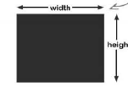

Fig 19: imagecreatetruecolor

**imagefilledrectangle($image, x1, y1, x2, y2, $color)**

It draws a rectangle whose interior is filled with the specified color.

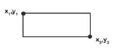

Fig 20: imagefilledrectangle

**imagecolorallocate($image, red, green, blue)**

It is **color identifier**

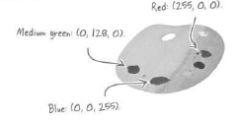

Fig 21: imageecolorallocate

**imagesetpixel($image, rand(0, $width), rand(0, $height), $graphic_color)**

The function draws a single pixel at a specified coordinate within the image. Coordinates start at 0,0 in the upper left corner of the image and increase to the right and down.

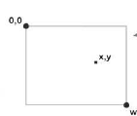

Fig 22: imagesetpixel

**imageline($image, 0, rand(0, $height), rand(0, $width), rand(0, $height), $graphic_color)**

This function draws a line between two co-ordinates (x1, y1 and x2, y2)

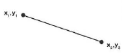

Fig 23: imageline

**imagefilledellipse(image, cx, cy, width, height, color)**

For drawing circles and ellipses, this function accepts a center point and a width and height. A perfect circle is just an ellipse with an equal height and width

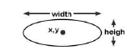

Fig 24: imagefilledellipse

**imagefilledarc(image, cx, cy, width, height, start, end, color, style)**

**imagefilledpolygon(image, points, num_points, color)**

These function works similar like the ellipses one

**imagepng(image, filename, 5)**

This function returns true or false depending on whether the image was successfully created.

We must call the header the function to have it delivered to the browser via header. Writes the image to a PNG file with the specified filename and a compression level of 5

**imagedestroy($image)**

Always free up images in memory with imagedestroy() one we have output them

**imagestring($image, 5, 25, 3, $phrase, $text_color);**

This function draws a string of text using PHP’s built-in font in the color specified.

Screen Clipping

Fig 25: imagestring

**imagestringup(image, font, x, y, string, color)**

This function draw the text vertically.

Screen Clipping

Fig 26: imagestringup

**imagettftext(image, size, angle, x, y, color, fontfile, text)**

Use the imagettftext() function to draw highly customized text with our own TrueType font.

**imagegif(image)**

It is used to create gif image

**imagejpeg(image)**

It is used to create jpeg image

**imagecolortranparent($image)**

This sets color as a transparent color with an image. This must be a color that we have created using imagecolorallocate(). To generate the image, just either imagegif() or imagepng(). image(jpeg) doesn’t support transparency

**sha1(str) or md5(str)**

PHP offers encryption

<?php

$no_of_words = 5;

$width = 100;

$height = 20;

$phrase = "";

**for**($i = 0; $i < $no_of_words; $i++){

$phrase .= chr(rand(97,122));

}

$image = imagecreatetruecolor($width, $height);

$bgd_color = imagecolorallocate($image, 255, 255, 255);

$text_color = imagecolorallocate($image, 255, 0 , 0);

$graphic_color = imagecolorallocate($image, 0, 255, 0);

$graphic_color2 = imagecolorallocate($image, 0, 0, 255);

imagefilledrectangle($image, 0, 0, $width, $height, $bgd_color);

**for**($i = 1; $i < $no_of_words; $i++){

imageline($image, 0, rand(0, $height), rand(0, $width), rand(0, $height), $graphic_color);

}

**for**($i = 1; $i < ($no_of_words * 10); $i++){

imagesetpixel($image, rand(0, $width), rand(0, $height), $graphic_color2);

}

imagettftext($image, 15, 0, 22, 18, $text_color, "fonts/ubuntu/Ubuntu-regular.ttf", $phrase);

header("Cache-Control: no-cache, must-revalidate");

header("Content-Type: image/png");

imagepng($image);

imagedestroy($image);

?>

Code 55: captcha2.php

<?php

session_start();

$no_of_words = 5;

$width = 100;

$height = 20;

$phrase = "";

**for**($i = 0; $i < $no_of_words; $i++){

$phrase .= chr(rand(97,122));

}

$_SESSION['phrase'] = sha1($phrase);

setcookie('phrase', sha1($phrase), time() + (3600 * 30), "/");

$image = imagecreatetruecolor($width, $height);

$bgd_color = imagecolorallocate($image, 255, 255, 255);

$text_color = imagecolorallocate($image, 255, 0 , 0);

$graphic_color = imagecolorallocate($image, 0, 255, 0);

$graphic_color2 = imagecolorallocate($image, 0, 0, 255);

imagefilledrectangle($image, 0, 0, $width, $height, $bgd_color);

**for**($i = 1; $i < $no_of_words; $i++){

imageline($image, 0, rand(0, $height), rand(0, $width), rand(0, $height), $graphic_color);

}

**for**($i = 1; $i < ($no_of_words * 10); $i++){

imagesetpixel($image, rand(0, $width), rand(0, $height), $graphic_color2);

}

imagettftext($image, 15, 0, 22, 18, $text_color, "fonts/ubuntu/Ubuntu-regular.ttf", $phrase);

header("Cache-Control: no-cache, must-revalidate");

header("Content-Type: image/png");

imagepng($image);

imagedestroy($image);

?>

Code 56: captcha.php

<?php

**require_once**("common/database.php");

**require_once**("common/constants.php");

$connection = mysqli_connect($server_name, $user_name, $password, $db_name)

**or** **die** ("Server Denied");

$showform = **TRUE**;

**if**(isset($_POST['submit'])):

**if**(

!**empty**($_POST['username']) &&

!**empty**($_POST['password']) &&

!**empty**($_POST['first_name']) &&

!**empty**($_POST['last_name']) &&

!**empty**($_POST['gender']) &&

!**empty**($_POST['date']) &&

!**empty**($_POST['city']) &&

!**empty**($_POST['state']) &&

!**empty**($_FILES['picture']) &&

$_POST['password'] == $_POST['password_two'] &&

$_COOKIE['phrase'] == sha1($_POST['captcha'])

):

$showform = **FALSE**;

$username = isset($_POST['username'])? mysqli_real_escape_string($connection, trim($_POST['username'])): **NULL**;

$password = isset($_POST['password'])? mysqli_real_escape_string($connection, trim($_POST['password'])): **NULL**;

$first_name = isset($_POST['first_name'])? mysqli_real_escape_string($connection, trim($_POST['first_name'])): **NULL**;

$last_name = isset($_POST['last_name'])? mysqli_real_escape_string($connection, trim($_POST['last_name'])): **NULL**;

$gender = isset($_POST['gender'])? mysqli_real_escape_string($connection, trim($_POST['gender'])): **NULL**;

$date = isset($_POST['date'])? mysqli_real_escape_string($connection, trim($_POST['date'])): **NULL**;

$city = isset($_POST['city'])? mysqli_real_escape_string($connection, trim($_POST['city'])): **NULL**;

$state = isset($_POST['state'])? mysqli_real_escape_string($connection, trim($_POST['state'])): **NULL**;

$picture = isset($_FILES['picture'])? mysqli_real_escape_string($connection, trim($_FILES['picture']['name'])): **NULL**;

$query = "INSERT INTO mismatch_user(username, password, join_date, first_name, last_name, gender, birth_date, city, state, picture)

VALUES('**$username**', SHA('**$password**'), NOW(), '**$first_name**', '**$last_name**', '**$gender**', '**$date**', '**$city**', '**$state**', '**$picture**')";

mysqli_query($connection, $query);

$destination = UPLOAD_PATH.$_FILES['picture']['name'];

move_uploaded_file($_FILES['picture']['tmp_name'], $destination);

**if**(isset($_SESSION['phrase']) && !**empty**($_SESSION['phrase'])):

$_SESSION = **array**();

**if**(isset($_COOKIE[session_name()])):

setcookie(session_name(), '', time() - 3600, '/');

**endif**;

session_destroy();

**endif**;

**if**(isset($_COOKIE['phrase']) && !**empty**($_COOKIE['phrase'])):

setcookie('phrase',' ', time() - 3600, "/");

**endif**;

**echo** "User Successfully Added";

**endif**;

**endif**;

**if**($showform):

**echo** '<!doctype html>';

**echo** ' <html>';

**echo** ' <head>';

**echo** ' <title> Add Users </title>';

**echo** ' <meta charset = "UTF-8"/>';

**echo** ' </head>';

**echo** ' <body>';

**echo** " <form enctype = 'multipart/form-data' method = 'post' action = '".$_SERVER['PHP_SELF']."'>";

**echo** ' <label for = "username">Username</label><br/>';

**echo** ' <input type = "text" name = "username"/><br/>';

**echo** ' <label for = "password">Password</label><br/>';

**echo** ' <input type = "password" name = "password"/><br/>';

**echo** ' <label for = "password_two">Retype Password</label><br/>';

**echo** ' <input type = "password" name = "password_two"/><br/>';

**echo** ' <label for = "first_name">First Name</label><br/>';

**echo** ' <input type = "text" name = "first_name"/><br/>';

**echo** ' <label for = "last_name">Last Name</label><br/>';

**echo** ' <input type = "text" name = "last_name"/><br/>';

**echo** ' <label for = "gender">Gender</label><br/>';

**echo** ' Male<input type = "radio" name = "gender" value = "male"/>';

**echo** ' Female<input type = "radio" name = "gender" value = "female"/><br/>';

**echo** ' <label for = "date">Date</label><br/>';

**echo** ' <input type = "date" name = "date"/><br/>';

**echo** ' <label for = "city">City</label><br/>';

**echo** ' <input type = "text" name = "city"/><br/>';

**echo** ' <label for = "state">State</label><br/>';

**echo** ' <input type = "text" name = "state"/><br/>';

**echo** ' <label for = "picture">Picture</label><br/>';

**echo** ' <input type = "file" name = "picture"/><br/>';

**echo** ' <label for = "captcha">Captcha</label><br/>';

**echo** " <img src = 'captcha.php' alt = 'Captcha Image'/>";

**echo** ' <input type = "text" name = "captcha"/><br/>';

**echo** ' <input type = "submit" name = "submit" value = "Submit"/><br/>';

**echo** ' </form>';

**echo** ' </body>';

**echo** ' </html>';

**require_once**("templates/pagefooter.php");

**endif**;

?>

Code 57: signup.php (Updated Data Control Sign Up Form)

#### Graph Data

Best way to extrapolate a graph is make a two-dimensional array.

<?php

$persons_info = [

"Samith" =>

[

"Physics" => 70,

"Chemistry" => 30,

"Math" => 50,

"Biology" => 90,

"English" => 54,

],

"Photon" =>

[

"Physics" => 10,

"Chemistry" => 40,

"Math" => 20,

"Biology" => 80,

"English" => 70,

],

"Erfan" =>

[

"Physics" => 100,

"Chemistry" => 49,

"Math" => 83,

"Biology" => 76,

"English" => 23,

],

];

**foreach** ($persons_info **as** $person_info => $subjects){

**echo** "<strong>".$person_info."</strong><br/>";

**foreach**($subjects **as** $subject => $score){

**echo** $subject.": ".$score."<br/>";

}

}

?>

Code 58: multidimensionalarray.php

#### Graphing Concept

Assuming, there are **four data**

Height

1 2 3 4 5 6 7 8 9

Width

Each **star** represents the **bar width of the data** and **other spaces** are just empty spaces in between two data (bar width/stars). Therefore, each **bar width** should be

Interpreting the equation, thought process

1. We divide the width by the total number of data,
2. We need space between each data which should be the same width as the bar width
3. Also, we need an extra space at the end

Looping through the data to display the data

|  |  |  |  |
| --- | --- | --- | --- |
| **Loop** | **Bar Position** | **Relative Position** | **Breakdown with Loop** |
| *0* | 2 | x | x + (2 * *0* * x) |
| *1* | 4 | x + 3x | x + (2 * *1* * x) |
| *2* | 6 | x + 5x | x + (2 * *2* * x) |
| *3* | 8 | x + 6x | x + (2 * *3* * x) |

Therefore, the starting positions of the bars would be

|  |
| --- |
| x + (2 * *0* * x) |
| x + (2 * *1* * x) |
| x + (2 * *2* * x) |
| x + (2 * *3* * x) |

The ending positiong of the bars would be

|  |
| --- |
| 2x + (2 * *0* * x) |
| 2x + (2 * *1* * x) |
| 2x + (2 * *2* * x) |
| 2x + (2 * *3* * x) |

(0, 0)

Height

1 2 3 4 5 6 7 8 9

**(Max Height)**

The division of each height is

For a given data the height of the bar is,

To give border, we use width -1 and height -1

For imagestring, we use the same concept as the bar width, make sure that the string is above the height, therefore it will be height – 2.

<?php

**require_once**("bargraph.php");

$server_name = "localhost";

$user_name = "root";

$password = "";

$db_name = "classroom";

$showform = **TRUE**;

$students = **array**();

$subjects = **array**();

**if**($showform):

**echo** "<!doctype html>";

**echo** " <html>";

**echo** " <head> ";

**echo** " <title>Classroom</title>";

**echo** " <meta charset = 'UTF-8'/>";

**echo** " </head>";

**echo** " <body>";

**echo** " <form method = 'post' action = '".$_SERVER['PHP_SELF']."'>";

**echo** " <label for = 'search'> Search </label><br/>";

$value = (!**empty**($_POST['search']))? $_POST['search'] : "";

**echo** " <input type = 'text' name = 'search'"

." value = '**$value**'/><br/>";

**echo** " <input type = 'submit' name = 'submit' value = 'Search'/>";

**echo** " </form>";

**echo** " </body>";

**echo** " </html>";

**endif**;

**if**(isset($_POST['submit'])):

*// $showform = FALSE;*

$connection = mysqli_connect($server_name, $user_name, $password, $db_name)

**or** **die** ("Server Connection Denied");

$search = $_POST['search'];

$query = "SELECT per.person_name, sub.subject_name, sc.score FROM score AS sc

INNER JOIN person AS per

ON sc.person_id = per.person_id

INNER JOIN subject as sub

ON sc.subject_id = sub.subject_id

WHERE per.person_name LIKE '%**$search**%' LIMIT 5";

$result = mysqli_query($connection, $query) **or** **die**("Query Denied");

**echo** "<table>";

**while**($row = mysqli_fetch_array($result)){

**if**(!in_array($row['person_name'], $students)):

**echo** "<tr>";

$students[] = $row['person_name'];

**echo** "<th align = 'left'> Student: ".$row['person_name']."</th>";

**echo** "</tr>";

**endif**;

**echo** "<tr>";

**echo** "<td> Subject: ".$row['subject_name']."</td>";

**echo** "<td> Score: ".$row['score']."</td>";

**echo** "</tr>";

$subjects[] = [$row['subject_name'],$row['score']];

}

**echo** "</table>";

**echo** "<pre/>";

**endif**;

draw_bar_graph(480, 240, $subjects, 100, "image.png");

**echo** "<img src = 'image.png' alt = 'bar graph'/>";

?>

Code 59: charting.php

<?php

**function** draw_bar_graph($width, $height, $data, $max_value, $filename){

$image = imagecreatetruecolor($width, $height);

$bg_color = imagecolorallocate($image, 255, 255, 255);

$text_color = imagecolorallocate($image, 0, 255, 0);

$bar_color = imagecolorallocate($image, 255, 0, 0);

$border_color = imagecolorallocate($image, 0, 0, 255);

imagefilledrectangle($image, 0, 0, $width, $height, $bg_color);

imagerectangle($image, 0, 0, $width - 1, $height - 1, $border_color);

$bar_width = $width/((count($data) * 2) + 1);

**for**($i = 0; $i < count($data); $i++){

imagefilledrectangle($image, ($i * $bar_width * 2) + $bar_width,

$height, ($i * $bar_width * 2) + ($bar_width *2),

$height - (($height/$max_value) * $data[$i][1]), $bar_color);

imagestringup($image, 5, ($i * $bar_width * 2) + $bar_width, $height - 5, $data[$i][0], $text_color);

}

imagepng($image, $filename, 5);

imagedestroy($image);

}

?>

Code 60: bargraph.php

### Web Services

Pushing web content to users is a great way to help gain more exposure for a website. HMTL is for viewing. **RSS** is for **syndicating**. An RSS view on a particular set of data is called an **RSS Feed.** To view an RSS Feed, a person needs RSS **newsreader.** RSS is a markup language used to describe web content for syndication. RSS is based on general markup language XML language. **RSS** stands for Really Simple Syndication.

**XML** is a markup language used to describe any kind of data.

**Ground rules for XML language**

1. Tags that contain content must appear as matching pairs. <p> Phone Home! </p>
2. Empty tags that have no content must be coded with a space and a forward slash at the end before before the closing brace. <br />
3. All attributes values must be enclosed in double quotes.

An RSS newsreader is designed to consume the data made available by an RSS newsfeed. XML code consists of tags what are also sometimes referred to as elements that form parent-child relationships.

<?xml version="1.0" encoding="UTF-8" ?>

**<rss** version = "2.0"**>**

**<channel>**

**<title></title>**

**<link></link>**

**<description></description>**

**<language></language>**

**<item>**

**<title></title>**

**<link></link>**

**<pubDate></pubDate>**

**<description></description>**

**</item>**

**</channel>**

**</rss>**

Code 61: rss.xml

#### Dynamically Generate XML

To make the RSS feed run in the Google Chrome Browser, we need add an extension

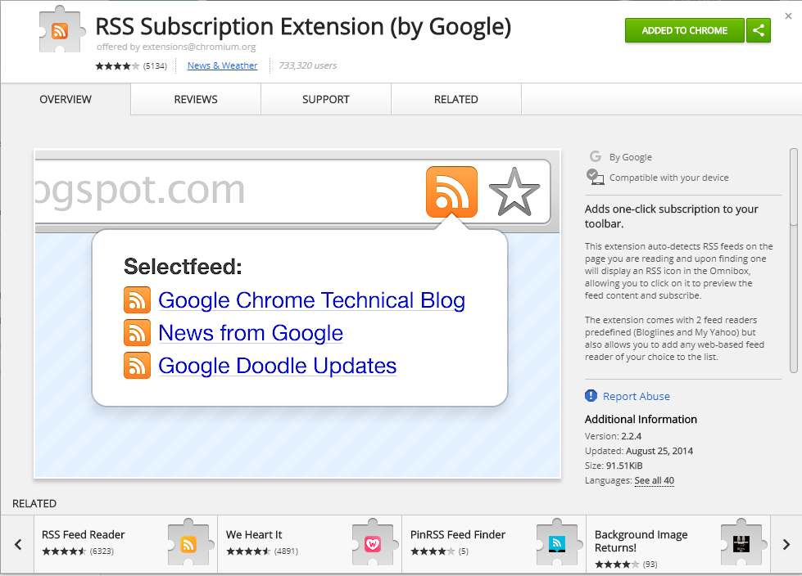

Fig 27: RSS Subscription Extension by Google

A standard icon is available to make it clear to users that offer an RSS Newsfeed

<?php header("Content-Type: text/xml"); ?>

<?php **echo** '<?xml version = "1.0" encoding = "UTF-8"?>'; ?>

<?php **echo** '<rss version = "2.0">'; ?>

<?php **echo** ' <channel>'; ?>

<?php **echo** ' <title>Job Search</title>'; ?>

<?php **echo** ' <link>http://sphotonkhan.com</link>'; ?>

<?php **echo** ' <description>Get to know about the hot jobs</description>'; ?>

<?php **echo** ' <language>en-us</language>'; ?>

<?php

$server_name = "localhost";

$user_name = "root";

$password = "";

$db_name = "riskyjobs";

$connection = mysqli_connect($server_name, $user_name, $password, $db_name)

**or** **die** ("Server Connection Denied");

$query = "SELECT * FROM riskyjobs ORDER BY date_posted DESC";

$result = mysqli_query($connection, $query)

**or** **die**("Query Denied");

**while**($row = mysqli_fetch_array($result)){

**echo** ' <item>';

**echo** ' <title>'.$row['title'].'</title>';

**echo** ' <link>'.$row['company'].'</link>';

**echo** ' <pubDate>'.$row['date_posted'].'</pubDate>';

**echo** ' <description>'.substr($row['description'], 0, 50).'</description>';

**echo** ' </item>';

}

**echo** ' </channel>';

**echo** ' </rss>';

?>

Code 62: newsfeed.php

#### REST and XML

Pulling content from another site to place it on our site. Syndicating videos from YouTube involves issuing requests and handling responses. **YouTube** videos expect videos to be queried through the use of a **REST request**. Rest stands from **Representational State Transfer**. The idea is web resources should be accessible through unique links, which means we should be able to access “RESTful” data simply by constructing a URL for it. GET is the REST ‘action’ used to access the resource. Youtube reponds to video requests XML data that describes the video.

The **simplexml_load_file($file)** function converts the specified XML file into a SimpleXMLElement object.

<?xml version="1.0" encoding="UTF-8"?>

**<note>**

**<to>**Elizabeth**</to>**

**<from>**Monkey King**</from>**

**<heading>**Party**</heading>**

**<body>**Don't forget to bring the chocolates!**</body>**

**</note>**

Code 62: note.xml

<?php

$note = simplexml_load_file("note.xml");

*//Accessing the value to w.r.t tags*

**echo** $note->to."<br/>";

**echo** $note->heading."<br/>";

**echo** $note->body."<br/>";

**echo** $note->from."<br/><br/>";

*//Accessing tags*

**echo** $note->getName()."<br/>";

**foreach**($note->children() **as** $child){

**echo** $child->getName().": ".$child."<br/>";

}

?>

Code 63: xmlload.php

When we an XML tag that has two names separated by a colon, we are looking at **namespace.** Namespaces are named groups of XML tags, while entities are used to encode special characters within XML documents.

XML entity, symbolic way of referencing a special character, such as &, < or >

&amp; = &

&lt; = <

&gt; = >

&quot; = “

&apos; = ‘

An element is just an abstract way of thinking of an XML tag and the data it contains. The XML data is organized into hierarchy of elements (tags)

A **PHP object** is a special data type that allows data to be packaged together with functions in a single construct. Objects also have **methods,** which are functions that are tied to an object. To access the data we use object **properties**, which are individual pieces of data stored within an object. XML document is a **collection of objects**. Namespaces make it a bit trickier to access elements within XML data. Use the children() method to isolate all elements associated with a namespace.

### Database Privileges

You can set very specific user privileges, even control what our user can do to a specific column

CREATE USER photon IDENTIFIED BY ‘khan_photon’

GRANT SELECT, INSERT ON table_name TO photon

### SQL Error Check

mysqli_error($connection) gives us a clue as to exactly what went wrong.

### Sanitize External Data

strip_tags() removes any html tags from a string.

### Precedence

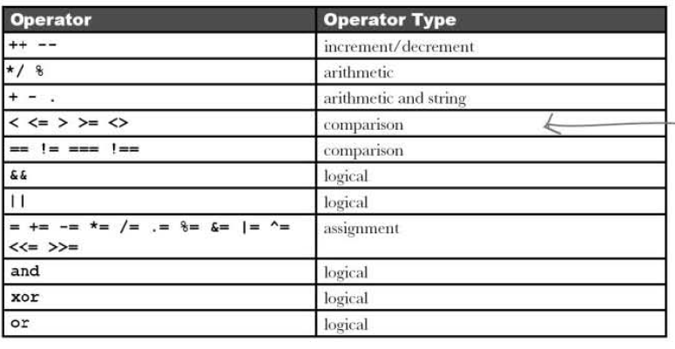

### Handling Errors

**readfile("web.txt")**

The readfile() function is useful if all we want to do is open up a file and read its contents.

**fopen(file_path, “r”)**

It contains the name of the file to be opened and the second parameter specifies in which mode the file should be opened.

**fread($myfile,filesize("web.txt"))**

First parameter of fread() contains the name of the file to read from and the second parameter specifies the maximum number of bytes to read.

**fclose($file)**

This function is used to close an open file.

**fgets($file)**

This function is used to read a single line from a file.

**feof($file)**

This function checks if the "end-of-file" (EOF) has been reached.

It is useful for looping through data of unknown length.

**fwrite($file, $string)**

It contains the name of the file to write to and the second parameter is the string to be written.

AJAX = Asynchronous JavaScript and XML

CSS = Cascading Style Sheets

HTML = Hyper Text Markup Language

PHP = PHP Hypertext Preprocessor

SQL = Structured Query Language

SVG = Scalable Vector Graphics

XML = EXtensible Markup Language

Code 64: web.txt

<?php

*//echo readfile("web.txt");*

**try**{

$file = fopen("web.txt", "r");

*/\*\**

*\* This reads out all text in one line*

*\*/*

*// echo fread($file, filesize("web.txt"));*

*/\*\**

*\* Searchs for the end of line and follows the format*

*\*/*

**while**(!feof($file)){

**echo** fgets($file)."<br/>";

}

}

**catch**(Except $e){

**echo** "Message: ".$e->getMessage();

}

**finally**{

fclose($file);

}

?>

Code 65: read.php

<?php

**try**{

$file = fopen("new.txt", "w");

$txt = "Damn sone **\n**";

fwrite($file, $txt);

$txt = "You crazy, Bro!**\n**";

fwrite($file, $txt);

}

**catch**(exception $e){

**echo** "Error: ".$e->getMessage();

}

**finally**{

fclose($file);

}

?>

Code 66: write.php

### PHP Terms

**mail($to, $subject, $message, 'From:'.$email)**

Send email

**$conn = mysqli_connect($server_name, $username, $password, $database_name)**

Connect PHP script with the server

**mysqli_close($conn)**

Closes the connection with the server

**mysqli_query($conn, $query)**

Sends MySQL Query to the server

**mysqli_select_db($connection, $databasename)**

It is used to change the default database for the connection

$**result = mysqli_query($conn, $query)**

**mysqli_fetch_array($result)**

It retrieves a single row of data from the results of a database query

**isset()**

Variable exists or not, any value is assigned to it or not

**empty()**

Checks whether the variable contains 0, NULL, FALSE or an empty string

**include(“file_path”), include_once(“file_path”)**

**require(“file_path”), require_once(“file_path”)**

Share script code across multiple files.

**$_FILES**

It is a built-in super global variable provides access to information about uploaded files.

**$_FILES[‘image’][‘name’]**

The name of the uploaded file

**$_FILES[‘image’][‘type’]**

MIME type of the uploaded file

**$_FILES[‘image’][‘tmp_name’]**

Temporary storage location of the file on the server

**$_FILES[‘error’][‘error’]**

The error code for the file upload, 0 indicates a success, other values indicate failure

**move_uploaded_file($_FILES[‘image’][‘tmp_name’], $target)**

Move file from temporary location to the targeted location

**trim($POST[‘name’])**

Eliminates Leading or trailing spaces

**mysqli_real_escape_string($connection, trim($_POST[‘name]));**

It converts dangerous characters into an escaped format that won’t adversely affect SQL queries.

**header(’Location:http://www.addinventory.php’);**

The header is called a location header and redirects the current page to addinventory.php

**header(’Refresh: 5; url=http://www.addinventory.php’);**

This header is called a refresh header since it refreshes a page after a period of time.

**header(’Content-Type: text-plain’);**

Context will be plain text

**header('HTTP/1.1 401 Unauthorized');**

This header lets the browser know that the user in not authorized to view the page

**header('WWW-Authenticate: Basic realm="Store"');**

Basic realm is just a phrase used to uniquely identify this. Particular authentication-it appears in the authentication window.

**setcookie($cookie_name, $cookie_value, time() + (86400 * 30), "/");**

The cookie will expire after 30 days (86400 * 30). The "/" means that the cookie is available in entire website

**dirname($_SERVER['PHP_SELF'])**

/education/Php/7. Personal Web Application

**$_SERVER['HTTP_HOST']**

Localhost

**session_start(), session_destroy(), session_name()**

Checks the session id

**array_push($array, $items)**

It tacks a new element onto the end of an array, causing the array to grow by one

**array_slice(array,start,length,preserve)**

Starts the array from the start the position

**explode(‘delimiter’, ‘phrase’)**

Delimiter separates the words in the phrase

**implode(‘delimiter’, ‘items’)**

Combines the string in the items array by adding delimiter after each item

**str_replace(‘delimiter’, ‘replace_item’, $string);**

The substring ‘delimiter’ gets replaced by ‘replace item’ in the string

**substr(string, start, length)**

The PHP function **substr()** function allows us to extract a portion of a string**.**

**ceil($total_query/$results_per_page)**

This rounds up the value

**preg_match($regex, $my_string)**

This function takes a regex pattern and a text string, it returns true if it matches

**checkdnsrr($domain)**

This function checks whether the domain is valid or not.

**rand()**

This function returns a random integer within a certain range.

**chr()**

This build-in function converts a number to its ASCII character equivalent.

**$image = imagecreatetruecolor($width, $height)**

The function creates a blank image in memory ready to be drawn to with other GD functions. This is an **image identifier**. Then to change the background color before drawing anything we need to call

**imagefilledrectangle($image, x1, y1, x2, y2, $color)**

It draws a rectangle whose interior is filled with the specified color.

**imagecolorallocate($image, red, green, blue)**

It is **color identifier**

**imagesetpixel($image, rand(0, $width), rand(0, $height), $graphic_color)**

The function draws a single pixel at a specified coordinate within the image. Coordinates start at 0,0 in the upper left corner of the image and increase to the right and down.

**imageline($image, 0, rand(0, $height), rand(0, $width), rand(0, $height), $graphic_color)**

This function draw a line between between two co-ordinates(x1, y1 and x2, y2)

**imagefilledellipse(image, cx, cy, width, height, color)**

For drawing circles and ellipses, this function accepts a center point and a width and height. A perfect circle is just an ellipse with an equal height and width

**imagefilledarc(image, cx, cy, width, height, start, end, color, style)**

**imagefilledpolygon(image, points, num_points, color)**

These function works similar like the ellipses one

**imagepng(image, filename, 5)**

This function returns true or false depending on whether the image was successfully created.

Writes the image to a PNG file with the specified filename and a compression level of 5

**imagedestroy($image)**

Always free up images in memory with imagedestroy() one we have output them

**imagettftext(image, size, angle, x, y, color, fontfile, text)**

Use the imagettftext() function to draw highly customized text with our own TrueType font.

**imagegif(image)**

It is used to create gif image

**imagejpeg(image)**

It is used to create jpeg image

**imagecolortranparent($image)**

This sets color as a transparent color with an image. This must be a color that we have created using imagecolorallocate(). To generate the image, just either imagegif() or imagepng(). image(jpeg) doesn’t support transparency

**sha1(str) or md5(str)**

PHP offers encryption

**unlink($file) + @ = @unlink(file)**

It deletes a file from the web server. We can suppress error reporting with @ in case the file upload didn’t actually happen.

The **simplexml_load_file($file)** function converts the specified XML file into a SimpleXMLElement object.

**mysqli_error($connection)**

gives us a clue as to exactly what went wrong.

**strip_tags()**

removes any html tags from a string.

**readfile("web.txt")**

The readfile() function is useful if all we want to do is open up a file and read its contents.

**fopen($file_path, “r”)**

It contains the name of the file to be opened and the second parameter specifies in which mode the file should be opened.

**fread($myfile,filesize("web.txt"))**

First parameter of fread() contains the name of the file to read from and the second parameter specifies the maximum number of bytes to read.

**fclose($file)**

This function is used to close an open file.

**fclose($file)**

This function is used to close an open file.

**fgets($file)**

This function is used to read a single line from a file.

**feof($file)**

This function checks if the "end-of-file" (EOF) has been reached.

It is useful for looping through data of unknown length.

**fwrite($file, $string)**

It contains the name of the file to write to and the second parameter is the string to be written.

### SQL Terms

DROP TABLE table_name

DESCRIBE table_name

SELECT * FROM table_name

DELETE FROM table_name

ALTER TABLE table_name ADD COLUMN column_name column_type

ALTER TABLE table_name CHANGE COLUMN old_column new_column new_column_type

ALTER TABLE table_name DROP COLUMN column_name

ALTER TABLE table_name MODIFY COLUMN column_name column_type AFTER column_nam

SELECT * FROM table_name ORDER BY column ASC/DESC

DELETE FROM table_name WHERE COLUMN = match LIMIT num

INSERT INTO table_name(column_name…) VALUES(column_values…)

UPDATE table_name SET column_name = some_value WHERE column_name = some_value

SELECT mismatch_topic.topic_id, mismatch_category.name

FROM mismatch_topic

INNER JOIN mismatch_category

USING (category_id)

WHERE mismatch_topic.name = “Easy Listening Music”

CREATE TABLE Orders (  
    OrderID int NOT NULL,  
    OrderNumber int NOT NULL,  
    PersonID int,  
    PRIMARY KEY (OrderID),  
    FOREIGN KEY (PersonID) REFERENCES Persons(PersonID)  
);

ALTER TABLE Orders  
ADD FOREIGN KEY (PersonID) REFERENCES Persons(PersonID);

ALTER TABLE Orders  
DROP FOREIGN KEY FK_PersonOrder;

SELECT job_id title, description FROM jobs WHERE title LIKE ‘%fighter%’

SELECT FROM table_name WHERE COLUMN = match LIMIT num(skip) num(show)

Encrypt data using MD5() in my MySQL

SHA() is considered a little secure more than MD5()

CREATE USER photon IDENTIFIED BY ‘khan_photon’

GRANT SELECT, INSERT ON table_name TO photon

### Homework

1. Combine HTML(form.html) and PHP file(report.php) into one PHP file (form.php)
2. Edit (addemail.php, addemail.html) into one PHP file(addemailupdated.php) and this time only unique email addresses would be added to the database.
3. Edit (filevalidation.php) to make it more robust.
4. Add approve and unapproved to the store files.
5. Add Validation to the Personal Web Application files.
6. Change the authentication from cookies to session for personal web application.
7. Revamp the templates for the personal web application
8. Create a REGEX for email and NID number
9. Create a Form with validation and captcha

## PHP Certification

### Basics

PHP’s syntax is derived from many languages – predominantly the C language then Perl, Java. PHP is primarily designed as a text processor. PHP can be inserted directly into a text file using a special set of tags; the interpreter will then output any text outside the tags as-is and execute the code that is between

the tags

#### Types of Tags

|  |  |
| --- | --- |
| Standard Tags | **<?php … code … ?>** |
| Short Tags | **<? … code … ?>** || **<?= $variable ?>** |
| Script Tags | **<script language = “php”> …code … </script>** |
| ASP Tags | **<% … code … %>** |

**Standard tags** are the are the best solution for portability and backwards compability

**Short tags** have major drawback of conflicting with XML headers

**Script tags** can also be used but however it ignores the code in standard tags

**Short tags, Script tags and ASP tags are all considered deprecated**

**echo** is not a function and it does not have a return value.

We can out data through a function, which is **print(),** it has a **return value of 1**.

**die(),** is an alias of exit() It allows us to terminate the scripts output.

#### PHP Data Types

PHP support smany different data types, they are divided into two categories: ***scalar and composite***.

A scalar value contains only one value at a time. PHP support four scalar types

**boolean, int, float, string**

There are two types of numbers, **integers and floating-point** values. Numbers can be declared using several different **notations**.

**Subsection of INT numbers (Notations: Decimal, Octal, Hexadecimal)**

Calculating *Octal to Decimal*

Calculating *Hexadecimal to Decimal*

Ox: It means the following number is hexadecimal,

**Subsection of Float-point values (Notations: Decimal, Exponential)**

They are also called floats and sometimes doubles.

Converting *Exponential to decimal*

**Strings** are ordered collection of binary data (text, music, spreadsheet, image file)

**Booleans** can only be written in two values: TRUE or FALSE;

**Compound Data Types**

They are usually the container of data types

**Arrays** are containers of ordered data elements

**Objects** are containers of both data and code.

**Other Data Types**

**NULL** indicates the variable has no value.

**Resource** indicates external resouces that are not used natively by PHP

$fp = fopen("index.php",'r');

$conn = mysqli_connect(localhost,"root","admin","animals");

**Converting Data types**

Enclosed in brackets and placed before an expression

<?php

*//Octal Number*

$a = 0123;

**echo** $a."<br/>";

*//Hexadecimal Number*

$a = 0x1A;

**echo** $a."<br/>";

*//Exponential*

$a = 2E7;

**echo** $a."<br/>";

*//Casting*

$x = 10.88;

**echo** (int) $x;

?>

**Code 1: numbernotation.php**

**Variables**

PHP is loosely typed, meaning that it will implicity change the type of a variable as needed

**$name,** ‘valid’;

**$_name,** ‘valid’;

**$1name,** ‘invalid’;

**Variable Variables**

<?php

$name = "full_name";

$$name = "Photon Khan";

**echo** $full_name."<br/>";

$number = '123';

$$number = '456';

**echo** ${'123'}."<br/>";

**function** display($text){

**echo** $text."<br/>";

}

$function_name = 'display';

$function_name("I am a disco dancer");

?>

**Code 2: variablevariable.php**

#### Bitwise Operator

This operator allows us to manipulate bits of data. They are designed to work only on integers.

|  |  |
| --- | --- |
| $a && $b | **Logical AND** between a and b (BOOLEAN) |
| $a || $b | **Logical OR** between a and b (BOOLEAN) |
| $a & $b | **Bitwise AND** between a and b |
| $a | $b | **Bitwise OR** between a and b |
| $a ^ $b | **Bitwise XOR** between a and b |
| ~ $a | **Bitwise NOT** of a |
| $a << $b | **Shift left** -- Shift the bits of $a $b steps to the left (each step means "multiply by two") |
| $a >> $b | **Shift right** -- Shift the bits of $a $b steps to the right (each step means "divide by two") |

**Signed variables**, such as signed integers will allow you to represent numbers both in the positive and negative ranges.

**Unsigned variables**, such as unsigned integers, will only allow you to represent numbers in the positive.

Binary Representation

|  |  |  |
| --- | --- | --- |
| **Decimal** | **Binary** | **Hexadecimal** |
| 0 | 0000 | 0000 |
| 1 | 0001 | 0001 |
| 2 | 0010 | 0010 |
| 3 | 0011 | 0011 |
| 4 | 0100 | 0100 |
| 5 | 0101 | 0101 |
| 6 | 0110 | 0110 |
| 7 | 0111 | 0111 |
| 8 | 1000 | 1000 |
| 9 | 1001 | 1001 |
| 10 | 1010 | A |
| 11 | 1011 | B |
| 12 | 1100 | C |
| 13 | 1101 | D |
| 14 | 1110 | E |
| 15 | 1111 | F |

AND

|  |  |  |  |
| --- | --- | --- | --- |
| **Input(a)** | **Input(b)** | **Output(y)** | **Boolean** |
| 0 | 0 | 0 | FALSE |
| 0 | 1 | 0 | FALSE |
| 1 | 0 | 0 | FALSE |
| 1 | 1 | 1 | TRUE |

OR

|  |  |  |  |
| --- | --- | --- | --- |
| **Input(a)** | **Input(b)** | **Output(y)** | **Boolean** |
| 0 | 0 | 0 | FALSE |
| 0 | 1 | 1 | TRUE |
| 1 | 0 | 1 | TRUE |
| 1 | 1 | 1 | TRUE |

NOT

|  |  |  |
| --- | --- | --- |
| **Input(a)** | **Output(y)** | **Boolean** |
| 0 | 1 | TRUE |
| 1 | 0 | FALSE |

XOR

|  |  |  |  |
| --- | --- | --- | --- |
| **Input(a)** | **Input(b)** | **Output(y)** | **Boolean** |
| 0 | 0 | 0 | FALSE |
| 0 | 1 | 1 | TRUE |
| 1 | 0 | 1 | TRUE |
| 1 | 1 | 0 | FALSE |

Most computers use two's-complement arithmetic**. Negative numbers** are created by taking the one's-complement (flip all the bits) and adding one:

Converting -5 to binary

|  |  |
| --- | --- |
| 5 (Decimal) | 0101 (binary) |
| 1’s complement | 1010 (Flip) |
| Add 1 | 1011 (Adding) {According to Computer) |

**Signed byte** holds values from **-128 to +127**, the first bit indicates whether the value is negative or positive.

~7(decimal) 🡪 ~0111(binary) 🡪 1000 (first bit 1 means negative) 🡪 -8

**Unsigned byte** holds values from **0 to 255**

*PHP do not support the unsigned integers*

Bitwise Math

|  |  |  |  |  |  |  |
| --- | --- | --- | --- | --- | --- | --- |
| **Bitwise AND** | | | | **Bitwise OR** | | |
| 3 | & | 7 | | 3 | | | 7 |
| 0011 | & | 0111 | | 0011 | | | 0111 |
| 0011  0111  0011 🡪 3 | | | | 0011  0111  0111 🡪 7 | | |
| **Bitwise XOR** | | | |
| 3 | ^ | 7 |
| 0011 | ^ | 0111 |
| 0011  0111  0100 🡪 4 | | | |

|  |
| --- |
| **Bitwise NOT** |
| ~7  ~0111  1000 (Flip)  -8 (signed)  8 (unsigned) |

Bitwise NOT -5(~-5) 🡪 1011(Flip) 🡪 0100 🡪 4 (in decimal)

Shifting Operators

(Left Shift) (Multiply by the power of two)

3 ≪ 1

3 in binary 🡪 0011

3 shifts by 1 to the left 🡪 0110 🡪 6 (in decimal)

(Right Shift) (Multiple by the power of two)

3 ≫ 1

3 in binary 🡪 0011

3 shifts by 1 to the right 🡪 0001 🡪 1 (in decimal)

**Use** **pow(number, power)**

2^3 = 8

<?php

$a = 3;

$b = 7;

$c = -5;

$shift_by_one = 1;

**echo** "<!doctype html>";

**echo** " <html>";

**echo** " <head>";

**echo** " <title>Bitwise Operations</title>";

**echo** " <meta charset = 'UTF-8'>";

**echo** " </head>";

**echo** " <body>";

**echo** "<table>";

**echo** " <tr>";

**echo** " <th align='left'>Operations</th>";

**echo** " <th align='left'>Solution</th>";

**echo** " </tr>";

**echo** " <tr>";

**echo** "<td>**$a** & **$b** (Bitwise AND)</td>";

**echo** "<td>".($a & $b)."</td>";

**echo** " </tr>";

**echo** " <tr>";

**echo** "<td>**$a** | **$b** (Bitwise OR)</td>";

**echo** "<td>".($a | $b)."</td>";

**echo** " </tr>";

**echo** " <tr>";

**echo** "<td> **$a** ^ **$b** (Bitwise XOR)</td>";

**echo** "<td>".($a ^ $b)."</td>";

**echo** " </tr>";

**echo** " <tr>";

**echo** "<td> ~**$b** (Bitwise NOT)</td>";

**echo** "<td>".(~$b)."</td>";

**echo** " </tr>";

**echo** " <tr>";

**echo** "<td> **$c** (Bitwise NOT)</td>";

**echo** "<td>".(~$c)."</td>";

**echo** " </tr>";

**echo** " <tr>";

**echo** "<td> **$a** << **$shift_by_one** (Bitwise Left Shift)</td>";

**echo** "<td>".($a << $shift_by_one)."</td>";

**echo** " <tr>";

**echo** "<td> **$a** >> **$shift_by_one** (Bitwise Right Shift)</td>";

**echo** "<td>".($a >> $shift_by_one)."</td>";

**echo** " </tr>";

echo " <tr>";

echo "<td> 2 to the power of 3 </td>";

echo "<td> ".pow(2,3)." </td>";

echo " </tr>";

**echo** "</table>";

**echo** " </body>";

**echo** " </html>";

?>

**Code 3: bitwise.php**

1 ≪ 32 in 32-bit computer gives a value of 0

#### Referencing Variables

<?php

*//Referencing variables*

$a = 10;

**echo** nl2br("Before Changing: **$a\n**");

$b = &$a;

$b = 20;

**echo** nl2br("After Changing: **$a\n**");

*//Referencing variables through function*

$ready_to_change = 4;

**echo** nl2br("Before Changing: **$ready_to_change\n**");

**function** change_me(&$let_me_change){

$let_me_change = 6;

}

change_me($ready_to_change);

**echo** "After Changing: **$ready_to_change**";

?>

**Code 4: referencing.php**

#### Comparison Operators

|  |  |
| --- | --- |
| $a == $b | Check if $a is equal to $b |
| $a === $b | Check if $a is equal to $b and their data type should be same |
| $a != $b | Chech if $a is not equal to $b |
| $a !== $b | Check if $a is not equal to $b and its data type |
| $a < $b | Check if $a is less than $b |
| $a > $b | Check if $a is greater than $b |
| $a ≤ $b | Check if $a is less or equal to $b |
| $a ≥ $b | Check if $a is greater or equal to $b |

#### ASCII Values

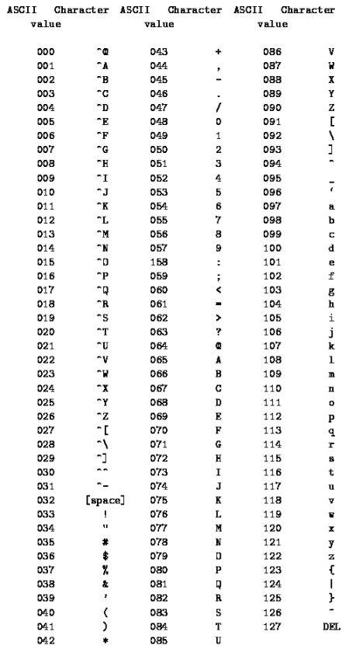

<?php

*//String to String Comparison*

$left = "ABC";

$right = "ABD";

*// A = 065, B = 066, C = 067, D = 068*

**if**($left > $right):

*// 065 066 067 > 065 066 068*

**echo** "TRUE"."<br/>";

**else**:

**echo** "FALSE"."<br/>";

**endif**;

*//Lower case and Upper case comparison*

**if**("apple" > "Apple"):

*// 097 065*

**echo** "TRUE"."<br/>";

**else**:

**echo** "FALSE"."<br/>";

**endif**;

?>

**Code 5: comparison.php**

#### Binary Operators

|  |  |  |
| --- | --- | --- |
| **Binary Operator** | **Alternative** | **Description** |
| $a && $b | $a and $b | Gives true when both the variables are true |
| $a || $b | $a or $b | Gives true when **0 1**, **1 0**, **1 1** |
| $a XOR $b | -------- | Gives truen when **0 1, 1 0** |

#### Other Operators

$x = @mysqli_connect();

@ error suppression operator

$a = `ls -l`;

This allows to run the shell command

<?php

*//Works in Linux Only*

$a = `ls -l`;

**echo** $a;

*//Works in windows (To show what the command window will say)*

system("python 2>&1",$output) ;

?>

**Code 6: backtick.php**

#### Alternative Syntaxes

<?php

$bunch_of_numbers = [23, 42, 12, 100, 14, 29, 10];

$max_number = 0;

*//Finding out the maximum value;*

**foreach**($bunch_of_numbers **as** $number):

**if**($max_number < $number):

$max_number = $number;

**endif**;

**endforeach**;

**echo** nl2br("Highest Number is: **$max_number\n**");

**echo** nl2br("**\n**");

*//While Loop*

**echo** nl2br("While Loop**\n**");

$i = 0;

**while**($i < 4):

**echo** nl2br("**$i\n**");

$i++;

**endwhile**;

**echo** nl2br("**\n**");

*//For Loop*

$i = 0;

**echo** nl2br("For Loop**\n**");

**for**($i = 0; $i < 3; $i++):

**echo** nl2br("**$i\n**");

**endfor**;

**echo** nl2br("**\n**");

*//Do While (No Alternative Syntax)*

**echo** nl2br("Do While**\n**");

$i = 0;

**do**{

**echo** nl2br("**$i\n**");

}**while**($i > 0);

**echo** nl2br("**\n**");

*//Switch Case*

**echo** nl2br("Switch Case**\n**");

$items = ["Apple", "Bat", "Cat", "Date", "Fall"];

**foreach**($items **as** $item):

**switch**($item):

**case** "Cat":

**echo** nl2br("Moderate**\n**");

**break**;

**case** "Bat":

**echo** nl2br("Good Work**\n**");

**break**;

**case** "Apple":

**echo** nl2br("Excellent**\n**");

**break**;

**case** "Fall":

**echo** nl2br("Dang it!**\n**");

**break**;

**case** "Date":

**echo** nl2br("Phew!**\n**");

**break**;

**endswitch**;

**endforeach**;

?>

**Code 7: alternativesyntax.php**

<?php

*//Continue*

**echo** nl2br("Continue**\n**");

$total = 4;

**for**($i = 1; $i <= $total; $i++):

**if**($i == 2):

**continue**;

**endif**;

**echo** nl2br("**$i\n**");

**endfor**;

*//Break*

**echo** nl2br("**\n**");

**echo** nl2br("Break**\n**");

$total = 4;

**for**($i = 1; $i <= $total; $i++):

**if**($i == 2):

**break**;

**endif**;

**echo** nl2br("**$i\n**");

**endfor**;

?>

**Code 8: continue.php**

**nl2br(“\n”)**

New line syntax

**PHP_EOL**

Create space between two numbers. EOL is End of Line

#### Types of Errors

|  |  |
| --- | --- |
| Compile-time Errors | Error while compiling (by **parser, compiler, interpreter**) |
| Fatal Errors | Halt the execution of the script |
| Recoverables errors | Failures that can be handled in a safe way |
| Warnings | Recoverable errors at run-time |
| Notices | Error condition but not significant enough to halt the script |

**Custom Error Handler**

It is useful to automatically notify the coder where the problem lies.

**set_error_handler("customError")**

This script can declare a catch-all function that is called by PHP when an error condition occurs

**customError(error_level,error_message, error_file, error_line, error_ context)**

Error Message (required), it is the user defined error

Error Levels (required)

|  |  |
| --- | --- |
| 2 | Warnings |
| 8 | Notice |
| 256 | User Error |
| 512 | User Warning |
| 1024 | User Notice |
| 4096 | Recoverable Error |
| 8191 | All |

**ob_start()**

Turn on output buffering

**ob_get_contents()**

Return the contents of the output buffer

**ob_end_clean()**

Clean (erase) the output buffer and turn off output buffering

*/\*\**

*\* [customError]*

*\* @param int $errno error number*

*\* @param string $errstr error string*

*\* @return NULL*

*\*/*

*//Show Error (Notice: 8)*

**function** customError($errno, $errstr, $errfile, $errline){

*// ob_start();*

**echo** "Error: [**$errno**] **$errstr**, on line **$errline**";

*// $str = ob_get_contents();*

*// error_log($str);*

*// ob_end_clean();*

*// var_dump($str);*

error_log("Error: [**$errno**] **$errstr**, on line **$errline**",1,

"khan.photon@gmail.com","From: khan.photon@gmail.com");

}

set_error_handler("customError");

**echo**($test);

**echo** "<br/>";

*//Trigger Error (User Notice: 1024)*

$i = 2;

**if**($i > 1){

trigger_error("Value should be 1");

}

?>

**Code 9: handlingerrors.php**

**error_log("Message",1,"$email","From: $email");**

Send Email About the Error

### Functions

#### Returning Reference

Functions can also be declared so that they return by reference; this allows us to return a variable as the result of the function. We must return a variable – we cannot return an expression by reference, or use an empty return statement to force a NULL return value

#### Variable Scope

There are three variable scope: the global scope, function scope, and class scope. There are two ways to access variables in the global scope from inside a function. global $var and $GLOBALS[‘var’]

<?php

$number = 10;

**function** &getValue(){

*// global $number;*

*// We cannot return return global $number;*

*// return $number;*

**return** $GLOBALS['number'];

}

$collect =& getValue();

--$collect;

**echo** nl2br("Returning reference: **$number**");

?>

**Code 9: returningreference.php**

PHP provides three built-in-function to handle variable-length argument lists:

**func_num_args()**

Get the number of arguments passed in the function

**func_get_arg()**

Get the one argument passed int the function

**func_get_args()**

Get the arguments value passed in the function

**array_shift($array)**

Remove the first element (red) from an array, and return the value of the removed element

$a=array("a"=>"red","b"=>"green","c"=>"blue");  
**echo array_shift($a);** Output: red  
**print_r ($a);** Output**: (**"b"=>"green","c"=>"blue");

<?php

**function** getdata(){

**if**(func_num_args() == 0):

**echo** "You need to specify at least one argument";

**else**:

$args = func_get_args();

**switch**(func_num_args()):

**case** 1:

**return** "One Item: ".$args[0];

**break**;

**case** 2:

**return** "Two items: ".array_shift($args).", ".array_shift($args);

**break**;

**default**:

**endswitch**;

**endif**;

}

$one_item = getData("potato");

$two_items = getData("potato", "tomato");

**echo** nl2br("**$one_item\n**");

**echo** nl2br("**$two_items\n**");

?>

**Code 9: variablelengtharguments.php**

**strlen($string)**

Measure the length of the string

**<?php echo strlen("Potato");?>**

### Arrays

All arrays are ordered collections of items, ***called element.***

#### Printing Array

With arrays, echo function is not used due to its inability to deal with composite data types like arrays and objects. PHP provides two functiosn that can be used to output a variable’s value recursively: print_r() and var_dump().

|  |  |
| --- | --- |
| **print_r()** | **var_dump()** |
| Prints out the data from the array | Prints out data with its data type for each value |
| Prints only for one variable | Capable of outputting the value of more than one variable. |
| It can return its output as a string | It outputs scripts standard output |
| **Both of them offer a more specialized set of functionalities as an aid in debugging** | |

#### Enumerative vs Associative

Arrays can be divided into in two categories: enumerative and associative.

**Enumerative arrays** are indexed using only numerical indexes.

$collection = [eat, sleep, drink]; 0 🡪 eat, 1 🡪 sleep, 2 🡪 drink

$collection[0] 🡪 eat

$collection[1] 🡪 sleep

$collection[2] 🡪 drink

**Associative arrays** are sometimes referred to as dictionaries.

$collection = [‘name’ => ‘Sam’, ‘phone’ => ‘123’]

$collection[‘name’] 🡪 ‘sam’;

$collection[‘phone’] 🡪 ‘123’;

PHP automatically assigns a numberic one that is equal to the greatest numeric key already in existence in the array plus one.

<?php

$employees = [

'Photon' =>[

'id' => '433',

'occupation' => 'engineer'

],

*//Assuming we couldn't get the name*

'0' => [

'id' => '512',

'occupation' => 'Technician'

],

'Sam' => [

'id' => '102',

'occupation' => 'Human Resource'

],

];

**foreach**($employees **as** $employee => $datas):

**echo** nl2br("<strong>**$employee**</strong>**\n**");

**foreach**($datas **as** $information => $data):

**echo** nl2br("**$information**: **$data\n**");

**endforeach**;

**echo** nl2br("**\n**");

**endforeach**;

$employees[] = 'Brianna';

**echo** "<strong>".$employees[1]."</strong>";

**echo** "<pre>";

var_dump($employees);

**echo** "</pre>";

?>

**Code 9: associative.php**

#### Array Operations

A number of operators behaves differently ently if their operarands are arrays. If two arrays have the same common elements that also share the same string keys or that have numeric keys, they would only appear once in the end.

<?php

$collection_one = [1, 2, 3];

$collection_two = ["a" => 1, "b" => 2, "c" => 3];

*/\*\**

*\* Therefore the addition of $collection_one + $collection_one:*

*\* 0 --> 1, 1 --> 2, 2 --> 3*

*\*/*

**echo** "<pre>";

var_dump($collection_one + $collection_one);

**echo** "</pre>";

*/\*\**

*\* Therefore the addition of $collection_one + $collection_two:*

*\* 0 --> 1, 1 --> 2, 2 --> 3, a --> 1, b --> 2, c --> 3*

*\*/*

**echo** "<pre>";

var_dump($collection_one + $collection_two);

**echo** "</pre>";

*/\*\**

*\* Therefore the addition of $collection_one + $collection_two:*

*\* 0 --> 1, 1 --> 2, 2 --> 3, a --> 1*

*\*/*

$collection_one = [1, 2, 3];

$collection_two = ['a' => 1, 2, 3];

**echo** "<pre>";

var_dump($collection_one + $collection_two);

**echo** "</pre>";

?>

**Code 10: arrayoperations.php**

#### Comparing Arrrays

The **equivalence operator** == returns true if both arrays have the same number of elements with the same values and keys, regardless of their order.

**Identity operator** === returns true only if the array contains the same key/value pairs in the same order.

<?php

$a = [1, 2, 3];

$b = [1 => 2, 2 => 3, 0 => 1];

$c = ['a' => 1, 'b' => 2, 'c' => 3];

**echo** "<pre>";

var_dump($a == $b);

**echo** "<pre/>";

**echo** "<pre>";

var_dump($a === $b);

**echo** "<pre/>";

**echo** "<pre>";

var_dump($a == $c);

**echo** "<pre/>";

**echo** "<pre>";

var_dump($a === $c);

**echo** "<pre/>";

?>

**Code 11: comparingarrays.php**

#### Counting, Searching and Deleting Elements

**count($array)**

It counts the number of elements in an array

**is_array($array)**

Checks whether the variable contains array or not

**isset()** has the major drawback of considering an element whose value is NULL, Therefore, it cannot but used to figure out whether an array with a given key exists or not. Instead use **array_key_exists()**

**unset($key)**

An element can be deleted from an array by unsetting it.

<?php

$collection = ["Sam" => "Fat", "Peter" => "thin", "Robert" => **NULL**];

**echo** nl2br(count($collection)."**\n**");

**echo** "<pre>";

var_dump(is_array($collection));

**echo** "</pre>";

**echo** "<pre>";

var_dump(isset($collection['Robert']));

**echo** "</pre>";

**echo** "<pre>";

var_dump(array_key_exists("Robert", $collection));

**echo** "</pre>";

unset($collection['Peter']);

**echo** "<pre>";

var_dump($collection);

**echo** "</pre>";

?>

**Code 12: countsearchdelete.php**

#### Flipping and Reversing

**array_flip($array)**

Inverts the value of each elements of an array with its key

**array_reverse($array)**

Reverses the order of the elements in an array. Key association is only lost for those whose key association are numeric.

<?php

$a = ["Neville" => "Smart", "Harry" => "Intelligent", "Ron" => "Dumb"];

*// Smart --> Neville, Harry --> Intelligent, Dumb --> Ron*

*// Key becomes the value and the value becomes the key*

**echo** "<pre>";

var_dump(array_flip($a));

**echo** "</pre>";

$a = ["Neville" => "Smart", "10" => "Intelligent", "Ron" => "Dumb"];

*//Reversing the order*

**echo** "<pre>";

var_dump(array_reverse($a));

**echo** "</pre>";

?>

**Code 12: flippingreversing.php**

#### Array Pointer

Each array has a pointer that indicates the “current” element of an array in an iteration.

**reset($array)**

It reset the pointer to its intial position of an array

**prev($array)**

Move backward in an array

**next($array)**

Move forward in an array

**current($array)**

Current element in an array

**key()**

Current element’s key

**end($array)**

Start the iteration from the end of the array

<?php

$books = ["Da Vinci Code" => "Dan Brown", "Harry Potter" => "J.K Rowling", "John Oliver" => "Charles Dickens"];

reset($books);

**while**(key($books) != **NULL**):

**echo** "Book Name:: ".key($books)."<br/>";

**echo** "Author Name:: ".current($books)."<br/><br/>";

next($books);

**endwhile**;

**echo** nl2br("**\n**");

reset($books);

end($books);

**while**(key($books) != **NULL**):

**echo** "Book Name:: ".key($books)."<br/>";

**echo** "Author Name:: ".current($books)."<br/><br/>";

prev($books);

**endwhile**;

?>

**Code 12: arraypointers.php**

#### Referencing array in a loop

Modifying the contents of the array directly by assigning the value of each element to the iterated variable by reference rather than by value.

<?php

*//Modify the values of the all the elements*

$values = **array**("100", "200", "300");

**foreach**($values **as** $key => &$value):

$value++;

**endforeach**;

**echo** "<pre>";

var_dump($values);

**echo** "</pre>";

*//Modify all the elements except the last one*

$values = **array**("100", "200", "300");

**foreach**($values **as** $key => &$value):

**endforeach**;

*//Loop Result 0 --> 100, 1--> 200, 2 --> 300*

**echo** "<pre>";

var_dump($values);

**echo** "</pre>";

**foreach**($values **as** $key => $value):

**endforeach**;

*//Loop Result 2 --> 100, 2 --> 200, 2 --> 200*

**echo** "<pre>";

var_dump($values);

**echo** "</pre>";

?>

**Code 12: arrayloopvaluereference.php**

*//Modify all the elements except the last one*

As soon as the second loop starts, $values is now assigned the value of each element. However, $v is already a referene to $values[2]; therefore, any value assigned to it will ve copied automatically into the last element of the arrays.

#### Passive Iteration

**array_walk()** and **array_walk_recursive()** can be used to perform an iteration of an array in which user-defined function is called.

**array_combine($keys, $values)**

Creates an array by using one array for keys and another for its values

**strtoupper($var)**

Changes lower case letter to uppercase

<?php

$employees = ["Peter","James"];

$description[] = ["Spiderman", "Photographer"];

$description[] = ["Guitar Player", "Metallica"];

$combine = array_combine($employees, $description);

**function** setCase(&$value, &$key){

$value = strtoupper($value);

}

array_walk_recursive($combine, "setCase");

**echo** "<pre>";

var_dump($combine);

**echo** "</pre>";

?>

**Code 13: passiveiteration.php**

#### Sorting Arrays

**sort($array)**

It modifies the actual array. This means that we cannot call this function by passing anything other than a single variable to it. It effectively destroys all the keys in the array and renumbers its elements starting from zero.

**asort($array)**

It is similar to sort but it maintains the key association

Both sort() and asort() accept a second optional parameter

|  |  |
| --- | --- |
| **SORT_REGULAR** | Compare items as they appear in the array without conversion |
| **SORT_NUMERIC** | Convert each element to a numeric value for sorting purposes |
| **SORT_STRING** | Compare all elements in strings |

**rsort($array), arsort($array)**

Sorts the array in reverse order

**natsort($array)**

Natural sorting. The string value of “10t” will be considered “lower” than “2t” because it starts with the character 1, which has a lower value than 2.

**natcasesort($array)**

Natural case-insensitive version of natural sort

**ksort($array)**

Sort the array using the keys

**krsort($array)**

Sort the array using the keys in reverse order

**usort($array)**

User defined sorting of an array.

One of the custom defined array could be, to sort an arrat according to the length of each elements’s string representation. If the elements are of same length use string compare function strcmp($string, $string)

**uksort($array)**

User defined sorting of an array by key.

**ursort($array)**

User defined sorting of an array by key in reverse order.

**strcmp($string, $string)**

Compares the length of the two strings

#### Anti-Sort

**shuffle($array)**

Scramble the order of the array contents

**array_keys($array)**

Saves the keys with its value

<?php

*//sort*

**echo** "sort<br/>";

$groceries = ["a"=>'apple', "o" =>'orange', "l" => 'lemon'];

sort($groceries);

*//It destroys the keys*

**echo** "<pre>";

var_dump($groceries);

**echo** "</pre>";

*//asort*

**echo** "asort<br/>";

$groceries = ["a"=>'apple', "o" =>'orange', "l" => 'lemon'];

asort($groceries);

*//It maintains the keys*

**echo** "<pre>";

var_dump($groceries);

**echo** "</pre>";

**echo** "===================================================";

**echo** "<br/>";

*//rsort*

**echo** "rsort<br/>";

$groceries = ["a"=>'apple', "o" =>'orange', "l" => 'lemon'];

rsort($groceries);

*//It destroys the keys*

**echo** "<pre>";

var_dump($groceries);

**echo** "</pre>";

*//arsort*

**echo** "arsort<br/>";

$groceries = ["a"=>'apple', "o" =>'orange', "l" => 'lemon'];

arsort($groceries);

*//It maintains the keys*

**echo** "<pre>";

var_dump($groceries);

**echo** "</pre>";

**echo** "===================================================";

**echo** "<br/>";

*//natsort*

**echo** "natsort<br/>";

$groceries = ["a"=>'10T', "O" =>'20t', "l" => '30t', "f" => '40T'];

natsort($groceries);

**echo** "<pre>";

var_dump($groceries);

**echo** "</pre>";

*//natcasesort*

**echo** "natcasesort<br/>";

$groceries = ["a"=>'10T', "O" =>'20t', "l" => '30t', "f" => '40T'];

natcasesort($groceries);

**echo** "<pre>";

var_dump($groceries);

**echo** "</pre>";

**echo** "===================================================";

**echo** "<br/>";

*//ksort*

**echo** "ksort<br/>";

$groceries = ["a"=>'10T', "O" =>'20t', "l" => '30t', "1" => '40T'];

ksort($groceries);

**echo** "<pre>";

var_dump($groceries);

**echo** "</pre>";

*//krsort*

**echo** "krsort<br/>";

$groceries = ["a"=>'10T', "O" =>'20t', "l" => '30t', "1" => '40T'];

krsort($groceries);

**echo** "<pre>";

var_dump($groceries);

**echo** "</pre>";

**echo** "===================================================";

**echo** "<br/>";

*//usort*

**echo** "usort<br/>";

$items = ["three", "2two", "one", "two"];

usort($items, "organize");

**function** organize($left, $right){

$diff = strlen($left) - strlen($right);

**if**(!$diff):

**return** strcmp($left, $right);

**endif**;

**return** $diff;

}

**echo** "<pre>";

var_dump($items);

**echo** "</pre>";

**echo** "===================================================";

**echo** "<br/>";

*//shuffle*

**echo** "shuffle<br/>";

$items = ["a"=>'apple', "o" =>'orange', "l" => 'lemon'];

shuffle($items);

*//It destroys the keys*

**echo** "<pre>";

var_dump($items);

**echo** "</pre>";

**echo** "===================================================";

**echo** "<br/>";

?>

**Code 14: sort.php**

#### Arrays as Stacks, Queues and Sets

Arrays are often used as **stacks** (**Last in, First Out, or LIFO**)

Array are also used as **queues** (**First in, First Out, or FIFO**)

PHP simplifies the approach by providing a set of functions that can be used to push an pull for stacks and shift and unshift for queues

*Add item at the end and remove the item at the end*

**array_push($stack, “$item”, “item”)**

Add elements at the end of the array

**array_pop($stack)**

Remove element at the end of the array

*Add item at the start and remove the item at the start*

**array_shift($queues)**

Remove element at the start of the array

**array_unshift($queues, “$item”)**

Add element at the start of the array

<?php

*/\*\**

*\* Stack (Last In, First Out)*

*\*/*

**echo** "Array Push";

$list = **array**("guitar", "amp", "cables");

array_push($list, "keyboard", "drums");

**echo** "<pre>";

var_dump($list);

**echo** "</pre>";

**echo** "============================";

**echo** "<br/>";

**echo** "Array Pop";

$last_in = array_pop($list);

**echo** "<pre>";

var_dump($last_in);

var_dump($list);

**echo** "</pre>";

**echo** "============================";

**echo** "<br/>";

*/\*\**

*\* Queues (First in, First Out)*

*\*/*

**echo** "Array Shift";

$list = **array**("guitar", "amp", "cables");

array_shift($list);

**echo** "<pre>";

var_dump($list);

**echo** "</pre>";

**echo** "============================";

**echo** "<br/>";

**echo** "Array Unshift";

array_unshift($list, "keyboard", "drums");

**echo** "<pre>";

var_dump($last_in);

var_dump($list);

**echo** "</pre>";

**echo** "============================";

**echo** "<br/>";

?>

**Code 15: stackqueues.php**

#### Set Functionalities

**array_diff($array, $array)**

It is used to compute the difference between two arrays

**array_diff_assoc($array, $array)**

It is used to compute the difference between two arrays based on key value pairs

**array_diff_key($array, $array)**

It is used to compute the difference between two keys

**array_diff_uassoc($array, $array)**

User define differences between two arrays based on key value pairs

**array_diff_ukey($array, $array)**

User define difference between two keys

**array_intersect($array, $array)**

Common section of two arrays

**array_intersect_key($array, $array)**

Common keys between two arrays

**array_intersect_assoc($array, $array)**

Common section between two arrays using key value pairs

**array_intersect_ukey($array, $array)**

User define common section of two array using key

**array_intersect_uassoc($array, $array)**

User define common section of two array using key value pair

<?php

**echo** "array diff<br/>";

$collection = [299, 23, 15, 90];

$collection2 = [23, 15, 100, 70];

**echo** "<pre>";

var_dump(array_diff($collection, $collection2));

**echo** "</pre>";

**echo** "=====================================<br/>";

**echo** "array intersect<br/>";

$collection = [299, 23, 15, 90];

$collection2 = [23, 15, 100, 70];

**echo** "<pre>";

var_dump(array_intersect($collection, $collection2));

**echo** "</pre>";

?>

**Code 16: setfunctionalities.php**

### Strings and Patterns

Escape sequences are sometimes called control characters and take the form of a backslash followed by one or more characters.

Encapsulate the variables in curly braces.

**Heredoc Syntax**

It can be used to declare complex strings.

**Binary safe**: This means that all characters in the string are counted, reagardless of their value. In some languages notably C, some functions are designed to work with “zero-terminated” strings, where was the NULL character is used to signal the end of the string.

<?php

*/\*\**

*\* Encapsulation*

*\*/*

**echo** "Encapsulation</br>";

$describe = "toy";

$persons = ["John", "Dwayne", "Mary"];

**echo** "There are loads of **{**$describe**}**s in the store"."<br/>";

**echo** "Citation: **{**$persons[1]**}**[1984]<br/>";

**echo** nl2br("**\n**");

*/\*\**

*\* Herodoc*

*\*/*

**echo** "Herodoc</br>";

$describe = "toy";

**echo** <<<BOOM

There are loads of {$describe}s in the store.

BOOM;

**echo** nl2br("**\n**");

?>

**Code 17: encapsulation.php**

#### Compare string

**strcmp($string, $string)**

Check whether the string matches or not, sensitive to cases.

**strcasecmp($string, $string), substr_compare($string, $string)**

Check whether the string matches or not, insensitive to cases.

**strpos($haystack, $string)**

It allows us to find the position of substring(***needle***), inside a string (***haystack***)

**strstr($string, $word)**

Searches for the first occurrence of a string inside another string. Then reveals everything after that.

**stripos()**

It allows us to find the position of substring(***needle***), inside a string (***haystack***) (case-insensitive)

**stristr($string, $word)**

Searches for the first occurrence of a string inside another string. Then reveals everything after that. (case-insensitive)

**strspn($string, $mask, $starting_position, $ending_position)**

Match a string against a “whitelist” mask of allowed characteristics. It returns the length of the intial segment of the string that contains any of the characters specified in the mask.

**strcspn($string, $mask, $starting_position, $ending_position)**

Match a string against a “blacklist” mask of allowed characteristics.

<?php

*/\*\**

*\* Shows find the letter prints it after that searched letter*

*\*/*

**echo** "strstr<br/>";

$string = "abc";

**echo** strstr($string, "b")."<br/>";

**echo** "==============";

**echo** "<br/>";

**echo** "String Array<br/>";

$string = "abc";

**echo** $string[1]."<br/>";

**echo** "==============";

**echo** "<br/>";

*/\*\**

*\* Compares between two strings (Case Insensitive)*

*\*/*

**echo** "String Compare<br/>";

$string = "I am a good boy";

**echo** "<pre>";

var_dump(strcasecmp($string, "i am a good boy"));

**echo** "</pre>";

**echo** "==============";

**echo** "<br/>";

*/\*\**

*\* WhiteList*

*\*/*

**echo** "strspn<br/>";

$haystack = "aaaabbbccddasdf";

$needle = "abcd";

**echo** strspn($haystack, $needle)."<br/>";

**echo** "==============";

**echo** "<br/>";

?>

**Code 18: transformer.php**

### PHP Terms

**print($string)**

Exactly like echo but returns a value of 1

**Use** **pow(number, power)**

2^3 = 8

**system("python 2>&1",$output)**

Prints out what command will say in the web server

**nl2br(“\n”)**

Syntax for the new lines

**PHP_EOL**

Create space between two numbers. EOL is End of Line

**set_error_handler("customError")**

**customError(error_level,error_message, error_file, error_line, error_ context)**

This script can declare a catch-all function that is called by PHP when an error condition occurs

**ob_start()**

Turn on output buffering

**ob_get_contents()**

Return the contents of the output buffer

**error_log("Message",1,"$email","From: $email");**

Send Email About the Error

**global $var and $GLOBALS[‘var’]**

Access the global variable inside a function

**func_get_arg()**

Get the one argument passed int the function

**func_get_args()**

Get the arguments value passed in the function

**array_shift($array)**

Remove the first element (red) from an array, and return the value of the removed element

**strlen($string)**

Measure the length of the string

**var_dump($array)**

Prints out data with its data type for each value

**print_r($array)**

Prints out the data from the array

**count($array)**

It counts the number of elements in an array

**is_array($array)**

Checks whether the variable contains array or not

**array_key_exists($array[‘x’])**

Checks whether an array with a given key exists or not

**unset($key)**

An element can be deleted from an array by unsetting it.

**array_flip($array)**

Inverts the value of each elements of an array with its key

**array_reverse($array)**

Reverses the order of the elements in an array. Key association is only lost for those whose key association are numeric.

**reset($array)**

It reset the pointer to its intial position of an array

**prev($array)**

Move backward in an array

**next($array)**

Move forward in an array

**current($array)**

Current element in an array

**key($array)**

Current element’s key

**end($array)**

Start the iteration from the end of the array

**array_walk()** and **array_walk_recursive()** can be used to perform an iteration of an array in which user-defined function is called.

**array_combine($keys, $values)**

Creates an array by using one array for keys and another for its values

**strtoupper($var)**

Changes lower case letter to uppercase

**sort($array)**

It modifies the actual array. This means that we cannot call this function by passing anything other than a single variable to it.

**rsort($array), arsort($array)**

Sorts the array in reverse order

**natsort($array)**

Natural sorting.

**natcaseort($array)**

Case insensitive natural sorting.

**ksort($array)**

Sort the array using the keys

**krsort($array)**

Sort the array using the keys in reverse order

**usort($array)**

User defined sorting of an array.

**uksort($array)**

User defined sorting of an array by key.

**ursort($array)**

User defined sorting of an array by key in reverse order.

**strcmp($string, $string)**

Compares the length of the two strings

**array_keys($array)**

Saves the keys with its value

**shuffle($array)**

Scramble the order of the array contents

**array_push($stack, “$item”, “item”)**

Add elements at the end of the array

**array_pop($stack)**

Remove element at the end of the array

**array_shift($queues)**

Remove element at the start of the array

**array_unshift($queues, “$item”)**

Add element at the start of the array

**array_diff($array, $array)**

It is used to compute the difference between two arrays

**array_diff_assoc($array, $array)**

It is used to compute the difference between two arrays based on key value pairs

**array_diff_key($array, $array)**

It is used to compute the difference between two keys

**array_diff_uassoc($array, $array)**

User define differences between two arrays based on key value pairs

**array_diff_ukey($array, $array)**

User define difference between two keys

**array_intersect($array, $array)**

Common section of two arrays

**array_intersect_key($array, $array)**

Common keys between two arrays

**array_intersect_assoc($array, $array)**

Common section between two arrays using key value pairs

**array_intersect_ukey($array, $array)**

User define common section of two array using key

**array_intersect_uassoc($array, $array)**

User define common section of two array using key value pair

**strstr($string, $word)**

Searches for the first occurrence of a string inside another string.

**strcmp($string, $string)**

Check whether the string matches or not, sensitive to cases.

**strcasecmp($string, $string), substr_compare($string, $string)**

Check whether the string matches or not, insensitive to cases.

**strpos()**

It allows us to find the position of substring(***needle***), inside a string (***haystack***)

**stripos()**

It allows us to find the position of substring(***needle***), inside a string (***haystack***) (case-insensitive)

**stristr($string, $word)**

Searches for the first occurrence of a string inside another string. Then reveals everything after that. (case-insensitive)

**strspn($string, $mask, $starting_position, $ending_position)**

Match a string against a “whitelist” mask of allowed characteristics. It returns the length of the intial segment of the string that contains any of the characters specified in the mask.

**strcspn($string, $mask, $starting_position, $ending_position)**

Match a string against a “blacklist” mask of allowed characteristics.

# Software Learning

## GitHub

GitHub is a code hosting platform for version control and collaboration. It lets us work together on projects from anywhere. Create a GitHub account first.

### STEP 1: Create a Repository

It is usually used to organize a single project. Repositories can contain folders and files, images, videos, spreadsheet, and data-sets anything that our project needs

* In the upper right corner, next to your avatar or identicon, click + and then select New repository.
* Name your repository hello-world.
* Write a short description.
* Select Initialize this repository with a README.

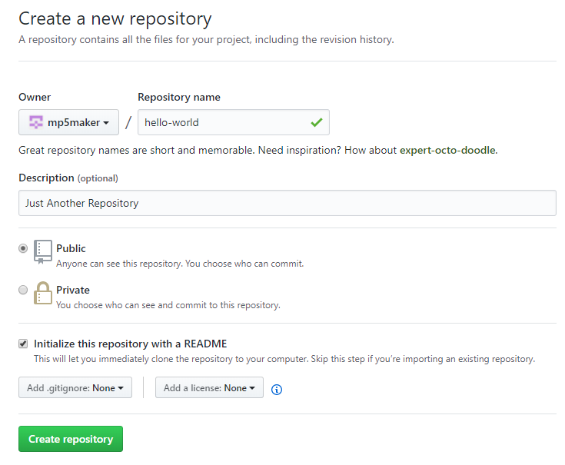

Fig 1. GitHub, Creating New Repository

### STEP 2: Branching

It is the way to work on different versions of a repository at one time. By default, our repository has one branch named master which is considered to be the definitive branch. We use branches to experiment and make edits before committing them to master. When we create a branch off the master branch, you’re making a copy, or snapshot, of master as it was at that point in time. If someone else made changes to the master branch while we were working on your branch, we could pull in those updates.

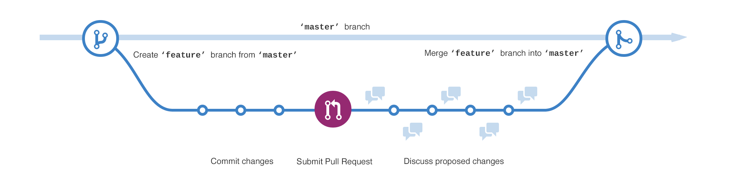

Fig 2. GitHub, Branching

#### To create a new branch

Go to your new repository hello-world.

Click the drop down at the top of the file list that says branch: master.

Type a branch name, readme-edits, into the new branch text box.

Select the blue Create branch box or hit “Enter” on your keyboard.

Now we have two branches, master and readme-edits. They look exactly the same. Next, we’ll add our changes to the new branch.

### STEP 3: Commit Changes

We are on the code view for our readme-edits branch, which is a copy of master.

On GitHub, **saved changes** are called **commits**. Each commit has an associated commit message, which is a description explaining why a particular change was made. Commit messages capture the history of our changes, so other contributors can understand what we have done and why.

### STEP 4: Open a Pull Request

When we open a pull request, we are proposing our changes and requesting that someone review and pull in your contribution and merge them into their branch. Pull requests show diffs, or differences, of the content from both branches. The changes, additions, and subtractions are shown in green and red.

As soon as we make a commit, we can open a pull request and start a discussion, even before the code is finished. By using GitHub’s **@mention** system in your pull request message, you can ask for feedback from specific people or teams. We can even open pull requests in your own repository and merge them ourselves.

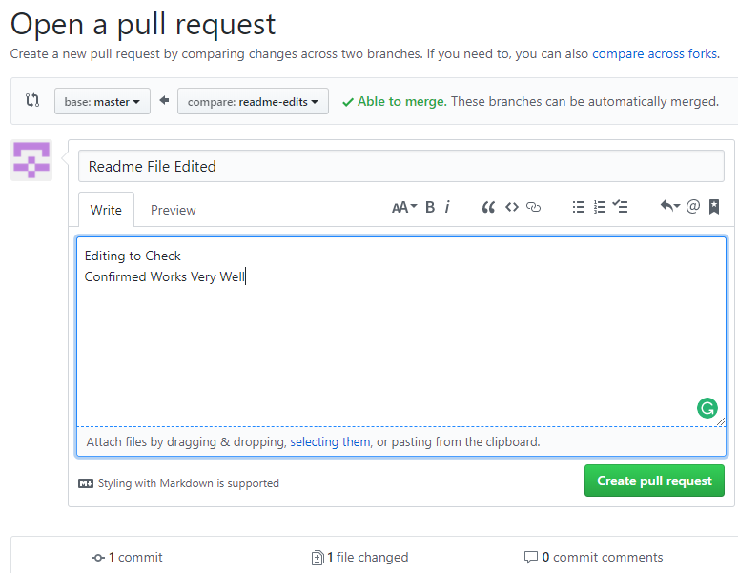

Fig 3. GitHub, Open a Pull Request

### STEP 5: Merge our Pull Request

In this final step, it’s time to bring our changes together – merging our readme-edits branch into the master branch.

Click the green Merge pull request button to merge the changes into master.

Click Confirm merge.

Go ahead and delete the branch, since its changes have been incorporated, with the Delete branch button in the purple box.

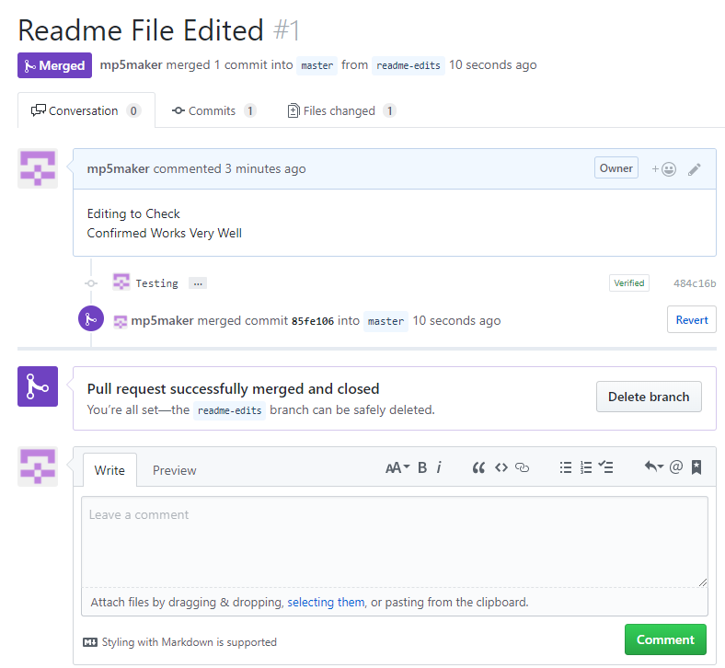

Fig 4. GitHub, Merge the Pull Request